16th Information Exchange Meeting on Actinide and Fission
Product Partitioning and Transmutation
G. Grassi¹, R. Tarsi¹, A. Dupont²
¹OECD Nuclear Energy Agency
²CEA, France
This document explains how to prepare conference papers for the 16th Information Exchange Meeting on Actinide and Fission Product Partitioning and Transmutation and provides instructions on titles and headings, figures and tables, sources and references.
Short summaries should briefly describe the contents of the paper. They should include as many keywords as possible, related to the content covered in a given paper. They should not contain bulleted lists, or any kind of stylised content.

Introduction
The text of the paper should be prepared in Microsoft Word, in Times New Roman font, size 11 and should be approximately 1-5 pages long. All conference papers contain an Introduction, which includes the scope of the study and presents the objectives of the paper.

Titles and headings
The text should be divided into first and second-level headings and typed in one column, single-spaced, justified left and right. UK English spelling should be used. The words “Table”, “Figure”, “Equation” and “Reference” should be written in full and not contracted to “Tab.”, “Fig.”, “eq.” and “Ref.”

Figures and tables
Figures and tables should be numbered carefully from 1 to x. The purpose of figures and tables is to present data clearly. All figures and tables should be properly numbered and referred to in the text. Each figure and table should have an explanatory title, which should be as concise and clear as possible. The sources of the data (name of the author or the institution, year) should be provided in full beneath the figure or table. If the data presented in the table or figure come from calculations based on other data, the authors should make sure they have all necessary permissions for reproduction of third-party material.
Where possible, tables should not be broken over several pages. If they are, the title should be repeated on each page with the mention “Cont’d”, for “continued”, as well as the source and notes. Figures must be of high resolution and carefully prepared. Figures are often reduced to half of their original size and so the lettering and symbols must be sufficiently clear and large. Figure and table titles should be typed in Times New Roman bold font, size 10, in sentence case, centred above the figure or table.

Figure 1. Figure titles are bold and centred
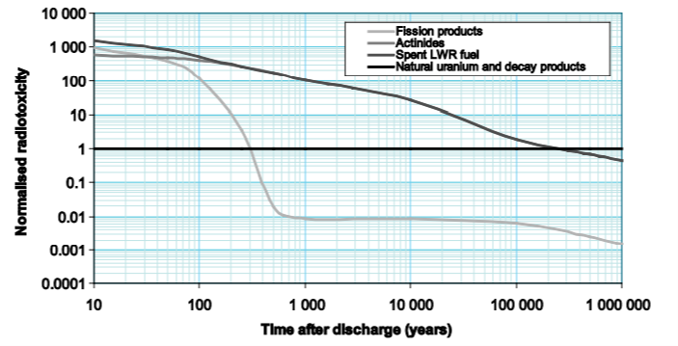
Source: Institution, year.
Table 1. Table titles are bold and centred
Element | Removed by cladding wash (wt % of UNF) | Remaining in washed clad  (wt % of UNF) | Reduction factor | Residual clad contamination (ppm)
U | 0.6 | 0.0037 | 162 | 100.0
Pu | 0.3 | 0.0130 | 23 | 6.0
Am | 0.2 | 0.0130 | 15 | 0.6

Source: Institution, year.

Conclusions
Conference papers should contain conclusions, which outline the results of the study.

Acknowledgements
Acknowledgements are used for brief acknowledgements of help received in the preparation of the paper.

References
A complete list of references must be provided at the end of the paper. References cited in the text should use the author’s surname and the year of publication between parentheses. When the author’s name is mentioned in the text, only the publication year should be cited in parentheses. Where there are two or more publications by the same author and the years of publication are the same, a lower-case “aˮ should feature after the date in the first entry, “bˮ in the second, and so on, listed in the order in which they appear in the text.
Bibliographical entries should be provided in alphabetical order according to the authors’ surnames. Every bibliographical entry in the list of references should contain:
- author’s surname, initials;
- year of publication (in parentheses);
- title of the work;
- publisher;
- place of publication;
- DOI or URL.
NEA (2005), Assessment of Neutron Cross-section Evaluations for the Bulk of Fission Products, International Evaluation Co-operation, Volume 21, NEA/WPEC-21 Report, OECD Publishing, Paris. www.oecd-nea.org/jcms/pl_13958.
Nichols, A.L. and J.K. Tuli (2007), “The aims and activities of the International Network of Nuclear Structure and Decay Data Evaluators”, Proceedings of the International Conference on Nuclear Data for Science and Technology 2007, 1, pp. 37, DOI:10.1051/ndata:07149.
Ishibashi, K., H. Takada, T. Nakamoto, et al. (1997), “Measurement of Neutron-Production Double-Diﬀerential Cross Sections for Nuclear Spallation Reaction Induced by 0.8, 1.5 and 3.0 GeV Protons”, Journal of Nuclear Science and Technology, 34, pp. 529-537.

