SATIF-12 proceedings – Instructions for authors
Jim Gulliford¹, Akifumi Yamaji^{1,2}
¹OECD Nuclear Energy Agency
²Another Affiliation, Country
Abstract

Text (1 page maximum): These instructions concern the full contribution to the SATIF-12 workshop. The proceedings will be published by the OECD Nuclear Energy Agency (NEA). Only MS Word contributions will be accepted. In order to comply with NEA publication standards, authors are asked to use the present document as a template and follow the recommendations for the style. For your font style, you may also use Times New Roman.

Introduction
This document provides general instructions for the preparation of the full contributions to the SATIF-12 workshop. The proceedings will be published by the OECD Nuclear Energy Agency (NEA). Only MS Word contributions will be accepted. There is no strict limitation on the number of pages (between 5 and 15 to give an indication). In order to comply with NEA publication standards, authors are asked to use the present document as a template and follow the recommendations for the style.

(1)
Submission of your full contribution
See the SATIF-12 website for up-to-date instructions.
Manuscript preparation
Headings and numbering
Do not use section numbers. The major headings should be formatted as “Heading 2”, the secondary headings as “Heading 3”, etc. The first paragraph following a heading is not indented. If a Heading 3 immediately follows Heading 2, suppress the 12 pts above the Heading 3 (as done in this section).
Subsequent paragraphs have a .75 cm indent. This is the subsequent paragraph.
Figures and tables
The words “Figure(s)” and “Table(s)” are not abbreviated in the text or in the caption, which is placed above in both cases. Please, see Figure 1 and Table 1 for formatting instructions.
Table 1: Table titles are bold and centred
Scenarios | 0%  scenario | 15%  scenario | 20-25%  scenario | Current  (2010)
Nuclear | 0 % | 15 % | 20-25 % | 26 %
Renewable energy | 35 % | 30 % | 25 -30 % | 10 %
Fossil fuel | 65 % | 55 % | 50 % | 63 %
Greenhouse gas emission1 | ▲23 % | ▲23 % | ▲25 % | ▲0.3 %
Nuclear fuel cycle | Direct disposal | Reprocessing/direct disposal | Reprocessing/direct disposal | Reprocessing

Table source

Figure 1: Figure titles are bold and centred
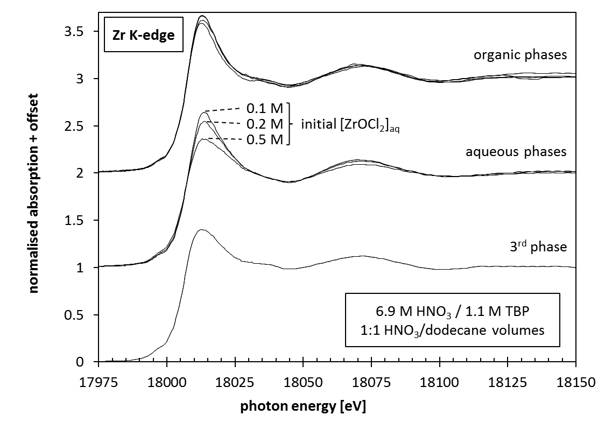

Equations
Large equations should be centred with a right-adjusted Arabic numeral between parentheses. References to the equation in the text are abbreviated. Please see Equation (1).
(1)

Acknowledgements

Your acknowledgements should be entered here.
References
Please use numbered references. They should be consecutively numbered in order of their appearance in the text and listed at the end of the paper. Citations in the text are given using brackets [1] or [1] [2] or [1-3].
[1] T. Yamashita et al. (2002), “Rock-Like Oxide Fuels and Their Burning in LWRs”, J. Nuclear Sci. Technol., 39[8], pp. 865-871.
[2] H. Akie, Y. Sugo, R. Okawa (2003), “Core burnup calculation and accidents analyses of a pressurized water reactor partially loaded with rock-like oxide fuel”, J. Nucl. Mat., 319, pp. 166-172.
[3] T. Wakabayashi et al. (1997) “Feasibility studies on plutonium and minor actinide burning in fast reactors”, Nucl. Technol., 118, pp. 14-25.

