OECD/NEA
Burnup Credit Criticality Benchmark Phase IIIC

Nuclide Composition and Neutron Multiplication Factor of
BWR Spent Fuel Assembly for Burnup Credit and
Criticality Control of Damaged Nuclear Fuel

Kenya SUYAMA¹
Yuriko UCHIDA¹
Takuya ITO²
Takamasa MIYAJI²

September 2012

1- Japan Atomic Energy Agency
2- Nuclear Fuel Industries, Ltd.

1. Introduction

After the accident of Fukushima Daiichi Nuclear Power Station(hereinafter referred to as 1FNPS), which occurred by the 2011 off the pacific coast of Tohoku earthquake in 11 March 2011, technical developments have been started to recover the environment and the decommissioning of the damaged nuclear power reactors. The criticality control of the damaged nuclear fuel is one of the key issues to be confirmed strictly during the decommissioning operation. For this purpose, criticality parameters of the mixtures of damaged nuclear fuel and other materials such as iron or concrete should be evaluated. It requires, at first, averaged isotopic composition of spent nuclear fuel as the function of the burnup value.

The Expert Group on Burnup Credit Criticality Safety (EGBUC) of Working Party of Nuclear Criticality Safety (WPNCS) under the Nuclear Science Committee (NSC) of OECD/NEA has been assessing the accuracy of the burnup calculation code systems by organizing several international benchmarks. For BWR fuel, the Phase-3B benchmark [1] is a remarkable landmark to give us general information on the burnup properties of the BWR spent fuel. That information is useful for considering the basic criticality parameters of the damaged fuel of Fukushima accident. However it is based on the 8 by 8 type fuel assembly adopting large water rod. In 1FNPS, the 9 by 9 type fuel assemblies adopting updated fuel design were widely used. It has different geometry specification and assembly averaged ²³⁵U enrichment. This type of fuel assembly is called as “STEP-3 fuel” in Japan.

After the Phase-3B benchmarks carried out more than 10 years ago, nuclear data libraries have been revised, i.e., in Japan from JENDL-3.2 to JENDL-4, in Europe from JEF-2.2 to JEFF-3.1 and in U.S. ENDF/B-VI to ENDF/B-VII, and the method of burnup calculation has also been improved by adopting continuous energy Monte Carlo code or based on the modern neutronics method. Considering the importance of the isotopic composition of STEP-3 BWR fuel from the view point of the criticality control of damaged fuel generated by 1FFNPS accident, it is worth to organize new international burnup calculation benchmark for BWR fuel assembly to carry out the inter-comparison of the averaged isotopic composition of the STEP-3 nuclear fuel and to obtain related factors to be interested in the burnup credit criticality safety community.

2. Geometry Specification

Figure 1 shows a horizontal cross section of a BWR fuel assembly of a typical 9 by 9 type. A large water channel is located in the center of the fuel assembly. The dimensions of the fuel assembly are shown in Table 1. Because there are several design parameters of BWR fuel assembly, we defined this benchmark specification based on the typical design parameters which have already been published in the opened reports in Japan. This means that this is a benchmark calculation model which is closed to and not far from a real fuel assembly design, i.e., not identical with the real fuel assembly. In the calculation, the reflective boundary condition should be applied to the water regions outside of the assembly and axial direction is infinite.

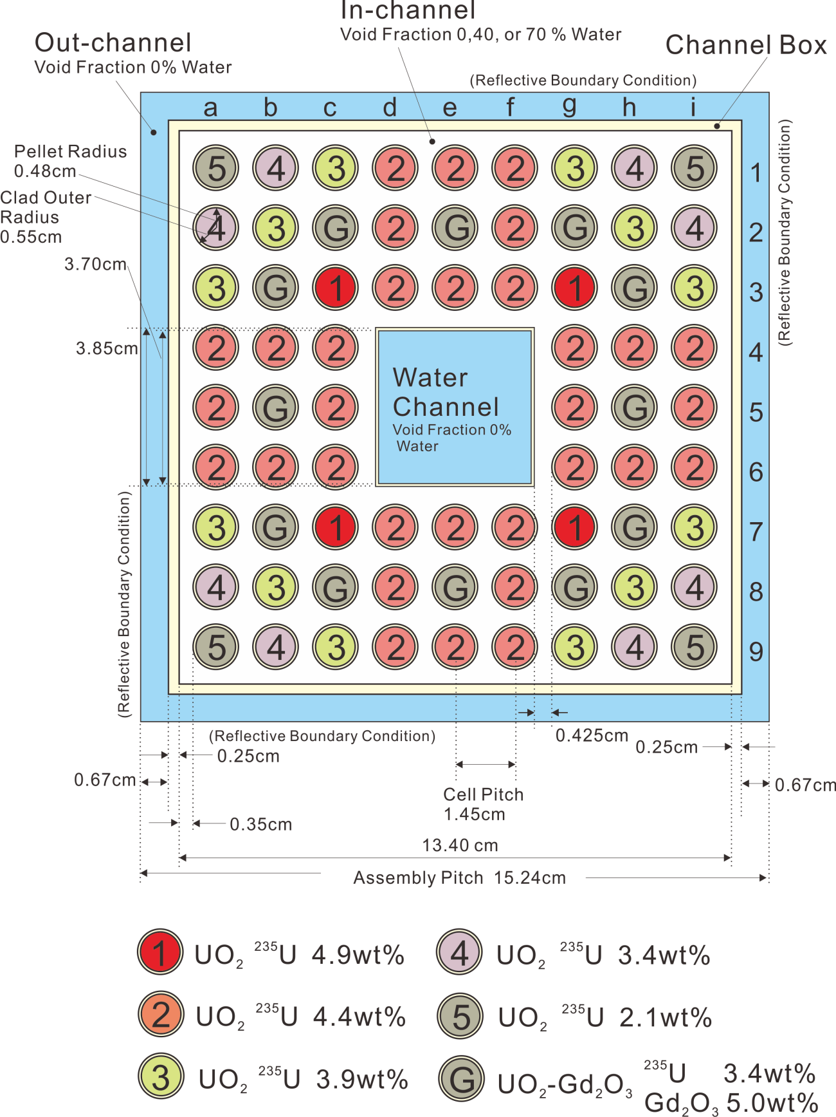
Figure 1: Fuel Assembly of BWR – Axial direction is infinite.

Table 1: Specifications of Fuel Assembly and Fuel Rod
Fuel Assembly  Lattice  Fuel rod pitch  Fuel assembly pitch  Number of fuel rods  Assembly average ²³⁵U enrichment | 9×9  1.45cm  15.24cm  72  3.9wt%
Fuel Rod  Outer diameter  Cladding thickness  Cladding material  Pellet diameter  Pellet material  Pellet ²³⁵U enrichment  Gd₂O₃ content | 1.1cm  0.07cm  Zry-2  0.96cm  UO₂, UO₂-Gd₂O₃  2.1wt%(min.) to 4.9wt%(max.)  5.0wt%
Water Channel  Dimension (outside)  Material  Channel thickness | Square 3.85cm×3.85cm  Zry-2  0.075cm
Channel Box  Dimension(outside)  Material  Channel thickness | Square 13.9cm×13.9cm  Zry-2  0.25cm

3. Material Specification

The design of the fuel assembly of BWR is complicated compared with PWR assembly. As shown in Figure 1, it consists of five kinds of ²³⁵U-enriched UO₂ rods, 4.9, 4.4, 3.9, 3.4 and 2.1wt% without gadolinium and 3.4wt% ²³⁵U-enriched UO₂ rods with 5.0wt% Gd₂O₃ and a water channel. Table 2 shows nuclide densities of each fresh rod. In this table, the number densities shown are the values averaged over the entire inner rod region (pellet + gap). These of cladding and moderator are shown in Tables 3 and 4, respectively.

Table 2: Initial Isotopic Composition of Fuel and Water Channel:
(Temperature: Fuel at 900K and Cladding and Water Channel at 559K.)

Rod Type ID | Enrichment | Gadolinia | Isotope | Number Density(10²⁴/cm³)
1 | 4.9wt% | - | ²³⁴U  ²³⁵U  ²³⁸U  ¹⁶O | 8.5649×10⁻⁶  1.1221×10⁻³  2.1495×10⁻²  4.5252×10⁻²
2 | 4.4wt% | - | ²³⁴U  ²³⁵U  ²³⁸U  ¹⁶O | 7.6910×10⁻⁶  1.0076×10⁻³  2.1609×10⁻²  4.5249×10⁻²
3 | 3.9wt% | - | ²³⁴U  ²³⁵U  ²³⁸U  ¹⁶O | 6.8170×10⁻⁶  8.9315×10⁻⁴  2.1723×10⁻²  4.5247×10⁻²
4 | 3.4wt% | - | ²³⁴U  ²³⁵U  ²³⁸U  ¹⁶O | 5.9431×10⁻⁶  7.7865×10⁻⁴  2.1838×10⁻²  4.5244×10⁻²
5 | 2.1wt% | - | ²³⁴U  ²³⁵U  ²³⁸U  ¹⁶O | 3.6708×10⁻⁶  4.8094×10⁻⁴  2.2134×10⁻²  4.5238×10⁻²
G | 3.4wt% | 5.0wt% | ²³⁴U  ²³⁵U  ²³⁸U  ¹⁶O  ¹⁵⁴Gd  ¹⁵⁵Gd  ¹⁵⁶Gd  ¹⁵⁷Gd  ¹⁵⁸Gd  ¹⁶⁰Gd | 5.5429×10⁻⁶  7.2622×10⁻⁴  2.0367×10⁻²  4.4678×10⁻²  3.6051×10⁻⁵  2.4475×10⁻⁴  3.3852×10⁻⁴  2.5881×10⁻⁴  4.1079×10⁻⁴  3.6481×10⁻⁴
Water Channel* | - | - | ¹H  ¹⁶O | 4.9316×10⁻²  2.4658×10⁻²
* No void in the water channel region.

Table 3: Cladding, Water Channel and Channel Box Material - Zircalloy-2 (at 559K)
Isotope | Number Density [10²⁴/cm³]
Sn  Fe  Cr  Ni  Zr | 4.9797×10⁻⁴  9.1782×10⁻⁵  7.5861×10⁻⁵  4.0314×10⁻⁵  4.2465×10⁻²

Table 4: Moderator - Water (at 559K)
Region | Void Fraction [%] | Isotope | Number Density [10²⁴/cm³]
in-channel | 0 | ¹H  ¹⁶O | 4.9316×10⁻²  2.4658×10⁻²
in-channel | 40 | ¹H  ¹⁶O | 3.0588×10⁻²  1.5294×10⁻²
in-channel | 70 | ¹H  ¹⁶O | 1.6542×10⁻²  8.2712×10⁻³
out-channel* | 0 | ¹H  ¹⁶O | 4.9316×10⁻²  2.4658×10⁻²
* No void in the out-channel region.

4. Parameters of the Calculation

4.1 Case Names and Burnup Parameters

The nuclide composition and k_{inf} are requested to be evaluated for three void fractions. Specific power is 25.3MW/tHM for all cases, maximum fuel burnup is 50GWd/tHM, and the cooling time after burnup is 0, 5 and 15 years. The relation of the case name and burnup parameters is shown in Table 5. Participants are requested to compile averaged nuclide densities of each case number 1b, 2a, 2b, 2c, 3b, 5b, 5c, 6b, 8b, 8c, 9b, 11b, 11c and 12b respectively. Note that the temperatures of fuel and other components of the assembly are assumed to remain in the hot condition even throughout the cooling period.

Table 5: Case Name
Burnup | 12 GWd/t |  |  | 20 GWd/t |  |  | 30 GWd/t |  |  | 50 GWd/t
Cooling  [Year] | 0 | 5 | 15 | 0 | 5 | 15 | 0 | 5 | 15 | 0 | 5 | 15
0%  V.F.* | 1a | 1b | 1c | 4a | 4b | 4c | 7a | 7b | 7c | 10a | 10b | 10c
40% V.F. | 2a | 2b | 2c | 5a | 5b | 5c | 8a | 8b | 8c | 11a | 11b | 11c
70% V.F. | 3a | 3b | 3c | 6a | 6b | 6c | 9a | 9b | 9c | 12a | 12b | 12c
* V.F. means Void Fraction

4.2 Benchmarked Nuclides

Nuclides that should be benchmarked are 13 actinides and 26 FPs, as shown in Table 6.

Table 6: Benchmarked Nuclides
Actinides | ^{234,235,236,238}U  ²³⁷Np  ^{238,239,240,241,242}Pu  ^{241,243}Am  ²⁴⁴Cm
FP | ⁹⁰Sr, ⁹⁵Mo,⁹⁹Tc,¹⁰¹Ru,¹⁰³Rh,¹⁰⁹Ag  ¹²⁹I, ¹³¹Xe, ^{133,134,137}Cs  ¹⁴⁴Ce, ^{143,145,148}Nd  ^{147,149,150,151,152}Sm  ^{153,154,155}Eu  ^{155,156,157,158}Gd

5. Requested Data

For the 9 by 9 assembly, participants are requested to evaluate the following quantities.

- Number densities of all nuclides including gadolinium isotopes specified in Table 6, which are averaged over all fuel rods, in the unit of 10²⁴/cm³, for selected case numbers 1b, 2a, 2b, 2c, 3b, 5b, 5c, 6b, 8b, 8c, 9b, 11b, 11c and 12b respectively.
- Neutron multiplication factors for the burnup of 0, 0.2, 10, 12, 20, 30 and 50 GWd/t.
- Maximum neutron multiplication factor and the corresponding burnup, which should be evaluated by each participant.
- Considering symmetrical fuel rod array, burnup of each fuel pin shown in Figure 2 in the unit of GWd/t at assembly averaged burnup of 12, 30 and 50 GWd/t

6. Results and Media

Please send e-mail attaching Microsoft Excel file containing the results to the following address,

nea-nsc-wpncs-egbuc-phase3c@jaea.go.jp

A recommended format of the Excel sheet for Case1b is shown in Table 7. This sheet should be made for all submitted cases. If you have any missing results, you are requested to indicate them with the tag ”NODATA” and to keep this format for our convenience.

k_{inf} at each burnup(0, 0.2, 10, 12, 20, 30, 50 [GWd/tHM]) and Peak k_{inf} and corresponding burnup [GWd/tHM] should be saved in the same Excel file. The format is shown in Table 8.

The burnup distribution data should be saved in the same Excel file. Its format is shown in Table 9.

Please describe your analysis environment in e-mail message. The description should include:

1. Institute and country
2. Participants
3. Neutron data library
4. Neutron data processing code or method
5. Number of neutron energy group
6. Description of your code system
7. Geometry modeling
8. Omitted nuclides, if any
9. Employed convergence limit or statistical errors for eigenvalue calculations
10. Other related information
11. References to your code system or library, if any

7. Schedule

End of February 2013: Deadline for participants to provide their results
End of May 2013: Deadline for coordinators to compile results into tables / figures
End of August 2013: Deadline for coordinators to send draft report to participants.

References

1) Hiroshi Okuno, Yoshitaka Naito and Kenya Suyama, ”OECD/NEA Burn-up Credit Criticality Benchmark Phase III-B Burnup Calculations of BWR Spent Fuel Assemblies in Storage and Transport,” JAERI-Research 2002-001 (as NEA/NSC/DOC(2002)2), Japan Atomic Energy Research Institute(2002).

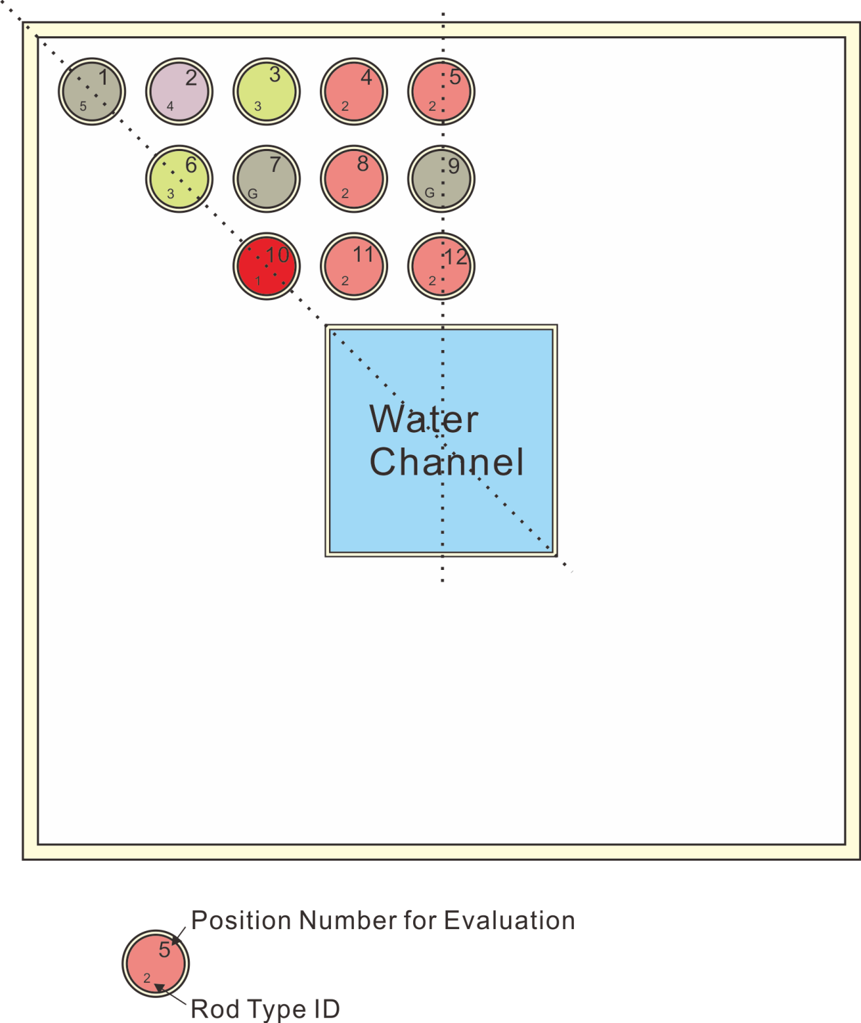

Figure 2: Position Number of Fuel Rod for Evaluation. Rod Type ID is shown in Figure 1

Table 7: Format of Requested Data for Case1b
Line Number | Data
1  2  3  4  5 | Date  Institute  Contact person  E-mail address  Telefax number
6  7  8  9  10  11  12  13  14  15  16  17  18  19  20  21  22  23  24  25  26  27  28  29  30  31  32  33  34  35  36  37  38  39  40  41  42  43  44  45  46 | Case name tag ”Case1b:Burnup=12GWd/t, V.F=0%, Cooling=5year”  Nuclide density of ²³⁴U  Nuclide density of ²³⁵U  Nuclide density of ²³⁶U  Nuclide density of ²³⁸U  Nuclide density of ²³⁷Np  Nuclide density of ²³⁸Pu  Nuclide density of ²³⁹Pu  Nuclide density of ²⁴⁰Pu  Nuclide density of ²⁴¹Pu  Nuclide density of ²⁴²Pu  Nuclide density of ²⁴¹Am  Nuclide density of ²⁴³Am  Nuclide density of ²⁴⁴Cm  Nuclide density of ⁹⁰Sr  Nuclide density of ⁹⁵Mo  Nuclide density of ⁹⁹Tc  Nuclide density of ¹⁰¹Ru  Nuclide density of ¹⁰³Rh  Nuclide density of ¹⁰⁹Ag  Nuclide density of ¹²⁹I  Nuclide density of ¹³¹Xe  Nuclide density of ¹³³Cs  Nuclide density of ¹³⁴Cs  Nuclide density of ¹³⁷Cs  Nuclide density of ¹⁴⁴Ce  Nuclide density of ¹⁴³Nd  Nuclide density of ¹⁴⁵Nd  Nuclide density of ¹⁴⁸Nd  Nuclide density of ¹⁴⁷Sm  Nuclide density of ¹⁴⁹Sm  Nuclide density of ¹⁵⁰Sm  Nuclide density of ¹⁵¹Sm  Nuclide density of ¹⁵²Sm  Nuclide density of ¹⁵³Eu  Nuclide density of ¹⁵⁴Eu  Nuclide density of ¹⁵⁵Eu  Nuclide density of ¹⁵⁵Gd  Nuclide density of ¹⁵⁶Gd  Nuclide density of ¹⁵⁷Gd  Nuclide density of ¹⁵⁸Gd

Table 8: Format of Requested Data for peak k_{inf} and corresponding burnup
Line Number | Data
1  2  3  4  5 | Date  Institute  Contact person  E-mail address  Telefax number
6  7  8  9  10  11 | peak k_{inf} and corresponding burnup for Void Fraction 0% ( save in sequential row)  peak k_{inf} and corresponding burnup for Void Fraction 40% ( save in sequential row)  peak k_{inf} and corresponding burnup for Void Fraction 70% ( save in sequential row)  k_{inf} at each burnup(0, 0.2, 10, 12, 20, 30, 50 [GWd/tHM]) ( save in sequential row) for Void Fraction 0%  k_{inf} at each burnup(0, 0.2, 10, 12, 20, 30, 50 [GWd/tHM]) ( save in sequential row) for Void Fraction 40%  k_{inf} at each burnup(0, 0.2, 10, 12, 20, 30, 50 [GWd/tHM]) ( save in sequential row) for Void Fraction 70%

Table 9: Format of Requested Data for Burnup Distribution
Line Number | Data
1  2  3  4  5 | Date  Institute  Contact person  E-mail address  Telefax number
6  7  8  9  10  11  12  13  14 | Burnup [GWd/tHM] of each pin position 1, 2,...., 11, 12 ( save in sequential row) at 12 GWd/t for Void Fraction 0%  Burnup [GWd/tHM] of each pin position 1, 2,...., 11, 12 ( save in sequential row) at 12 GWd/t for Void Fraction 40%  Burnup [GWd/tHM] of each pin position 1, 2,...., 11, 12 ( save in sequential row) at 12 GWd/t for Void Fraction 70%  Burnup [GWd/tHM] of each pin position 1, 2,...., 11, 12 ( save in sequential row) at 30 GWd/t for Void Fraction 0%  Burnup [GWd/tHM] of each pin position 1, 2,...., 11, 12 ( save in sequential row) at 30 GWd/t for Void Fraction 40%  Burnup [GWd/tHM] of each pin position 1, 2,...., 11, 12 ( save in sequential row) at 30 GWd/t for Void Fraction 70%  Burnup [GWd/tHM] of each pin position 1, 2,...., 11, 12 ( save in sequential row) at 50 GWd/t for Void Fraction 0%  Burnup [GWd/tHM] of each pin position 1, 2,...., 11, 12 ( save in sequential row) at 50 GWd/t for Void Fraction 40%  Burnup [GWd/tHM] of each pin position 1, 2,...., 11, 12 ( save in sequential row) at 50 GWd/t for Void Fraction 40%

