APPENDIX C: Stochastic modeling of spatial correlations: another way to look at source convergence problems

In the previous sections it has been highlighted that the biases on local tallies and their uncertainties seem to find their origin in spatial correlations. In this section we will therefore propose a stochastic modelling of the spatial correlations affecting Monte Carlo criticality simulations, and we will show how it affects the estimation of tallies. The interplay between spatial correlations and entropy will be discussed in the following section dedicated on Monte Carlo metrics for diagnosing source convergence issues.

Introduction

The workhorse of Monte Carlo methods for criticality calculations is the stochastic version of the so-called power iteration algorithm (Duderstadt and Hamilton, 1976; Bell and Glasstone, 1970; Lux and Koblinger, 1991; Rief and Kschwendt, 1967; Brown, 2005), whose basic idea is to follow neutrons along generations (cycles), starting with a birth from a fission event and terminating when the neutron is lost by either leakage from the outer boundaries or absorption (including sterile captures and fissions). In between, neutrons are tracked along their random trajectories through the traversed media. Such ‘cycles’ are started from an arbitrary source and are iterated until the neutron population ultimately converges to a stable shape in both space and energy at some late generation. Once convergence has been attained, recording the appropriate estimators and taking the averages over all random realizations allows computing flux profiles, reaction rates, and other physical quantities of interest (Lux and Koblinger, 1991).

Such Monte Carlo scores correspond by definition to averages over a given element of phase space (typically, spatial volumes and energy intervals). Fluctuations around average values appear because of Monte Carlo simulations being intrinsically based on the transport of a finite number of particles: by increasing the number of simulated histories, it is well known that the fluctuations affecting the computed scores are progressively reduced (Lux and Koblinger, 1991; Brown, 2005). Another source of noise specific to Monte Carlo criticality calculations is related to fission events, because of two concurrent phenomena:

- fissions induce splitting of the trajectories, which increases the dispersion of the population number within a given volume;

- the birth of a neutron occurring at a fission site induces correlations between particle positions (Lux and Koblinger, 1991; Sjenitzer and Hoogenboom, 2011). Overall, the convergence of Monte Carlo scores to their respective average values will demand a larger number of generations, and in some cases it is even possible that convergence is never achieved (especially when the number of simulated particles is relatively small) (Brown, 2005). Understanding and quantifying these phenomena is a task of utmost importance so as to improve the reliability of Monte Carlo criticality calculations.

In the following we will address the mechanisms that are responsible for the above-mentioned fluctuations: we will show that the key reason behind these anomalous fluctuations is indeed a source convergence issue mainly due to under-sampling, and that this latter is due to the correlations affecting the neutron chains. We will in particular discuss the spatial form of these correlations, and present some basic element of the theory of “neutron clustering”.

The “variable length” pin-cell benchmark

In order to illustrate the issues mentioned above, we will first consider a simple and easily reproducible benchmark problem, namely a criticality Monte Carlo simulation of a PWR pin-cell.
The pin-cell system, as customary, is composed of a single UO₂ fuel rod (at 3.25% enrichment) of radius 0.407 cm. The fuel rod is enclosed in a Zircaloy cladding of outer radius 0.477 cm, and a water moderator surrounds the cladding. The moderator has a size R = 1.26 cm. All materials are kept at 300 K.
For Monte Carlo simulations, reflective boundary conditions are applied on the pin-cell, so that the expected equilibrium distribution for the flux is axially flat in space. As for the number of particles, we have run each simulation for 10³ cycles with 10⁴ neutrons per cycle, with a spatially uniform initial guess source.
Convergence of the criticality cycles (the power iteration algorithm) is monitored by measuring the effective multiplication factor (keff) at each cycle. Monte Carlo scores are recorded after convergence on keff has been attained. For the benchmark problem considered here, convergence of keff is typically achieved within very few cycles. At the end of each cycle after convergence, the neutron flux is recorded over a regular spatial grid composed of 40 bins along the axial direction. Three sets of simulations are run, by varying the axial length of the pin-cell (all the other physical parameters being kept constant).

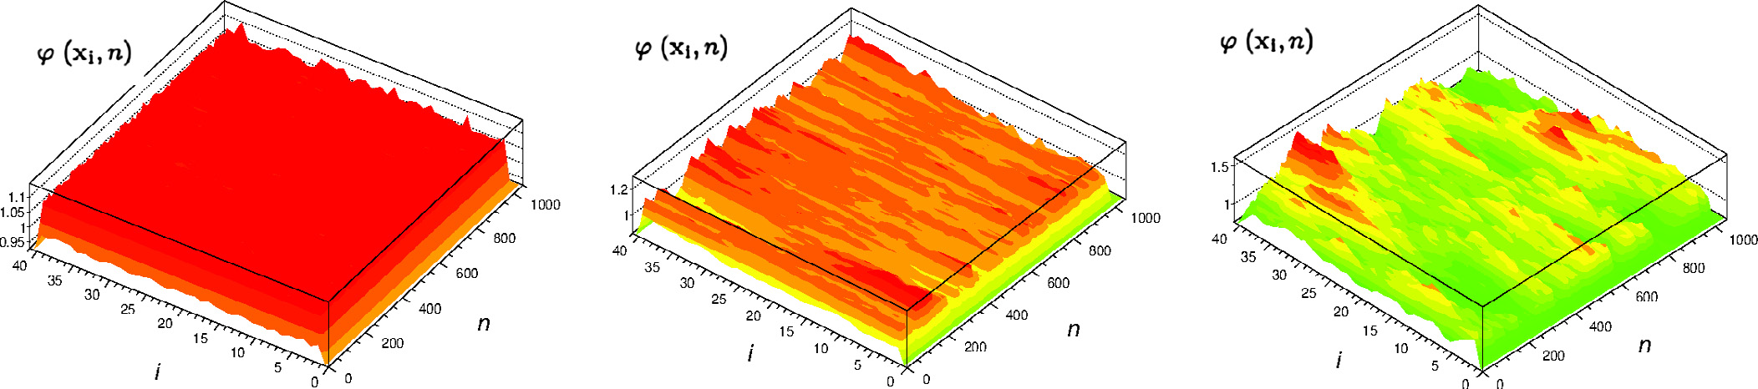

Figure [CLUST] Monte Carlo criticality simulations for a PWR pin-cell with varying axial length L, at fixed number of particles per cycle N = 104. The neutron flux ϕ(x_{i}, n) over an axially-distributed spatial mesh is displayed as a function of the mesh index i and the cycle number n. Left: L = 10 cm. Center: L = 100 cm. Right: L = 400 cm.

In the first simulation, a pin-cell length L = 10 cm is chosen, and the corresponding neutron flux (in arbitrary units) is shown in Fig. [CLUST] (left). The flux is plotted as a function of the spatial binning at each cycle. Fig. [CLUST] (left) clearly shows that the flux stays uniform in space all along the cycles, and that fluctuations around the average value are fairly small. In the second simulation, the pin-cell length is increased to L = 100 cm. In this case, Fig. [CLUST] (center) shows that the neutron flux suffers from much stronger fluctuations in space, which moreover evolve as a function of the cycles. These fluctuations are not localized and their size clearly extends to the whole domain length. This behavior is further enhanced when taking L = 400 cm, as shown in Fig. [CLUST] (right). In this case, fluctuations become even more important, and completely override the average flux value, so that (loosely speaking) it is no more possible to properly define an equilibrium flux distribution. In particular, the flux distribution has not converged in space, despite the multiplication factor having reached a stationary value.
Fig. [CLUST] (right) reveals a very interesting feature: the overall effect of these fluctuations is that neutrons gather into clusters, and empty ‘holes’ appear between them. While the total neutron population is preserved, the spatial distribution is strongly heterogeneous and randomly evolves along the cycles: in other words, the neutron clusters seem to wander around indefinitely.
This simple example shows that for large systems with a mild number of simulated particles monitoring the convergence of the effective multiplication factor might be misleading, since the spatial distribution of the neutron flux might not even achieve convergence. This clustering effect is amplified by increasing the system size, when keeping fixed the number of simulated particles.

Neutron clustering

- Short bibliography of temporal and spatial correlations in neutron transport

The analysis of neutron flux fluctuations at a given spatial site as a function of cycles has been discussed at length in literature (see for instance (Ueki, 2012; Brown, 2009)). The impact of such fluctuations has been widely recognized, in that they affect the convergence of Monte Carlo scores by introducing cycle-to-cycle correlations, which in turn make the applicability of Central Limit Theorem questionable. Such correlations along cycles have been often studied within the mathematical framework provided by the eigenvalues analysis of the Boltzmann critical equation (Brown, 2005). Further work on correlations has concerned techniques aimed at improving the standard deviation estimates of Monte Carlo scores (Gelbard and Prael, 1990; Jacquet et al., 2000; Ueki et al., 2003; Ueki et al., 2004; Dumonteil and Malvagi, 2012; Ueki, 2015; Ueki, 2016). In order to detect fluctuations along cycles, effective diagnostic tools have been developed for Monte Carlo simulations, among which a prominent role is played by the so-called entropy (Ueki and Brown, 2003; L’Abbate et al., 2007).

However, an analysis based on cycle fluctuations alone (by averaging out or simply neglecting the spatial behavior) fails in interpreting the features that we have singled out in the pin-cell example discussed above. For instance, the cycle-to-cycle entropy estimator would be inefficient in detecting spatial correlations in the neutron flux distribution (Dumonteil and Courau, 2010). Therefore, instead of looking for proper statistics of neutrons at a given position through cycle/time (cycle-to-cycle/time correlations), a recent literature has been dealing with the spatial distribution of neutron population at a given time (spatial correlations). In particular, a phenomenon called “neutron clustering” has been put into evidence in 2014 (Dumonteil et al, 2014). This phenomenon has been the subject of further investigation aiming at taking into account several specificities of neutron transport, such as the effects of bounded domains (Zoia et al, 2014), those of population control (De Mulatier et al, 2015), of delayed neutrons (Houchmandzadeh et al, 2015), or of generational effects (Sutton et al, 2017). In a common work between CEA and MIT, the links between entropy and clustering were also discussed (Nowak et al, 2016). It is worth noting that a recent experimental program is currently on-going that looks to detect and possibly to characterize this effect in experimental reactors.
In the following we will recall the key ideas of neutron clustering by illustrating them on the simplified modeling of branching Brownian motion.

- Branching Brownian motion as a prototype model of multiplying population

Two main features have been singled out by the analysis of the “variable length” pin-cell benchmark: (a) fluctuations are more relevant in systems with high dominance ratio; and (b) fluctuations decrease by increasing the number of simulated neutrons per unit volume. This analysis has nonetheless shown that reliable tools for quantifying the impact of space and cycle fluctuations are still missing.
A complete description of cycle and space fluctuations of the Monte Carlo particle population would demand in principle the sophisticated tools provided by statistical mechanics and the theory of Monte Carlo games. In this respect, one would need to develop formulas for the average, the variance, and the correlation function of the number of particles at a given site and cycle by using the framework of branching processes and neutron noise analysis (Williams, 1974; Pázsit and Pál, 2008; Athreya and Ney, 1972; Osborn and Yip, 1966; Zoia et al., 2012), together with the so-called moment formulas for the Monte Carlo scores (Lux and Koblinger, 1991; Sjenitzer and Hoogenboom, 2011). The resulting equations, although in principle exact, would be in general too cumbersome to be practically used as a diagnostic tool for detecting fluctuations in Monte Carlo simulations. Also, the inclusion of all physical parameters (full energy and angular dependence, delayed neutrons effects, complex geometries, and so on) would hardly make possible to grasp the key ingredients responsible for the observed phenomena.

In order to improve our understanding of the clustering effects observed in the benchmark example of criticality simulations, we choose here to resort to the very simplest particle transport model that yet retains the key features of neutron multiplication in fissile media. Consider a particle undergoing a regular continuous-time Brownian motion with diffusion coefficient D. At Poissonian rate, the particle splits and gives rise to a random number k of descendants, whose number distribution is p(k). If k = 0, then it is assumed that the trajectory terminates, since there are no descendants. Otherwise, each descendant obeys the same stochastic behavior as the parent particle, i.e., it undergoes a regular Brownian motion. Events leading to the birth of k>1 descendants give rise to branching trajectories. For the sake of simplicity, we further assume that all system parameters are homogeneous, i.e., do not depend on the spatial position. As time goes on, the parent particle and its descendants form a branched structure evolving in space, hence the name of branching Brownian motion given to this model (Cox and Griffeath, 1985; Dawson, 1972; Athreya and Ney, 1972). For visualization purposes, an example is provided in Fig. [BBM].

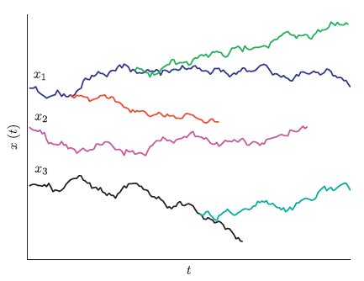

Figure [BBM] The random trajectories of three one-dimensional branching Brownian particles starting from x₁, x₂ and x₃, respectively, at time t = 0. Each particle is subject to branching events (equivalent to fissions and leading to a splitting of the parent trajectory) and absorption, occurring at Poissonian random times. Between branching events, particles independently undergo regular Brownian diffusion.

Formally, branching Brownian motion arises as the combination of a simple transport model (the Brownian motion) with a stochastic Galton–Watson birth–death process (Watson and Galton, 1875). Intuitively, the number Mt(x) of particles at any given spatial site x will fluctuate in time because of both spatial displacements and random variability of the particle number due to births and deaths. The former mechanism strongly depends on the diffusion coefficient D, whereas the latter is ruled by the descendant number distribution p(k).

Now, consider a family of N particles undergoing branching Brownian motion, each starting from a given spatial location at time t = 0 (as in Fig. 3). It can be shown that, in the absence of boundary conditions (i.e., for an infinitely extended medium), the ultimate fate of the population is governed by the average number <k> of particles emitted per collision: if <k> < 1, the population will become extinct at long times (sub-critical condition); if <k> > 1, the population will grow unbounded (super-critical condition); finally, if <k> = 1, the population will stay constant on average (exactly critical condition). In the first and second case, the decrease or increase of population number, respectively, will happen exponentially fast. Here, having in mind the application to criticality calculations, we will focus on the critical case, where population is conserved on average.

Branching Brownian motion has been long studied in connection with the mathematical modeling of biological populations, such as bacteria, plankton or amoebae (sometimes under the name of Brownian bugs) (Athreya and Ney, 1972; Young et al., 2001; Houchmandzadeh, 2008). In such systems, several experiences have shown the emergence of an astonishing tendency for neutral clustering: even in the absence of particle–particle interactions, individuals that are initially uniformly distributed spontaneously aggregate into spatial clusters (Young et al., 2001; Houchmandzadeh, 2008; Houchmandzadeh, 2002; Houchmandzadeh, 2009).

Based on the formalism of branching Brownian motion, the main findings of these papers in mathematics and in population ecology were applied to the three dimensional neutron transport and were found to be at the origin of the source convergence issues arising in Monte Carlo criticality simulations (Dumonteil, 2014). The very striking behavior of the neutron clustering behavior is illustrated Fig. [BOX]. At time t = 0, a collection of N branching Brownian particles is uniformly distributed over space. The system is then left free to evolve, starting from the initial positions. At later times, the particle positions begin to fluctuate because of diffusion and branching events. These fluctuations grow in time and eventually induce spatial clustering: while the average number of particles is constant on average, only a few spatial sites are actually occupied at the final observation time.

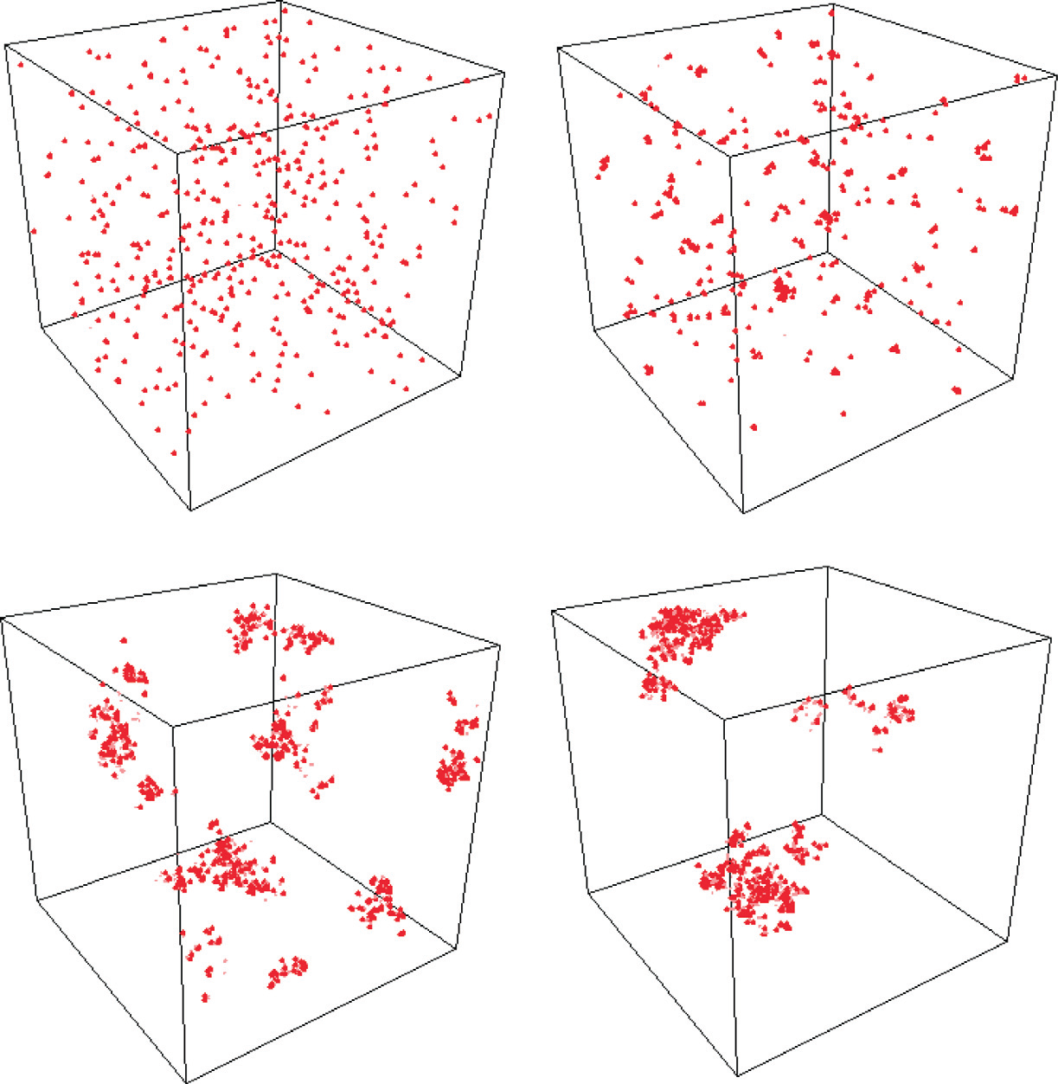

Figure [BOX] The evolution of a collection of N = 500 Brownian branching particles whose initial positions are initially homogenously distributed in a three-dimensional domain. As time grows, the diffusive mixing is not sufficient to overcome the spatial clustering effect induced by the death–birth mechanism, and particles at later times occupy only a small number of spatial sites (while the average population stays constant on average).

A simple, yet effective, explanation for this kind of behavior has been actually proposed: clustering is the result of particles dying uniformly in space, while births only happen close to a parent particle. Clusters will appear whenever diffusive mixing effects are too weak to overcome this asymmetry: this intuitively happens when the neutrons produced by fissions can not travel far enough to fill in the gaps lefts by the uniform capture. Clusters of neutrons start to form as well as gaps in the neutron population. Shockingly, the spatial correlation function These features, together with the formal analogy between branching Brownian motion and neutron transport in multiplying media, provide the main motivation for introducing this model.
In particular, it can be shown that for an exactly critical three-dimensional system starting from a uniform initial concentration of neutrons, we have
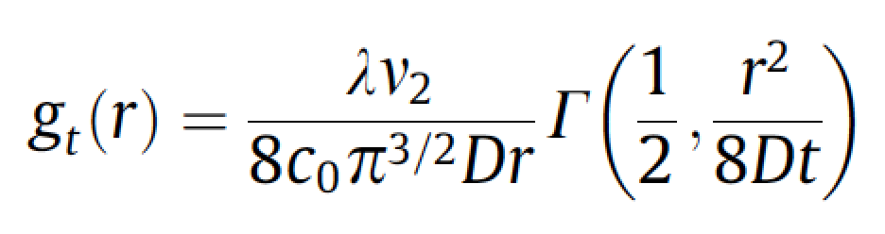
where g is the normalized and center pair correlation function
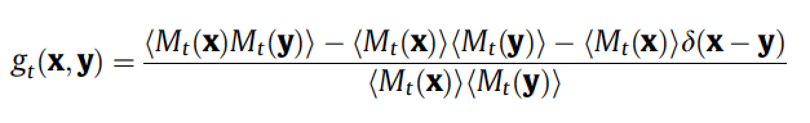
and where D is the diffusion coefficient, c0 is the initial concentration of neutrons, r is the distance between x and y, $ν2$ is the second descending factorial moment of p(k). This pair correlation function is probability to find a neutron next to another and its analysis shows that it grows with time.

It is important to notice that Brownian motion, while surely being a fairly adequate model in the context of biological systems, is perhaps oversimplified so as to realistically represent neutron trajectories. However, Brownian motion is expected to provide a good description of neutron transport at least when the one-speed diffusion approximation applies.

- Including transport and finite size effects

The emergence of clustering is a robust phenomenon, and is not an artifact of the diffusion approximation. Actually, the continuous-time Brownian motion discussed above can be replaced by a more realistic transport-theory-based stochastic model as follows: consider a homogeneous multiplying medium within a three-dimensional cube with sides of length L. Reflecting boundary conditions are applied to all six surfaces. We further assume one-speed neutrons and isotropic scattering. The Monte Carlo algorithm is purely analog with no survival biasing or other variance reduction method. The number of neutrons per generation is constant and denoted by N.

The starting locations for the neutrons in the initial generation are assumed to be sampled uniformly within the problem space. Since for our simple model every neutron will be absorbed (there being no leakage), the neutrons starting each generation will produce exactly N absorption locations. The starting locations for a neutron in any subsequent generation will be randomly chosen from all of the absorption locations created in the previous generation. Since the medium is homogeneous, each absorption location will be chosen with equal probability. Using this algorithm, some absorption locations may be chosen as the starting location for multiple neutrons while others may not be chosen at all.

The model problem was run using the one-speed cross sections Σ_{T} = 1, Σ_{S} = 0.6, Σ_{A} = 0.4, Σ_{F} = 0.2, for L = 400 cm and N = 1,000 . The number of generations was 10,000. Figure [CLUSTG] shows the locations of the source sites of the neutrons for the first generation in pink and the absorption sites for generations 1,000 and 10,000 in blue and black, respectively. As expected, the distribution of source sites in the first generation appears to be uniform. After 1,000 generations, however, the effect of clustering has become obvious with all 1,000 absorption sites being confined to a relatively small spatial region. After another 9,000 generations, the absorption sites are still tightly clustered not far from where they were after 1,000 generations. Despite the code being given the correct solution via the initial source guess, the solution has evolved to something that is quite different from a uniform distribution.

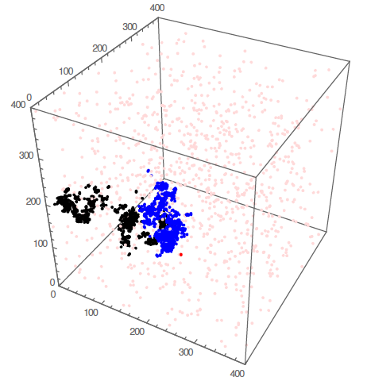
Figure [CLUSTG] Initial neutron source distribution (pink) and absorption distributions after 1,000 (blue) and 10,000 (black) generations. The red point marks the initial location of the original ancestor of all neutrons starting with generation 942.

A statistical mechanics approach to the behavior of spatial moments

A deeper understanding of the qualitative behavior of the generalized entropy and by the center of mass that we have observed above can be achieved by relating the features of these estimators to the key physical parameters that govern the evolution of the Monte Carlo power iteration. This is actually possible by resorting to the theory of branching stochastic processes. Since the features of the generalized entropy are almost identical to those of the center of mass, for our analysis in the following we will focus on this latter.

The nuclear reactor model described above can be conceptually represented as a collection of N particles undergoing scattering, reproduction and capture within a homogeneous box of finite volume V, with reflecting (mass-preserving) boundaries. In order to keep notation simple, and yet retain the key ingredients of the model, we will approximate the exponential paths of the neutrons by regular Brownian motion with a constant diffusion coefficient D (in other words, we are assuming that the diffusion approximation holds). For the same reason, instead of working with discrete generations we will initially introduce a continuous time t. A theory explicitly accounting for discrete generations will be discussed later.

The diffusing walker undergoes a birth–death event at rate β = v Σ_{f} : the neutron disappears and is replaced by a random number k of descendants, distributed according to a law q(k) with average <k> = ν. We will assume that exactly two neutrons are emitted at fission. In the Monte Carlo power iteration, some population control mechanisms are typically applied (such as Russian roulette and splitting), and the neutron population is typically normalized at the end of each generation in order to prevent the number of individuals from either exploding or shrinking to zero. For our purposes, the effect of such population control mechanisms on our model can be mimicked by imposing that the total number N of neutrons in V is exactly preserved. The simplest way to ensure a constant N is to correlate fission and capture events (Zhang et al., 1990; Meyer et al., 1996): at each fission, a neutron disappears and is replaced by 2 descendants, and 1 neutron is simultaneously captured (i.e., removed from the collection) in order to ensure the conservation of total population.

Analysis of this model shows that the evolution of the neutron population is governed by two distinct time scales: a mixing time τ_{D} = L² / D and a renewal time τ_{R} = N / β. The quantity τ_{D} physically represents the time over which a particle has explored the finite viable volume V by diffusion. The emergence of the time scale τ_{D} is a distinct feature of confined geometries having a finite spatial size: for unbounded domains, τ_{D} goes to infinity. The quantity τ_{R} represents the time over which the system has undergone a population renewal, and all the individuals descend from a single common ancestor (see the discussion below concerning the coalescence of neutron generations). When the concentration N/V of individuals in the population is large (and the system is spatially bounded), it is reasonable to assume that τ_{R} > τ_{D}.

Consider then a collection of N such particles moving around randomly, whose vector positions are recorded
at time t. The spatial behavior of the individuals can be characterized in terms of several moments, namely, the square center of mass

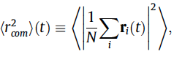 (10)
the mean square displacement

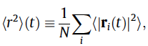 (11)
and the mean square distance between pairs of particles

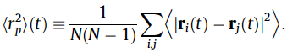 (12)

Brackets denote the expectation with respect to the ensemble of possible realizations.

By construction, these three quantities are related to each other. By developing the series in the definitions above, we can in particular express the center of mass as a function of the mean square displacement and of the particle pair distance (Meyer et al., 1996), namely,

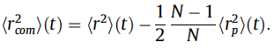 (13)

In the following, we will explicitly compute the center of mass for the homogeneous reactor and relate its behavior to the model parameters.

- Neutron density and spatial correlations

Let us denote by

the instantaneous density of neutrons located at x at time t. For a critical reactor, the average neutron density at a point x reads

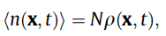 (14)

where we have set

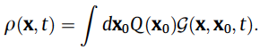 (15)

Here Q is the spatial probability distribution function of the neutrons at time t = 0, and the Green’s function G(x, x₀, t) satisfies the backward diffusion equation

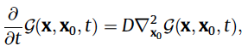 (16)

with the appropriate boundary conditions (de Mulatier et al., 2015). Assuming that the initial neutron population has a uniform spatial distribution (in other words, we already prepare the initial population on the configuration that is expected to be found at equilibrium), we have Q = 1/V, and the average neutron density at any time will be spatially uniform. For arbitrarily distributed sources at t = 0, the neutron density will asymptotically converge towards N/V for long times. By construction, the average density at equilibrium, namely,

(17)

does not convey any information concerning the spatial fluctuations of the neutron population.

In order to go beyond the average behavior, we introduce the pair correlation function h(x, y, t) between positions x and y at time t, which is proportional to the probability density of finding a pair of particles with the former at x and the latter at y (de Mulatier et al., 2015). It is important to stress that the correlation length
can be extracted from the shape of the function h: if h is almost flat in space, then the correlations will have the same relevance at any spatial site; on the contrary, the presence of a peak in h at short distances might reveal clustering phenomena (Zhang et al., 1990; Meyer et al., 1996). The overall intensity of the correlations is simply provided by the amplitude of h.

When the particles can only diffuse (i.e., if the probability of fission and capture are artificially suppressed), the neutron population behave as an ideal gas of N independent random walkers, and the corresponding correlation function yields

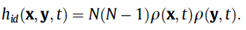 (18)

For the particular configuration where the particles are uniformly distributed at the initial time,

(19)

For the homogeneous reactor benchmark defined above, the pair correlation function h can be exactly computed by resorting to the approach originally proposed in Meyer et al. (1996) for infinite domains and later refined by de Mulatier et al. (2015) for bounded domains. Explicit calculations yield

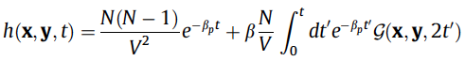 (20)

when imposing the initial uniform source Q = 1/V. The quantity β_{p} denotes

. (21)

When branching events are absent (β = 0), we have

(22)

since spatial correlations are suppressed. The integral of the Green’s function appearing in Eq. (20) is bounded thanks to the exponential term, and at long times the correlation function converges to an asymptotic shape. The same asymptotic behavior is expected for arbitrary initial sources.

- Relating the spatial moments to  and h

The spatial moments of the neutron population defined above can be formally expressed in terms of the particle density ρ(x, t) and of the correlation function (x, y, t). In particular, for the mean square displacement we have
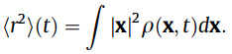 (23)

As for the mean square distance between pairs of particles, we have

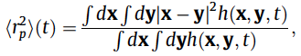 (24)

which is to be compared to the ideal average square distance of an uncorrelated population uniformly distributed in the viable volume, namely,

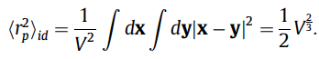 (25)

Replacing V = L³, we get thus <r²_{p}>_{id} = L² / 2. Deviations of <r²_{p}>(t) from the ideal behavior <r²_{p}>_{id} allow quantifying the impact of spatial clustering (Meyer et al., 1996; de Mulatier et al., 2015).

- Analysis of the homogeneous reactor benchmark

Let us now consider the case of the homogeneous reactor benchmark introduced above, with size L and V = L³. At the boundaries, we impose reflecting (Neumann) conditions. The Green’s function for this system reads (Grebenkov and Nguyen, 2013)

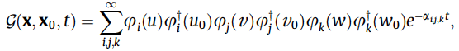 (26)

where

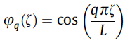 (27)

are the eigen-modes of the Laplace operator and

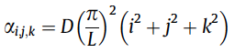 (28)

are the associated eigenvalues. The vector x is defined by its components, namely

By inspection, the mixing time of the neutron population is identified with τ_{D} = L² / (π² D). Ortho-normalization of the eigen-modes yields

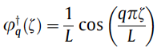 (29)

for q = 0, and

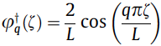 (30)

for q > 0. Assuming a uniform spatial distribution Q = 1/V at time t = 0, the average density simply reads

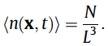 (31)

The mean square displacement can be easily computed, and yields

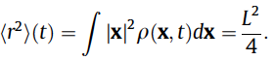 (32)

From Eq. (20) we get the pair correlation function

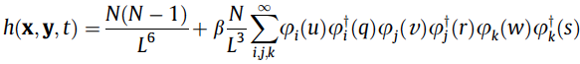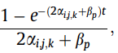 (33)

where the sum is extended to all indexes i,j,k, except i = j = k = 0, and we have set

and

The series appearing at the right-hand side is bounded, and for times t >> τ_{D} we obtain the asymptotic shape of the pair correlation function

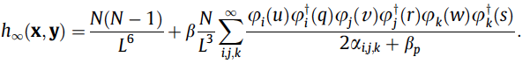 (34)

As for the average square distance, at time t = 0 we have

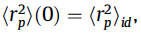 (35)

as expected. The asymptotic behavior of <r²_{p}>(t) at times t >> τ_{D} can be computed exactly and reads

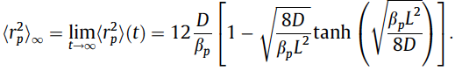 (36)

By recalling the definitions of the mixing time τ_{D} and the renewal time τ_{R}, we can rewrite Eq. (36) as

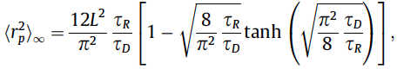 (37)

which shows that the impact of the spatial correlations is ruled by the dimensionless ratio between the renewal time and the mixing time. Intuitively, we expect the effects of the correlations to be stronger when the typical time scale of fission renewal is in competition with diffusive mixing (i.e., τ_{D} = τ_{R}), and to be weaker when diffusive mixing is faster than renewal (i.e., τ_{D} << τ_{R}).

Let us first consider the case of a system where the effects of the spatial correlations induced by clustering are very weak (i.e., τ_{R} tends to infinity), which is obtained for a very large number of particles or a vanishing fission rate. By taking the limit of small β or equivalently large N, we have
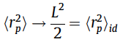 (38)

and we recover the ideal case corresponding to uncorrelated trajectories. In this case, the center of mass of the population obeys

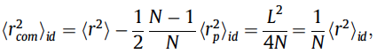 (39)

which basically means that for a collection of independent particles the mean square displacement of the center of mass is equal to the mean square displacement of a single particle of the collection, divided by the number of particles.

Consider now a finite reproduction rate b and a large but finite number of particles N. In this case, we can expand Eq. (37) for τ_{D} << τ_{R}, which yields

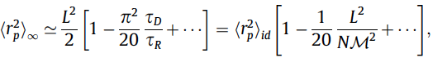 (40)

where we have used the definition of the migration area M² = D / β. This result relates the typical inter-particle distance to the physical parameters of the reactor model, namely, N, L, and M², and implies in particular that the particle pair distances will be smaller than in the uncorrelated case because of the effects of spatial clustering.

As for the center of mass, we finally get

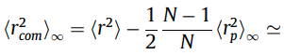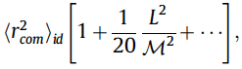 (41)

which again relates the mean square displacement of the center of mass to the physical parameters N, L, and M². In particular, <r²_com> will be larger than that of an uncorrelated system. The correction factor increases for increasing system size L, and decreases for increasing migration area M², as expected on physical grounds.

- From continuous time to discrete generations

The calculations developed for the continuous-time model can be adapted to a discrete-generation version, which would be more appropriate to address the behavior of Monte Carlo power iteration. The basic steps are the following. Let us introduce the expected fraction of uncorrelated particle pairs at generation g, namely,
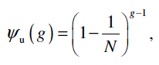 (42)

and the expected fraction of correlated pairs with a most recent common ancestor in generation g’, where 1 ≤ g’ ≤ g − 1, i.e.,

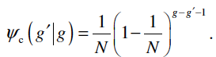 (43)
From Eq. (42) one sees that the expected number of uncorrelated pairs is a monotonically decreasing function of the generation number. Since the members of an uncorrelated pair must come from different families, the implication is that the expected number of families remaining is also monotonically decreasing with increasing generation number.

The two-particle distribution function h₂(x , y , g) will be now proportional to the joint probability density for one neutron being absorbed at x and a different neutron being absorbed at y in generation g. For the homogeneous benchmark problem considered here, the absorption probability density per neutron is uniform and equal to 1 / L³. In the first generation all of the neutrons are uncorrelated, hence

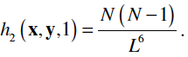 (44)

In subsequent generations, the contribution to the two-particle distribution function due to uncorrelated neutrons decreases proportionally to the fraction of uncorrelated
pairs, i.e.

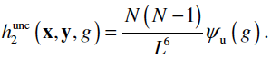 (45)

The contribution to the two-particle distribution function at generation g due to neutron pairs with a most recent common ancestor in a previous generation g’ is given by

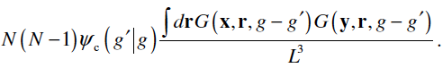 (46)

Here, the Green’s function G(x , r , g – g’) represents the expected number of neutrons (per unit volume) absorbed at x in generation g, given that its ancestor in generation g’ was absorbed at r.

Finally, by closely following the derivation for the continuous time process, we obtain

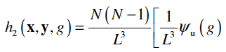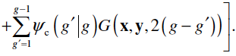 (47)

In particular, retaining the diffusion approximation as before, for the homogeneous reactor we get

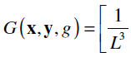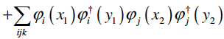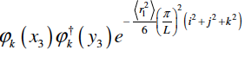 (48)

where <r₁²> is the mean-squared distance between a neutron’s birth and absorption in a single generation.

Developing the same calculations as above, the expected mean-squared distance between pairs of absorption locations after a large number of generations

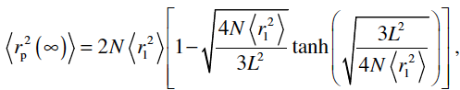 (49)

which is identical in form to equivalent expression obtained for the case of continuous-time process after a long observation time. In particular, for sufficiently large but finite N, Eq. (49) may be approximated as

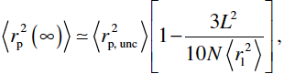 (50)

with

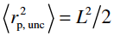 (51)

being the average particle pair distance in the absence of correlation (the distribution of absorption locations would be uniform). These expressions are again identical in form to those derived for the continuous-time model. Observe that the quantity

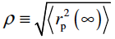 (52)

can be used as a characteristic length associated with the radial extent of the cluster. Fig. [MFP] shows a superimposed sphere of radius ρ centered on the center of mass of the neutron population. By taking the ratio of the volume of the sphere to that of the 400 cm cube in which it is located, we see that after the cluster has formed all of the neutrons are found in less than 5% of the volume of the problem.

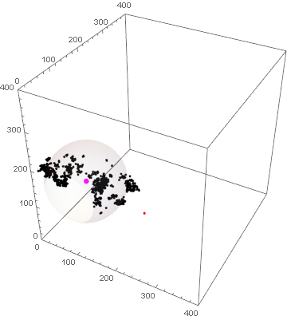

Figure [MFP] Absorption distribution after 10,000 generations (black), a sphere of radius r centered at the center of mass (magenta), and the location of the original ancestor (red).

- Simulation results for the homogeneous reactor benchmark

It is interesting to compare the numerical values of the center of mass predicted by Eq. (41) to the behavior of the center of mass displayed in Fig. [HC5] (bottom). In particular,

(53)

intuitively represents the typical amplitude of the fluctuations of the center of mass around the average. The value of the migration area M² can be estimated by computing l² in each Monte Carlo simulation and then setting M² = l² / 6, according to diffusion theory. Because of the geometrical symmetries of the cube configuration, along a given axis, say x, we get

(54)

When the number of particles is kept fixed at N = 10⁴, and the size L varies, from Eq. (41) we get the values reported in Tab. [COM].

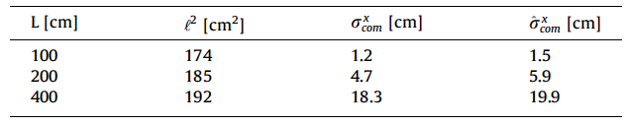
Table [COM] Measured and predicted values for the fluctuations of the x component of the center of mass for the homogeneous cube reactor. Here the number of neutrons per generation is kept fixed at N = 10⁴, and the reactor size L varies.

These findings are entirely consistent with the typical size of the fluctuations of the x component of the center of mass observed in Fig. [HC5] (bottom): for comparison, the standard deviation of the recorded statistical series is also reported in Tab. [COM].

When the reactor size is kept fixed at L = 400 cm (l² = 192 cm2) and N varies, from Eq. (41) we get the
values reported in Tab. [COM2].

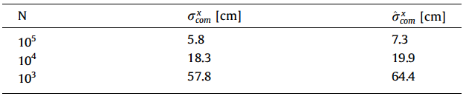
Table [COM2] Measured and predicted values for the fluctuations of the x component of the center of mass for the homogeneous cube reactor. Here the reactor size L is kept fixed at L = 400 cm, and the number N of neutrons per generation varies.

These predictions are again entirely consistent with the typical size of the fluctuations of the x component of the center of mass observed in our Monte Carlo simulations, whose standard deviation is also reported in Tab. [COM2].

Extinction of families and fixation

We conclude by addressing the evolution number of neutron families in the course of the power iteration, an issue which is intimately related to the clustering phenomena. The analysis of spatial clustering that we have presented in the previous sections basically concerns the behaviour of pairs of neutrons within a generation, of which there are N (N − 1) / 2. For the initial generation, all of the pairs are uncorrelated since the starting location for each neutron is selected independently from that of the others. As the generations progress, spatial correlations are introduced due to the possibility that some absorption locations may give rise to more than one neutron in the next generation. Since the probability that a given neutron will start from a given absorption location is 1 / N, the probability that any given absorption location is chosen as a starting location exactly k times in a generation is given by the binomial distribution

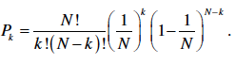 (55)
The expected number of correlated neutron pairs produced per absorption location is ν₂ / 2, where the second factorial moment is given by

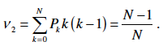 (56)

The total expected number of correlated pairs created in a generation with a most recent common ancestor in the previous generation is therefore ν₂ / 2 = (N – 1) / 2 . The fraction of all pairs represented by these is

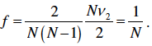 (57)

Since the total number of neutron pairs in a generation is fixed, the expected number of uncorrelated pairs and expected number of correlated pairs with a most recent common ancestor prior to the previous generation must each decrease by a corresponding factor of 1- f at each generation.

From Eq. (42) one sees that the expected number of uncorrelated pairs is a monotonically decreasing function of the generation number. Since the members of an uncorrelated pair must come from different families, the implication is that the expected number of families remaining is also monotonically decreasing with increasing generation number.

Using Eq. (55), one can compute the expected fraction of families that go extinct after the first generation as

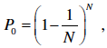 (58)

which for large N approaches 1/e = 0.367879. To extend the analysis of how the number of families varies as the Monte Carlo calculation proceeds beyond the first generation, we will resort to two methods from the field of population genetics: the Wright-Fisher (W-F) model (Wright, Durrett) and coalescent theory (Hudson, Kingman). The W-F model is an idealized model of the genetic evolution of a population of organisms. Coalescent theory provides a quantitative method for analyzing the number of generations between the current one and the generation containing the most recent common ancestor of the members of some subset of the population.

This W-F model uses the following assumptions:

• the population size is constant,
• generations do not overlap in time,
• the parent of an individual is chosen uniformly with replacement from all of the individuals in the preceding generation, and
• there is no selection, mutation, or recombination.

Because of these assumptions, the W-F model is an idealized representation of most real biological populations. The W-F model for haploid organisms (those with a single set of chromosomes), however, is exact for the Monte Carlo algorithm considered here. This is because the number of neutrons per generation is constant; the fission generations are sequential; the probability of selecting any one of the absorption locations in the previous generation as the source location of each neutron in the subsequent generation is uniform; and there are no equivalent concepts to selection, mutation, and recombination.

Using the W-F model, two important properties of the evolution of a population have been proved. First, in the limit as the number of generations goes to infinity the population becomes fixed. In genetics this means that all alleles but one disappear from a population. In our case, this means that all but one family becomes extinct for a sufficiently large number of generations. Second, the probability at some point in time that a particular allele will be the one that becomes fixed is given by its fraction of the total allele population at that time. For our application this means that at generation g the probability that a family will be the one that survives is equal to that family’s fraction of the total population at that generation. Since at the beginning of the first generation each family represents the same fraction 1/N of the population, each family initially has an equal probability of being the one that survives.

A detailed discussion of coalescent theory is beyond the scope of this document, so the method will only be briefly outlined below. Consider a subset n of the N neutrons in a generation. Denote the probability that none of the neutrons in the subset share a common parent by q_{n}. If these neutrons have no common parents, then they must have n distinct ancestors in the previous generation. The probability that these n distinct ancestors themselves have distinct ancestors is also q_{n}. The probability that the members of the subset share no common ancestors in the previous t - 1 generations, but that two or more share a common ancestor t generations in the past is thus

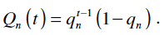 (59)

Using the terminology of coalescent theory, a ‘sample’ will refer to some subset of the neutrons at the ‘current’ generation. The theory is developed by following the lineages of the members of the sample backwards in time through the branches of the genealogical tree. The merging of two branches in some past generation is called a ‘coalescence’. It is assumed that at any generation the number of branches on the sample’s tree is much less than the population size N , so that the probability of more than one coalescence per generation is negligible. Thus, as one looks back in time from the current generation, the number of branches on the sample’s tree is reduced by one at coalescences and is constant between coalescences. Eventually, the there are just two branches left. These coalesce at the most recent common ancestor of the sample.

For the W-F model, we have the exact expression

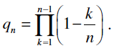 (60)

For n << N, we have the approximate expressions

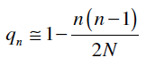 (61)

and

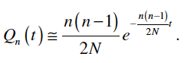 (62)

The expected number of generations to the next (again, going backwards in time) coalescence when there are i branches on the tree may be obtained from Eq. (62) as

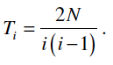 (63)

For a sample of size n, the average number of generations between the current generation and the generation
containing the most recent common ancestor is thus

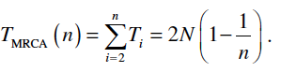 (64)

Fixation occurs when one of the original ancestors becomes a common ancestor of the entire population. We
use Eq. (64) to obtain an approximate expression for the expected number of generations to fixation by setting the sample size to the population size, i.e.

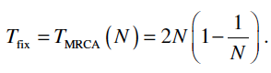 (65)

There are three aspects of this last step that involve approximations that warrant explanation. First, consider the generation at which all neutrons first share a common ancestor. One may then trace the lineages of the neutrons back through the generations until the MRCA is found. In general, this MRCA will be found in some generation after the initial generation. Equation (65) gives the expected number of generations between the MRCA and fixation, but does not account for the generations between the first and the one containing the MRCA.

Second, we have violated the assumption that the sample size is much smaller than the population size. However, using Eq. (64) we see that the expected number of generations required to coalesce from two ancestors to one is T₂ = N. Thus, for half of the expected number of generations required for fixation there are only two branches on the tree. For one-sixth of the number of generations there are only three branches, for one-twelfth the number of generations only four branches, etc. Thus, the approximation is valid for the terms in Eq. (65) that contribute the most to T_{fix}.

The final point is that fixation occurs at the first generation for which the entire population shares a common ancestor, but in the derivations leading to Eq. (65) the number of generations to the first coalescence (going backwards) is assumed to be drawn from a distribution. However, the probability that all N neutrons in a generation have distinct ancestors in the previous generation is P₁^{N}, where P₁ is computed using Eq. (55). For large values of N, P₁^{N},is an extremely small number so that the number of generations to the first coalescence is almost certainly one. Despite these approximations, as we will see Eq. (65) seems to yield a reasonably accurate result.

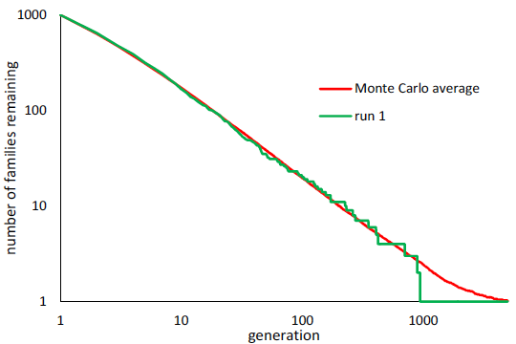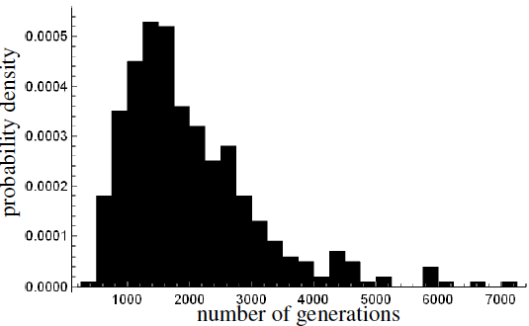

Figure [FAM] Left. Number of families as a function of generations. The red line is an average over 200 independent calculations. The green line is from a single representative calculation. Right. Probability density of the number of generations to fixation.

Fig. [FAM] (left) illustrates the extinction of families and fixation. The red line shows the average number of families as a function of generation for an ensemble of 200 calculations identical to the problem discussed in section 2.2. The green line is the number of families versus generation for a representative member of the ensemble (run 1 of 200, the same run that produced the results shown in Fig. 5). From Eq. (58), the expected fraction of families to become extinct during the first generation is 0.367695. The observed fraction from the ensemble of Monte Carlo calculations is 0.366895. Fig. [FAM] (right) shows a binned representation of the probability density for T_{fix} obtained from an ensemble of 400 calculations using the same model as before. The bin width is 250 generations. The average value is 2,008.88, which compares well with the value of 1,998 obtained using Eq. (65). As can be seen from the plot, there is a wide spread in the distribution of T_{fix}. For large N, the variance is given by

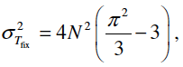 (66)

which yields a standard deviation of 1076.79, which also compares well with the value of 1091.10 obtained using the simulation data.

