Draft: Nov. 25, 2011

4. INTEGRAL EXPERIMENT COVARIANCE DATA

4.1. Introduction

In the core design of fast breeder reactors, it is important to improve the prediction accuracy of nuclear characteristics from the viewpoint of both reducing cost and insuring plant reliability. To utilize the past critical experimental data and power reactor operational experience to the reactor design work, the most powerful method is to adjust a cross-section set based on the Bayesian theory and least-square technique, see for example, ref. [4.1], where all related information including C/E (Calculation/Experiment) values, experimental and analytical errors, sensitivity coefficients of various experimental cores and parameters, and cross-section covariance, is synthesized with physical consistency. Based on Bayes’ theorem, i.e., the conditional probability estimation method, the posterior probability that a cross-section set, T, is true, is maximized under the condition that the information of integral experiments, R, is obtained as below:

J(T) = (T-T_{o})^{t}M⁻¹(T-T_{o}) + [R_{e} - R_{c}(T)]^{t}[V_{e} + V_{m}]⁻¹[R_{e} - R_{c}(T)] - - - (1)
where,
J(T): The error function targeted for the combined set of differential and integral data,
T_{o}: A prior cross-section set before adjustment,
M: Covariance of the prior cross-section set T_{o} before adjustment,
V_{e}: Experimental error matrix of an integral experiment set,
V_{m}: Analytical modeling error matrix of the integral experiment set,
R_{e}: Measured values of the integral experiment set, and,
R_{c}(T): Analytical values of the integral experiment set obtained with the cross-section set T.

To minimize the error function J(T), dJ(T)/dT = 0. - - - (2)

After analytical derivations, the posterior cross-section set, T', and its covariance, M', after adjustment are obtained as follows:

T' = T_{o} + MG^{t}[GMG^{t} + V_{e} + V_{m}]⁻¹[R_{e} - R_{c}(T_{o})] - - - (3)
M' = M - MG^{t}[GMG^{t} + V_{e} + V_{m}]⁻¹GM - - - (4)
where,
G: Sensitivity coefficients of a cross-section, t, to an integral parameter, R, that is, (dR/R)/(dt/t).

As seen in these equations, it is necessary to prepare the error matrices of integral parameters for both the experiments and the analytical modeling, V_{e} and V_{m}, to perform the cross-section adjustment procedure.

Correlations between two experiments arise if any components of the experimental uncertainty are fully or partially common for those experiments. The importance of accounting for the correlation of experimental uncertainties in evaluation of calculational uncertainties and in data adjustment methodologies has been demonstrated; see for example, ref. [4.2]. A typical procedure for evaluating the integral covariance data is described in ref [4.3]. A novel approach presented by Areva NP GmbH utilizes statistical sampling on uncertain parameters to assess the uncertainty in individual experiments as well as correlations between experiments [4.4]. Work is progressing to implement this stochastic approach in a module called PROTEUS (PaRametric Tool to Engineering Uncertainty analysis in SCALE) [4.5]. The reader may wish to know that the Expert Group on Uncertainty Analysis for Criticality Safety Assessment (UACSA), established under the guidance of the OECD/NEA Working Party on Nuclear Criticality Safety (WPNCS) to address issues related to Sensitivity/Uncertainty (S/U) studies for criticality safety calculations, is currently studying the effects of different methodologies to generate integral experiment covariance data.

This section now illustrates a reasonable method to quantitatively determine the integral error matrices which include both diagonal terms (standard deviations) and non-diagonal terms (correlation factors). This "Integral covariance estimation method based on the perfect correlation between common error components", or "Error component correlation method" in short, is based closely on the method described in ref [4.3].

4.2. Experimental Error Matrix

The experimental error values of an integral parameter are usually given by the experimenters with the error components. However, the correlations between multiple integral parameters are rarely found in the experiment report; therefore, these correlation factors must be estimated from the experimental information available. The Error component correlation method adopts the following three steps:

(Stage 1) Classification of Error Components to either Common or Independent

First, all-related components of the experimental errors for "Data A" and "Data B" with quantitative values reported are listed, and each individual component identified either as a "Common error (i.e., the correlation factor is 1.0) between Data A and B", or an "Independent error (i.e., the correlation factor is 0.0)". If an error component is judged as a mixture of common and independent errors, that is, the correlation factor is not considered as either 1.0 or 0.0, the error component must be divided into more detailed subcomponents until the error component becomes either a common or independent error. This classification requirement is extremely hard for the experimenters who evaluate the error components in their report, but today this kind of rigor is essential to retain full value of these experimental quantities. Recent experimental databases like the OECD/NEA ICSBEP and IRPhEP handbooks [4.6], [4.7] are beginning to include such detailed experimental error evaluation by the continuous efforts of the authors and reviewers.

(Stage 2) Summation of Common and Independent Errors

Next, the common and independent errors respectively, are summed by the statistical method, that is, the "square, sum and root" means to obtain each standard deviation, 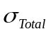, the diagonal term of matrix. The statistical treatment is justified by the assumption that all error components have already been divided until there are no correlations between any error items in the measurement of an integral parameter. The total errors of Data A and B, that is, the diagonal term of error matrix, Ve, are the summation of common and independent errors as below:
Standard deviation of Data A: 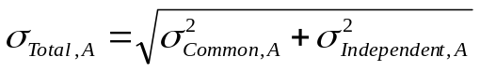 - - - (5)
Standard deviation of Data B: 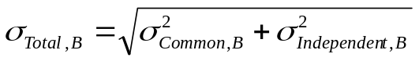 - - - (6)
where,
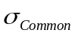: Summing up of all Common error components, and
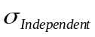: Summing up of all Independent error components.

(Stage 3) Evaluation of Correlation Factor

Finally, the correlation factor, non-diagonal term, of Data A and B is derived as the ratio of common errors to the total errors as Eq.7. The "Stage 1 to 3" procedures must be repeated for all matrix elements to generate a full experimental error matrix as the input of adjustment exercise. Note that, for example, the correlation factors between several sodium void reactivity measurements would be changed depending on the combination of void steps, even in the same experimental core.
Correlation Factor of Data A and Data B: 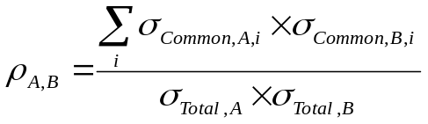 - - - (7)
where,
Suffix i: Common error components between Data A and Data B.

4.3. Examples to Evaluate Experimental Error Matrix

Typical examples to estimate the experimental error matrix are shown for the sodium void reactivity (SVR) measurement and the reaction rate ratio (RRR) measurement in the ZPPR-9 core.

4.3.1. Sodium Void Reactivity Measurement

Figure 4.1 summarizes the evaluation procedure for the SVR measurement in the ZPPR-9 core. The upper part of Figure 4.1 shows the measured void step in the ZPPR-9 experiment [4.8]. Treatment of the error values and their correlation between Step 3 and Step 5 of the SVR measurement in ZPPR-9 is provided as an example. Step 3 is a central void case in the core where neutron non-leakage term is dominant for the reactivity change by sodium voiding, on the other hand, Step 5 is an axially whole-core void case where the non-leakage term of the reactivity is largely cancelled by the leakage term. The net reactivity of both steps is almost the same with the value around +30 cents, though the mass of the removed sodium to simulate sodium voiding is quite different by more than factor 2, that is, 31 kg for Step 3 and 78 kg for Step 5, respectively. The left part of Figure 4.1 is the result of the experimental error evaluation [4.8] following the IRPhE evaluation guidance [4.9], where the error sources are classified to the three categories, (1) measurement technique, (2) geometry, and (3) composition.

(Stage 1) The detailed explanation of the error evaluation for the SVR measurement can be found in "Section 2.4: Evaluation of Reactivity Data" of [4.8], and it is judged the quality of error analysis and the classification level of the experimental error components fulfill the requirement of the necessary error matrix evaluation, that is, the correlation factor of each error component between the two
Figure 4.1. Example of Sodium Void Reactivity Measurement in ZPPR-9
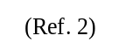
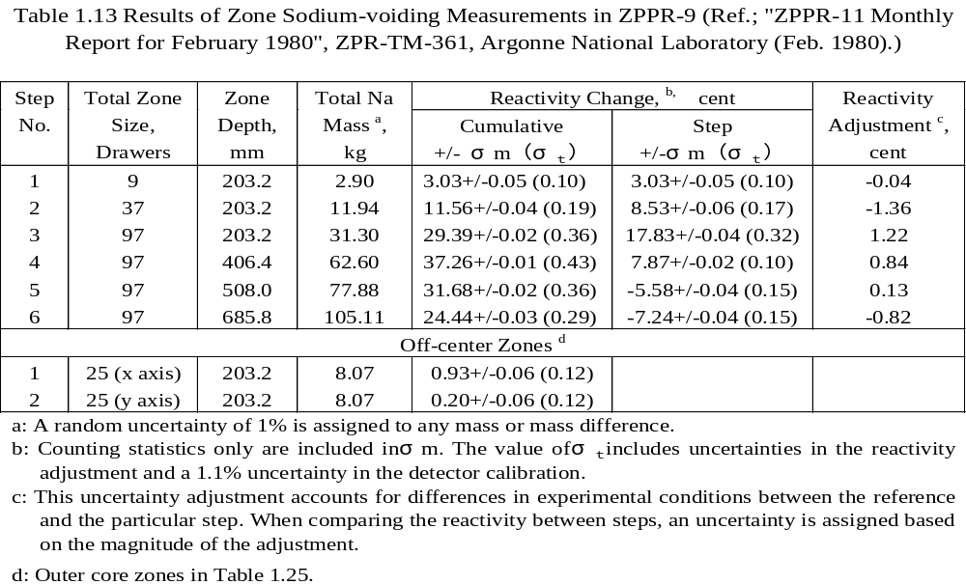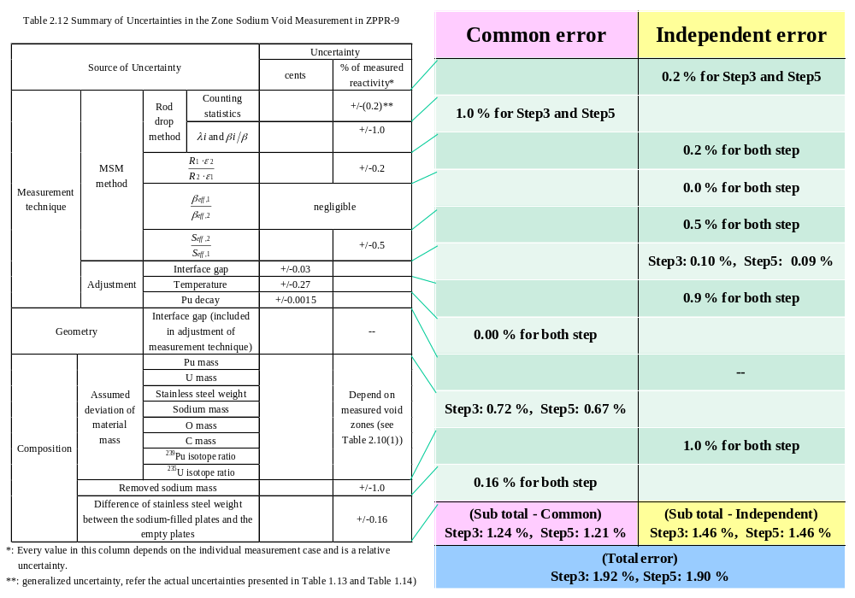
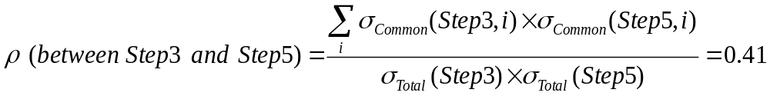

measurements must be 1.0 or 0.0. The following are brief comments for the important error components in Figure 4.1.

λ_{i} and β_{i}/β: To obtain the cent-unit reactivity by solving the inverse kinetics equation from the flux change measured, the family-wise decay constant (λ_{i} ) values of the delayed neutron precursors and the family-wise delayed neutron fraction ratio (β_{i}/β ) were needed as the input data. This error component greatly contributes to the total error with the common characteristics between two measurements, since ANL experimenters used the same λ_{i} and β_{i}/β values throughout the measurement.
Temperature adjustment: The correction of temperature difference was needed between two measurements. According to the ANL document, the temperature difference is usually 2 degree-C at maximum, and the uncertainty of the temperature coefficient would be 10%. The resulted error values are quite large with the independent characteristics, since the temperature change between two measurements could be considered as random.
Material mass-induced error: The assumed mass uncertainties were derived from some ANL documents, that is, 0.079% for plutonium, 0.15% for uranium, etc. The mass uncertainties were converted to the reactivity-unit errors using the sensitivity coefficients of each element to each void step, therefore, the error values were slightly changed in Step 3 and 5. This mass-induced error can be considered as a common component, since the shape of sensitivity coefficients for two measurements are quite similar.

(Stage 2) Summation of the results of the error values for Step 3 and 5 is shown in the right table of Figure 4.1. The Total error for Step 3 is 1.92%, and for Step 5, 1.90%. The contributions of common and independent errors are quite comparable.

(Stage 3) Finally, the correlation factor between Step 3 and 5 is shown at the bottom of Figure 4.1. The value is 0.41, which might be physically plausible from the quantitative evaluation of the common and independent error components.

4.3.2. Reaction Rate Ratio Measurement

Figure 4.2 shows the error matrix evaluation process for the RRR measurement in the ZPPR-9 core. Here, the foil activation method for the RRR measurement adopted in the ZPPR facility is provided as an example. Thin metallic activation foils were used to measure reaction rates in ZPPR-9 at the upper-left positions of Figure 4.2. Uranium and plutonium metal foils were placed between plates in various drawers in the assembly as shown in the upper-right figure, irradiated and then removed from the drawers. Capture and fission rates in the irradiated foils were determined by counting gamma rays emitted by capture or fission products.

(Stage 1) The error evaluation for the RRR measurement in ZPPR-9 is described in detail in "Section 2.7: Evaluation of Reaction Rate Distributions" [4.8]. The left part of Figure 4.2 shows the result of the experimental error evaluation.

Error caused by mapping foil activity measurement: This error component consist of (1) the counting statistics, (2) the positioning of a sample above a gamma-ray counter, (3) the foil mass and (4) the discrete channel boundary in peak integration, whose characteristics are all statistical.
Figure 4.2. Example of Reaction Rate Ratio Measurement in ZPPR-9
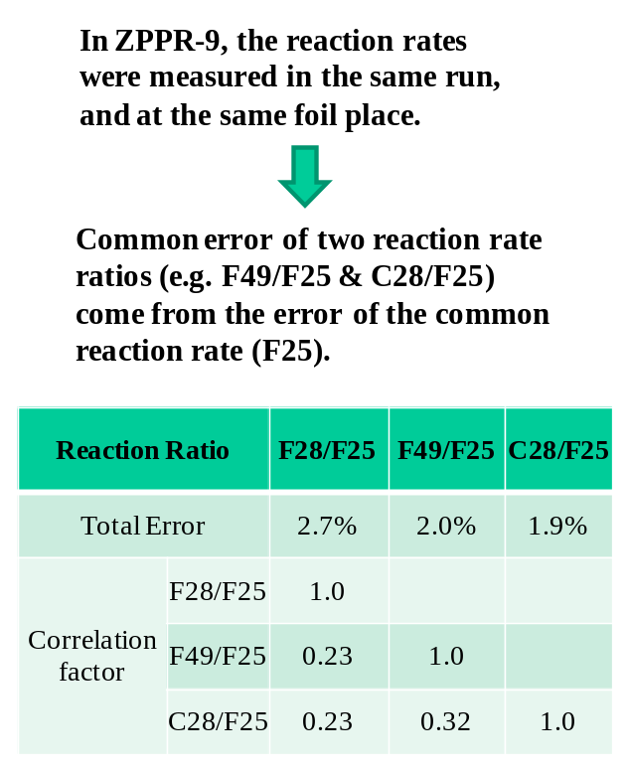
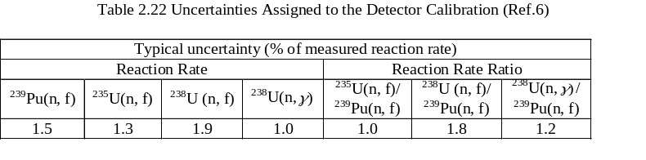
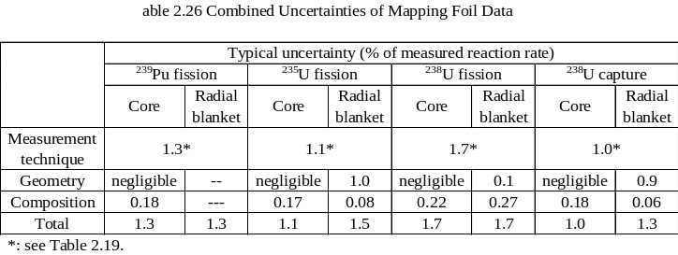
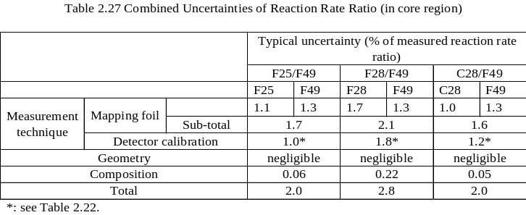
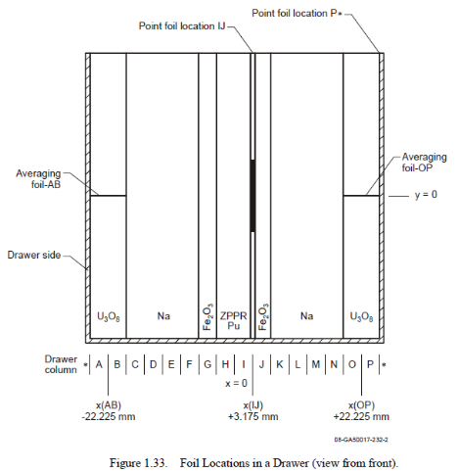
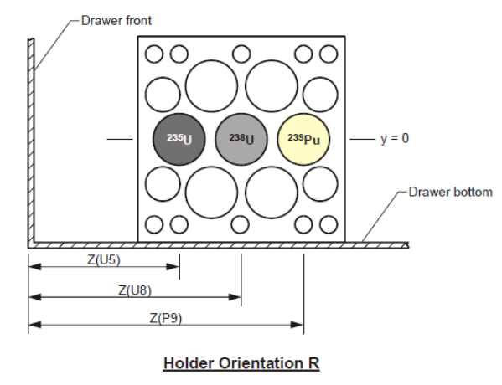

Error caused by detector calibration: The absolute calibration of each reaction is necessary to measure the RRR value, which was made by gamma–ray counting of ²³⁹Pu, ²³⁵U and ²³⁸U foils and deposits in back-to-back fission chambers. Note that the error induced by the detector calibration has the systematic characteristics to determine the absolute value of a kind of RRR, such as by averaging the F49/F25 values in the whole core, however, it has the statistical feature when the correlation between two kinds of RRRs, such as between F49/F25 and C28/F25, is considered.

Composition-induced error: Since the error caused by the foil composition is included in the mapping foil error, the composition column in Figure 4.2 is related to the chemical analysis error of the core fuel and other core materials, and possesses the common characteristics between two RRRs. The composition error to the reactivity was converted with the sensitivity coefficients like the SVR case, but the magnitude was found to be negligible, compared with other common error mentioned below.

(Stage 2) In the ZPPR experiment, the activation foils of ²³⁹Pu, ²³⁵U and ²³⁸U were irradiated in the same run, and at the same foil folders in a drawer. This means that the common error of two RRRs such as F49/F25 and C28/F25 must include the contribution from the common denominator, F25 in this case. The summing up results of the error values for F49/F25 and C28/F25 are shown in the right table of Fig.A.2. The total error for F49/F25 is 2.0%, and for C28/F25, 1.9%.

(Stage 3) The correlation factors between F49/F25 and C28/F25 becomes 0.32 as shown at the bottom of Figure 4.2.

4.3. Full Experimental Error Matrix in SG33 Exercise

Applying the above-mentioned methodology, the full matrix of the experimental error for the 20 experiments treated in the SG33 exercise is summarized in Figure 4.3. Additional comments for this table are below:

(1) The correlation factors of the RRRs in Jezebel-Pu239, Flattop and ZPR6-7 are borrowed from those of ZPPR-9, since the denominator of the RRRs, F25, is common in these experiments, and there is scarce information for the former three experiments to evaluate the common and independent components of the RRRs. The F37/F25 ratio is assumed to possess similar characteristics with F28/F25 which has a threshold feature against neutron energy.

(2) From the fuel composition tables of [4.8] and [4.10], the plutonium fuel plates used in ZPR6-7, ZPR6-7 Pu240 and ZPPR-9 experiments were found as identical ones. This means at least that the criticality of these three cores must be correlated through the composition errors. In Figure 4.3, the evaluated correlation factors with the sensitivity coefficients of core compositions are added. The correlations among other parameters of these three cores are neglected here, since the effects of common core material to other parameters are usually small compared with that to the criticality.

4.4. Analytical Modeling Error Matrix

The evaluation methodology of the analytical modeling error, V_{m}, depends on the analytical method adopted to obtain the calculation value of an integral experiment. Here, we consider three kinds of
Figure 4.3. Experimental Error Matrix V_{e} applied in SG33 Exercise
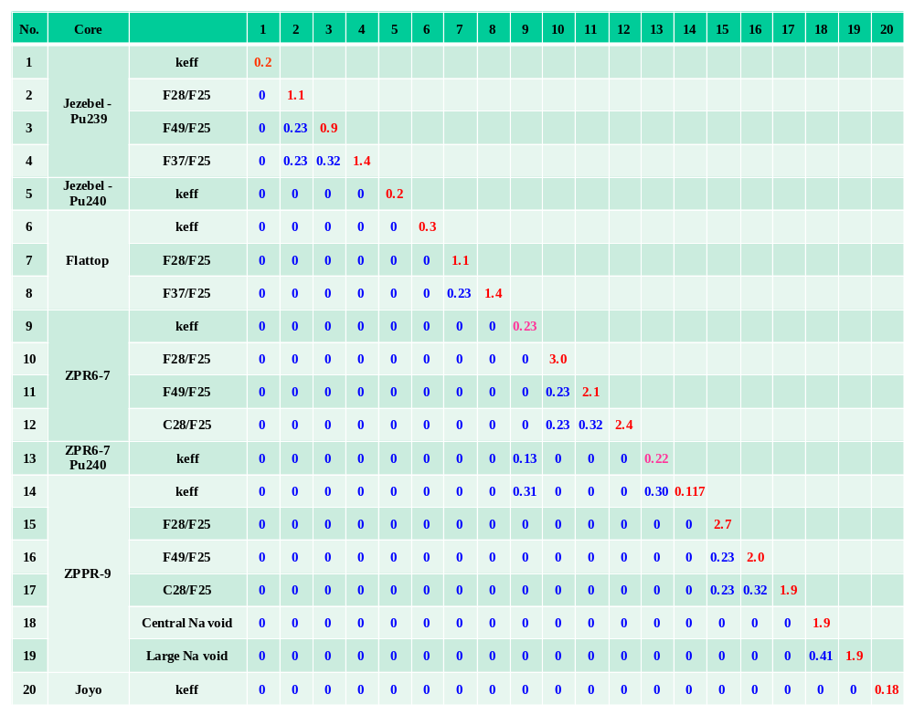
analytical methods, that is, (1) Continuous-energy Monte Carlo method based on the as-built experimental geometry and compositions (MC method, hereafter), (2) Deterministic analytical method based on the combination of the standard calculation and the corrections by the most-detailed analytical models (Deterministic method), and (3) Combination of the deterministic analytical calculation based on the simplified geometry and the correction by the Monte Carlo calculation with as-built geometry (Combined method).

4.4.1. MC Method

The standard deviation (diagonal term) of the analytical modeling error should be supplied from the statistical error value evaluated by the adopted MC code. However, there is one caution to adopt the statistical error evaluated by the MC code. According to [4.11] and [4.12], the existing MC codes cannot count on the effect of correlation among the fission source over successive MC cycles to evaluate the statistical error. This ignorance will result in the underestimation bias of the real statistical error, by the range of the factor 1.4 to 3.1 [4.11] depending on the target calculation systems, or by 69% for a small-size reactor core and by 80% for a medium-size one [4.12]. Here it is recommended to multiply the statistical error evaluated with a MC code by a factor of 2, in order to prepare the analytical modeling error as the input data of the cross-section adjustment.

The correlation factors of the analytical modeling error with the MC method are basically 0.0 from the chaotic nature of the Monte Carlo methodology. This would be also valid even for the correlation between two reaction rates at the same position in a core, since the detailed energy structure of two cross-sections are not identical, therefore, the energy-integrated reaction rate would be independent from each other. Only one exception is the correlation between two reaction rate ratios (RRRs) which have the same denominator such as F49/F25 and C28/F25. If the calculation results of two RRRs are obtained by one MC code run, these RRRs have the correlation of +0.5 if the statistical errors of each RRR are the same. Figure 4.4 shows an example of the analytical modeling Error matrix Vm applied in SG33 exercise, where all calculations are based on the MC method.

4.4.2. Deterministic Method

There is no established methodology to evaluate the analytical modeling error matrix for the deterministic analysis yet. Here a possible estimation method is submitted which is based on a kind of "sensitivity consideration" to the detailed degree of a physical modeling. The basic assumption is that the error value of analytical modeling would be large, if the analytical result significantly changes when the degree of physical modeling are replaced from simple one to detailed, such as from the diffusion theory to the transport theory. In other words, the error would be large if the sensitivity to the analytical modeling is large. Figure 4.5 summarizes the actual procedure to estimate the analytical modeling error matrix.

(1) First, the correction items of an integral parameter, the criticality for two experimental cores, ZPPR-9 and JOYO Mk-I in Figure 4.5, are listed up with their calculated values. The explanation of each correction is found in Section 4 of [4.13].
(2) For each correction item, a certain percent of the "smaller" correction value is assumed as the common error between two cores. The concept of this treatment for the transport-theory correction is illustrated in Figure 4.6. The physical mechanism of transport correction comes from the approximated treatment of neutron-flux gradient, which is common between ZPPR-9 and JOYO.
Figure 4.4. Example of Analytical Modeling Error Matrix V_{m} applied in SG33 Exercise
(All calculations are based on Continuous-energy Monte Carlo method.)
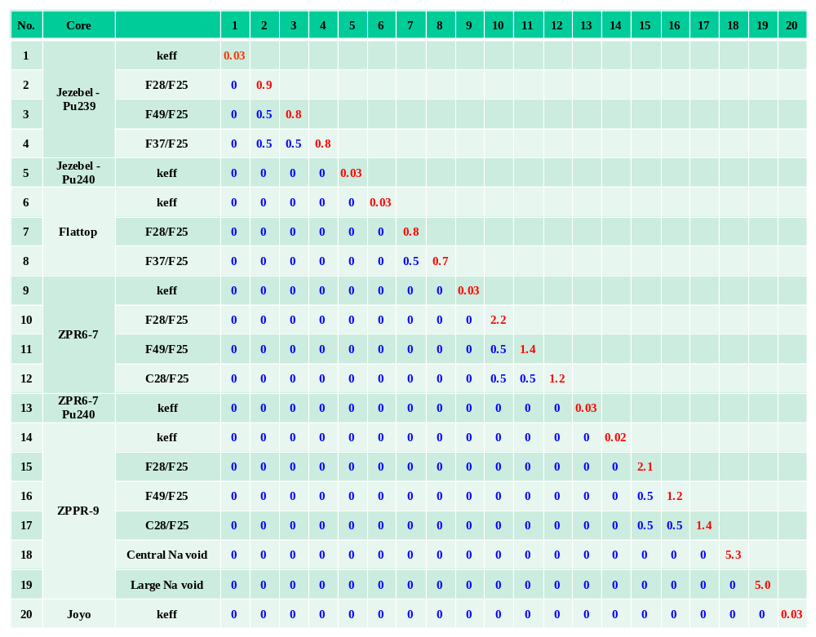
Figure 4.5. Example of Weak Correlation Case of Analytical Modeling Error
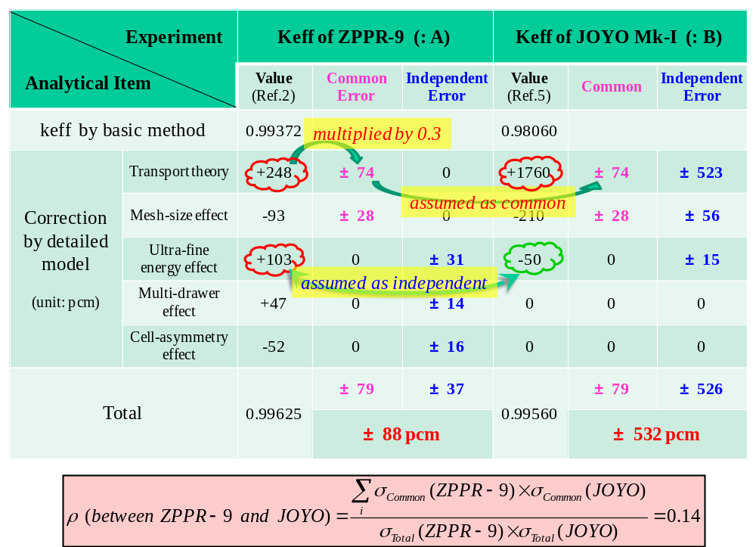

Figure 4.6 Illustration of Common-error Concept in Analytical Modeling Error Estimation
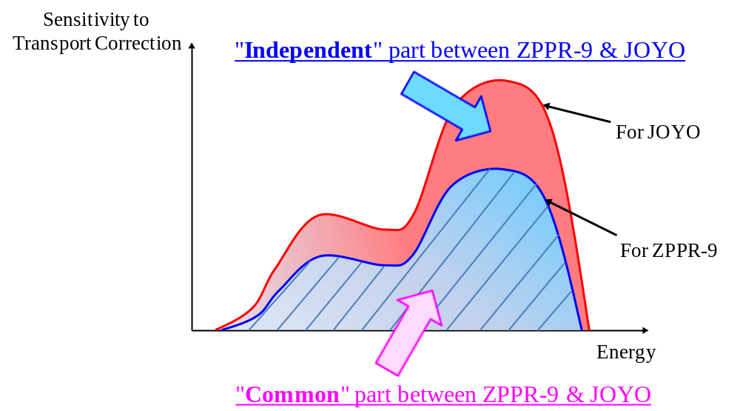

However, the sensitivity of the transport effect to JOYO is larger than that to ZPPR-9, since JOYO is a smaller core with steep flux gradient. We assume here the overlapped part of the transport correction would be common between these two cores, and the un-overlapped part might be an independent feature of JOYO only. If the sign of correction values for two cores are opposite, which is the case of the ultra-fine energy effect in Figure 4.5, this correction item would be judged as independent because the physical mechanism must be different between each other.
(3) The percentage value of the correction should be estimated by other engineering judgments, and we recommend a value of 30% from the past adjustment experiences where the chi-square balancing was surveyed among the set of the C/E-1 values, the integral experimental errors, the cross-section covariances and the analytical modeling errors.
(4) The following procedures are similar with those of the experimental error matrix evaluation. The Total error values of two cores are calculated by summing up both the common errors and the independent errors as Eq.5 and 6. The correlation factor is evaluated by the ratio of the common errors to the total errors as Eq.7.

Figure 4.5 shows the example of k_{eff} correlations between a large core, ZPPR-9, and a small core, JOYO. The correlations of them would be expected to be quite weak, and the estimated result was 0.14. On the other hand, Figure 4.7 is an example of the strong correlation case. The integral data evaluated are the criticality of ZPPR-10A, a 600MWe-class FBR core, and that of ZPPR-10C, an 800MWe-class FBR core. The drawer structures and arrangements of both cores are almost identical except small difference of core sizes, therefore, the correlation of them would be expected to be strong, and the estimated factor was 0.82. We consider these results would be coincident with our physical intuition.

4.4.3. Combined Method

The MC method could be generally regarded as the most desirable analysis tool to obtain the best-estimated calculation values and their error values for the complicated as-built geometry. However, the current computer power is still not enough to calculate small reactivity changes or local reaction rates by the MC method with realistic computing time. Further, the input data of the MC method tends to be huge if the core compositions are very complicated, such as the burnup conditions of a power reactor. On the other hands, the Deterministic method has the advantage that the computing time is relatively short, and it is rather practical to treat such complicated compositions, although the complicated as-built geometry is difficult to directly simulate by the Deterministic method. To make use of the merits of both methods, there is a possibility to combine the MC method with the Deterministic method to obtain the best-estimated calculation values. The idea is to make the calculation result of the Deterministic method equivalent to that of the MC method by the correction. The final values of the Combined method, R_{Combined} (Best estimated), would be expressed below:

R_{Combined} (Best estimated) = R_{Det} (Simplified geometry, As-built composition) +
{R_{MC} (As-built geomery, Simplified composition) –
R_{Det} (Simplified geometry, Simplified composition)} - - - (8)

where,
R_{Det}: Calculated value by the Deterministic method and
R_{MC}: Calculated value by the MC method.

In this case, the standard deviation of the Combined method could be considered as the same of the MC method, under the condition that the correction values, the second term of the right hand in Eq.8, are obtained through well-organized simulation models from the analytical modeling error viewpoint, in
Figure 4.7 Example of Strong Correlation Case of Analytical Modeling Error
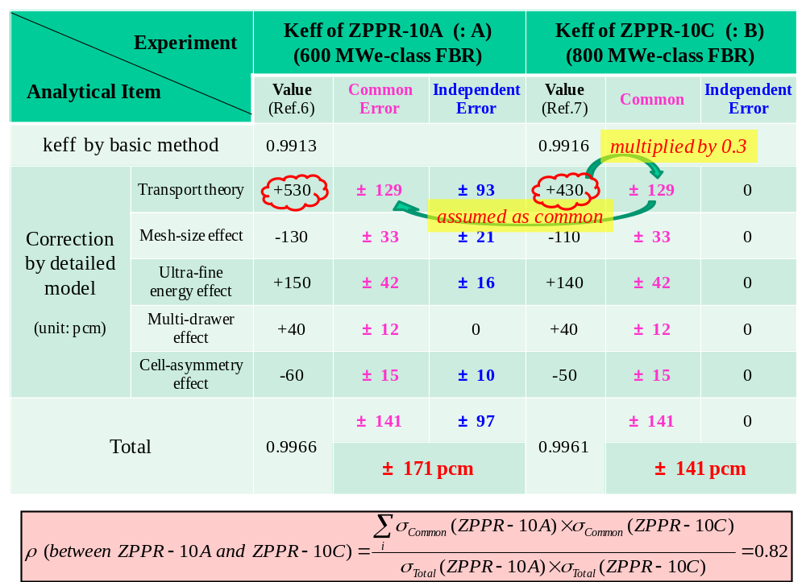

other words, if the analytical errors caused by two calculations with the Determination method are cancelled in Eq.8. The correlation factors of the Combined method would be also the same with those of the MC method, under such condition.

4.5. Concluding Remarks

In order to make the cross-section adjustment, the preparation of the integral experimental and analytical modeling errors is inevitable with the form of matrix, that is, the combination of standard deviations and correlation factors. A methodology and procedure to evaluate/estimate both matrices have been proposed herein, and with the hope these will be used in the actual adjustment exercise and improved to more sophisticated methods in the future.

References

[4.1] J. B. Dragt et al, "Methods of Adjustment and Error Evaluation of Neutron Capture Cross Sections; Application to Fission Product Nuclides", Nucl. Sci. Eng., 62, 117-129, 1977.
[4.2] T. T. Ivanova et al, “Influence of the Correlations of Experimental Uncertainties on Criticality Prediction,” Nucl. Sci. Eng., 145(1), 97–104 (2003).
[4.3] T. T. Ivanova et al, "Towards validation of criticality calculations for systems with MOX powders", Annals of Nuclear Energy, 36, (2009) 305–309.
[4.4] O. Buss, A. Hoefer, J. C. Neuber, and M. Schmid, “Hierarchical Monte-Carlo Approach to Bias Estimation for Criticality Safety Calculations,” Proc. of PHYSOR 2010, Advances in Reactor Physics to Power the Nuclear Renaissance, Pittsburgh, PA, May 9-14, 2010.
[4.5] B. T. Rearden and K. Dugan, “ Progress on Determination of Experimental Uncertainties and Correlation Coefficients,” Letter Report ORNL/LTR-2012/619, December 20, 2012.
[4.6] “International Handbook of Evaluated Criticality Safety Benchmark Experiments,” NEA/NSC/DOC(95)03, September 2012 Edition.
[4.7] “International Handbook of Evaluated Reactor Physics Benchmark Experiments,” NEA/NSC/DOC(2006)1, March 2013 Edition.
[4.8] T. Ikegami, "ZPPR-9 Experiment: A 650 MWe-class Sodium-cooled MOX-fueled FBR Core Mock-up Critical Experiment with Clean Core of Two Homogeneous Zones", International Handbook of Evaluated Reactor Physics Benchmark Experiments (IRPhE), ZPPR-LMFR-EXP-002, NEA/NSC/DOC(2006)1, OECD/NEA, 2011.
[4.9] V.G. Dean, "The Benchmark Evaluation Process: From Experimental Data to Benchmark Model", Nuclear Science and Engineering 145, pp.20-38, 2003.
[4.10] R.M. Lell, J.A. Morman, R.W. Schaefer and R.D. McKnight, "ZPR-6 Assembly 7 Experiments: A Fast Reactor Core with Mixed (Pu,U)-Oxide Fuel and Sodium with a Thick Depleted Uranium Reflector", International Handbook of Evaluated Reactor Physics Benchmark Experiments (IRPhE), ZPR-LMFR-EXP-001, NEA/NSC/DOC(2006)1, OECD/NEA, 2011.
[4.11] T. Ueki, T. Mori and M. Nakagawa, "Error Estimations and Their Biases in Monte Carlo Eigenvalue Calculations", Nucl. Sci. Eng., 125, 1-11, 1997.
[4.12] H.J. Shim and C.H. Kim, "Real Variance Estimation Using an Intercycle Fission Source Correlation for Monte Carlo Eigenvalue Calculations", Nucl. Sci. Eng., 162, 98-108, 2009.
[4.13] K. Yokoyama and A. Shono, "Japan's Experimental Fast Reactor JOYO Mk-I Core: Sodium-cooled Uranium-Plutonium Mixed Oxide Fueled Fast Core Surrounded by UO₂ Blanket", International Handbook of Evaluated Reactor Physics Benchmark Experiments (IRPhE), JOYO-LMFR-RESR-001, NEA/NSC/DOC(2006)1, OECD/NEA, 2011.
[4.14] M. Ishikawa and R. D. McKnight, "ZPPR-10A Experiment: A 650 MWe-class Sodium-cooled MOX-fueled FBR Homogeneous Core Mock-up Critical Experiment with Two Enrichment Zones and Nineteen Control Rod Positions", International Handbook of Evaluated Reactor Physics Benchmark Experiments (IRPhE), ZPPR-LMFR-EXP-001, NEA/NSC/DOC(2006)1, OECD/NEA, 2011.
[4.15] T. Sanda, "ZPPR-10C Experiment: A 800 MWe-class Sodium-cooled MOX-fueled FBR Homogeneous Core Mock-up Critical Experiment with Two Enrichment Zones and Nineteen Control Rod Positions", International Handbook of Evaluated Reactor Physics Benchmark Experiments (IRPhE), ZPPR-LMFR-EXP-006, NEA/NSC/DOC(2006)1, OECD/NEA, 2011.

The words "Common" and "Independent" adopted here are usually refered as "Systematic" and "Statistical", respectively, in many experimental reporting literatures. However, use of the former labels more clearly expresses the intention of this classification to evaluate their correlation factor for a specific pair of data in a large matrix than the latter labels.
Note this is not concerned with the conversion factor (β_{eff}) of the reactivity from cent-unit to delta-k, which is needed to compare the reactivity value of an experiment with that of calculation.
The common errors induced by composition errors are only considered here, since there is no information on other common error components among these.
The "a certain percent" means that value of the analytical modeling error is assumed to be proportional to the value of correction by the detailed models.

