Notes on ²³⁹Pu Unresolved Resonance Range (URR) in JEFF-3.1

Following feedback and proposal from :

Alain Hébert et al. see http://www.nea.fr/listsmh/jeff/msg00130.html

To: jeff@nea.fr
Subject: bug in Jef2.2 - Pu239
From: Alain Hebert <alain.hebert@polymtl.ca>
Date: Tue, 7 Jun 2005 18:53:31 -0400

There is a bug in Pu239 evaluation. The upper limit of the unresolved energy domain is set to 3.0E4 at one place and to 2.95E4 elsewhere. This is causing unresr to write undefined values on the PENDF file.

To correct the bug, replace the following line in tape8:

1.000000+3 3.000000+4 2 2 0 09437 2151 3373

with

1.000000+3 2.950000+4 2 2 0 09437 2151 3373

(Note that the line number is 3376 in the version used at Saclay)

I want to credit my PhD student, Karthikeyan Ramamoorthy, who greatly help me in finding the bug.

Alain Hébert
professor

Chris Dean see http://www.nea.fr/html/dbdata/jeff3feedback/feedback-31.html

09 June 2005: upper limit unresolved resonance range (2 solutions proposed by Dean and we ask to the evaluators to decide between the two solutions based on validation and comparisons JEFF31N9437_1.TMP and JEFF31N9437_2.TMP).

Option 1: change on MF=2 and MF=3 (MT=1 and MT=2) (all agree and the limit is 29.5 KeV)

JEFF31N9437_0.ASC vs. JEFF31N9437_1.TMP

< 2.500000+3 3.000000+4 2 2 0 09437 2151 1082
> 2.500000+3 2.950000+4 2 2 0 09437 2151 1082
---
< 1.000000+4 2.871000-1 2.000000+4 3.377000-1 3.000000+4 3.251000-19437 3 1 6
< 3.000000+4 1.457710+1 4.000000+4 1.414710+1 5.000000+4 1.380640+19437 3 1 7
> 1.000000+4 2.871000-1 2.000000+4 3.377000-1 2.950000+4 3.251000-19437 3 1 6
> 2.950000+4 1.457710+1 4.000000+4 1.414710+1 5.000000+4 1.380640+19437 3 1 7
---
< 3.000000+4 0.000000+0 3.000000+4 1.221000+1 4.000000+4 1.186000+19437 3 2 5
> 2.950000+4 0.000000+0 2.950000+4 1.221000+1 4.000000+4 1.186000+19437 3 2 5

Option 2: change only on MF=2 and move the limit to 30 keV

JEFF31N9437_0.ASC vs. JEFF31N9437_2.TMP

(l=0 J=0)
< 2.950000+4 8.474100+0 0.000000+0 9.474000-4 4.070000-2 2.697000+09437 2151 1156
> 3.000000+4 8.474100+0 0.000000+0 9.474000-4 4.070000-2 2.697000+09437 2151 1156

(l=0 J=1)
< 2.950000+4 2.892900+0 0.000000+0 3.234000-4 4.030000-2 8.710000-29437 2151 1228
> 3.000000+4 2.892900+0 0.000000+0 3.234000-4 4.030000-2 8.710000-29437 2151 1228

(l=1 J=0)
< 2.950000+4 8.474100+0 0.000000+0 1.412600-3 1.150000-2 0.000000+09437 2151 1301
> 3.000000+4 8.474100+0 0.000000+0 1.412600-3 1.150000-2 0.000000+09437 2151 1301

(l=1 J=1)
< 2.950000+4 2.892900+0 0.000000+0 2.411500-4 3.030000-2 9.210000-19437 2151 1373
> 3.000000+4 2.892900+0 0.000000+0 2.411500-4 3.030000-2 9.210000-19437 2151 1373

(l=1 J=2)
< 2.950000+4 1.820500+0 0.000000+0 3.035000-4 3.335000-2 5.790000-19437 2151 1445
> 3.000000+4 1.820500+0 0.000000+0 3.035000-4 3.335000-2 5.790000-19437 2151 1445

Here are a few personal comments.

Option 1 shifts down the URR boundary and modify accordingly cross-section values in file 3 (MT1, MT2, …) assuming σ(29.5 keV) = σ(30 keV).

Option 2 shifts up the last average parameter energy in file 2 assuming p(30 keV) = p(29.5 keV) for all parameters p = D, GN0, GG, GF.

I would support option 2 because (in the present case) extrapolation on model parameters should be more reliable than extrapolation on cross-sections.

However, I would recommend a third option (JEFF31N9437_3.TMP) using extrapolations based on the energy variation of the average parameters below 29.5 keV.

Average spacing D: linear extrapolation (see Figure 1)
Strength function S: constant value (see Figure 2)
Neutron width GN0: GN0=S*D/AMUN with AMUN the number of degrees of freedom
Radiative width GG: constant value
Fission width GF: linear extrapolation (see Figure 3)

Option 3: Extrapolation of URR average parameters up to EH = 30 keV

JEFF31N9437_0.ASC vs. JEFF31N9437_3.TMP (minor format changes are not shown)

(l=0 J=0)
< 2.950000+4 8.474100+0 0.000000+0 9.474000-4 4.070000-2 2.697000+09437 2151 1156
<
> 2.950000+4 8.474100+0 0.000000+0 9.474000-4 4.070000-2 2.697000+09437 2151 1156
> 3.000000+4 8.465900+0 0.000000+0 9.465000-4 4.070000-2 2.693000+09437 2151 1157

(l=0 J=1)
< 2.950000+4 2.892900+0 0.000000+0 3.234000-4 4.030000-2 8.710000-29437 2151 1228
<
> 2.950000+4 2.892900+0 0.000000+0 3.234000-4 4.030000-2 8.710000-29437 2151 1229
> 3.000000+4 2.890100+0 0.000000+0 3.231000-4 4.030000-2 7.647000-29437 2151 1230

(l=1 J=0)
< 2.950000+4 8.474100+0 0.000000+0 1.412600-3 1.150000-2 0.000000+09437 2151 1301
<
> 2.950000+4 8.474100+0 0.000000+0 1.412600-3 1.150000-2 0.000000+09437 2151 1303
> 3.000000+4 8.465900+0 0.000000+0 1.411300-3 1.150000-2 0.000000+09437 2151 1304

(l=1 J=1)
< 2.950000+4 2.892900+0 0.000000+0 2.411500-4 3.030000-2 9.210000-19437 2151 1373
<
> 2.950000+4 2.892900+0 0.000000+0 2.411500-4 3.030000-2 9.210000-19437 2151 1376
> 3.000000+4 2.890100+0 0.000000+0 2.408900-4 3.030000-2 9.180000-19437 2151 1377

(l=1 J=2)
< 2.950000+4 1.820500+0 0.000000+0 3.035000-4 3.335000-2 5.790000-19437 2151 1445
<
> 2.950000+4 1.820500+0 0.000000+0 3.035000-4 3.335000-2 5.790000-19437 2151 1449
> 3.000000+4 1.818700+0 0.000000+0 3.032000-4 3.335000-2 5.770000-19437 2151 1450

As far as validation is concerned I think we cannot afford to benchmark evaluations every time someone changes a few lines in the file. Just keep track of the modifications and benchmarking will come when the amount of modifications will worth a validation.

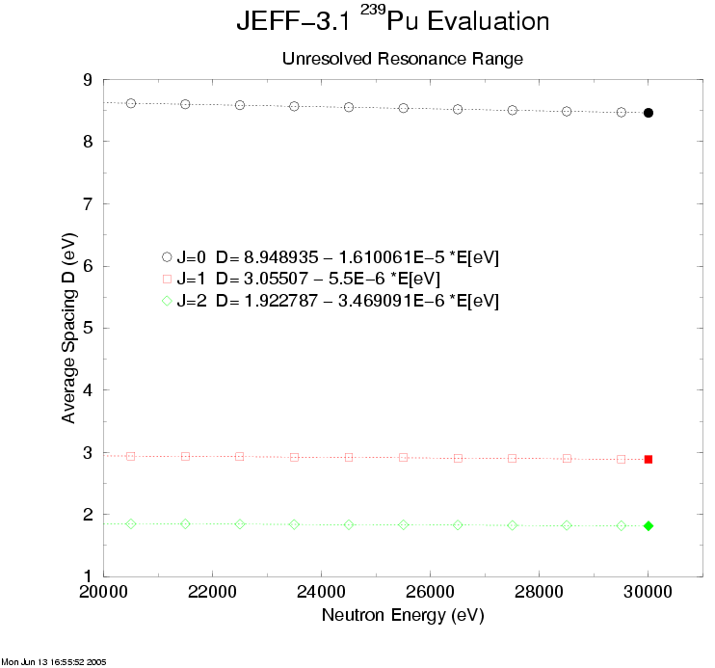

Figure 1 - Average Spacing vs. Neutron Energy for J = 0, 1, 2 (in URR)

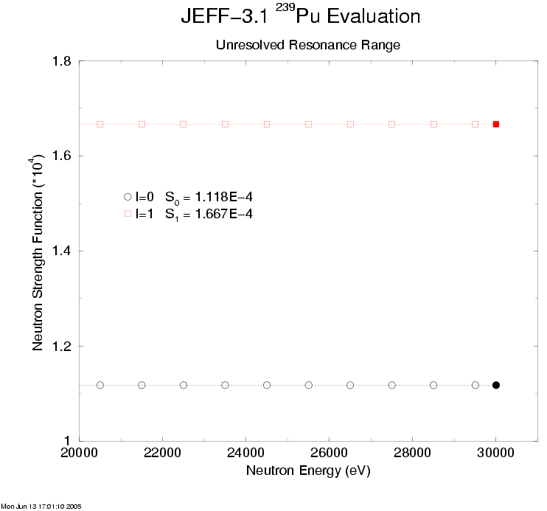

Figure 2 - Neutron Strength Function for s- and p-waves (in URR)

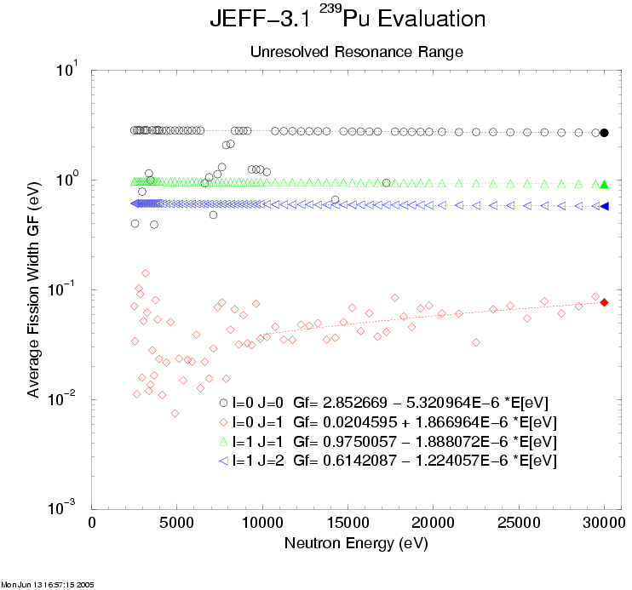

Figure 3 - Average Fission Widths vs. Neutron Energy (in URR)

