Level 2 PSA for the VVER 440/213 Dukovany NPP and its implications for accident management

J. Dienstbier, S. Hustak

Nuclear Research Institute Rez plc (UJV), cp. 130, 250 68 Husinec-Rez, Czech Republic

Plant features
NPP Dukovany is a VVER 440/213 type plant (pressurized water reactor) with four units arranged in two twin-units. The containment of each unit is a leaktight building of rectangular shape with a pressure suppression system, its section is in fig.1. Thick lines mark the containment boundaries in this figure. The plant systems and containment have many features that distinguish them from a standard PWR. Some of them that are referred to in the following text, are mentioned here.
The recirculation sump is not at the containment lowest level, fig.1 - sump. In certain cases like coolant loss to the reactor cavity, coolant loss to the pump (MCP) motor deck (plant modification is planned here), or failure closing the sump drainage, most of primary coolant and ECC water would collect in the ventilation centre, fig.1, and not reach the sump.
Another important feature is the reactor cavity wall being a part of the containment boundary, moreover, there are double steel access doors at its bottom. Some other features are mentioned in the text.

Figure 1 VVER-440/213 containment layout

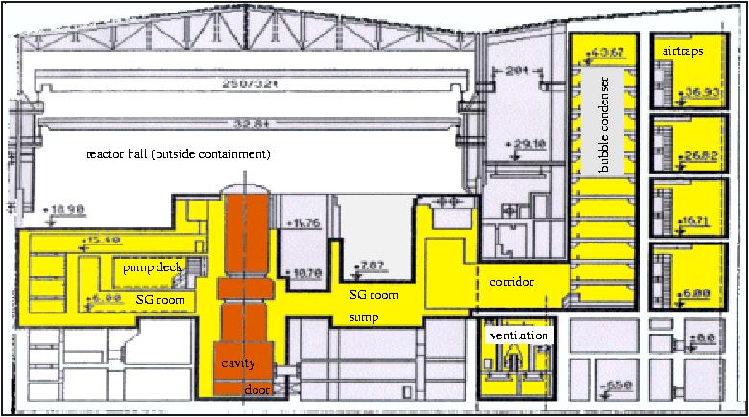

Level 2 PSA history
The first limited scope Level 2 PSA for the Unit 1 of this NPP was performed in the years 1995 to 1998 and completed in April 1998 [1]. It was financed from the USAID programme and the scientific lead was provided by Science Application International Corporation (SAIC) supported by UJV Rez and the plant operator - CEZ-EDU Dukovany, especially for plant data collection and physical accident analyses, which were performed in UJV. An important part of the work was also transfer of knowledge, understanding the PSA techniques. This enabled following two revisions of this Level 2 PSA later, using UJV own capacities.
The first revision was finished in 1998 [2]. Its reason was mainly the update of Level 1 PSA, where the recent version prepared in UJV was used instead of the PSA 1 study from 1994 prepared together with SAIC and used in the first Level 2 PSA. This revision required relatively large modification of the whole event tree, not only the PSA 1/2 interface. In 1999, this work continued with the same base case data by study of efficiency of accident management and preventive measures. Also a recommendation for sequences selection for detailed physical analyses was given.
The second revision was performed in 2002 [3]. Again, the update to the current PSA 1 was performed including some plant modifications and new symptom oriented emergency operating procedures (EOP) introduced at the plant before. Also some details in treatment of the hydrogen burning were revised and the possibility of containment failure due to slow pressurisation by gases added, that was not assumed in the previous revisions. The results of the latest revision are those mainly mentioned in this paper. Some results concerning accident management were, after critical review, taken from the previous revision.

Main characteristics of the PSA 2 performed
The techniques used in all revisions are similar to those employed in Individual Plant Examinations (IPEs) for US nuclear power plants [4] and were introduced by SAIC. It is thus a limited scope PSA where the term “limited scope” has more implications.
First, the scope is limited to normal operation excluding shutdown states. Also external events like earthquake or plane crash are excluded. In the first revision, also internal floods, fires and ATWS were excluded, the last revision includes all these categories, except that ATWS were screened out in the PSA 1/2 interface because of low frequency.
A very important limitation is the description of all basic events by their frequency only, not using probabilistic distributions. The treating of uncertainties is limited to sensitivity studies.
Finally, only four groups of fission products were traced including Cs, Te, Ba, noble gases, representing all others. The categorization of source terms is based only on Cs and Ba as shown further.
First phases during revision zero included also plant familiarization and writing a containment feature notebook. Then there were two main activities performed in parallel, severe accident deterministic model development and analyses using the MELCOR 1.8.3 code [5] and probabilistic model development and analysis using the accident progression event tree method (APET) and the EVNTRE code [6]. The APET method has been developed for full scope PSA 2 of US power plants reported in NUREG 1150 [7].
One large event tree is used describing the interface between PSA Level 1/2, continuing with whole progression of the accident and ending with the source term. In our case this event tree has 100 nodes (or questions), the first 12 are describing the PSA 1/2 interface, nodes 13 to 85 describe the accident progression and nodes 86 to 100 the source term. The last question sorts the source term into 12 categories. The nodes have usually more events than two. Among all the events, there were about 85 to 100 basic events, their number increased between revision 0 and 2. Before preparing the main tree, containment failure modes have been identified and connected with phenomena. First of all, we defined “early” phenomena occurring before vessel bottom head failure and “late” after it. For containment failures or source terms “early” means also within 2 hours after vessel failure. The containment failure modes identified are in tab.1.
Table 1 Containment failure modes
Failure mode | Assumed effective leak size | Caused by phenomena
Early bypass rupture |  | Bypass sequences – SGCB (single SG tube added to early leak)
Early or late rupture | 1 m² | Containment isolation failure*, pressurization due to hydrogen burn, hydrogen detonation, steam explosion, vessel rocket, cavity or cavity door failure
Early leak | 0.01 m² | Cavity door loss of tightness, SGTR
Late leak | 0.01 m² | Cavity basemat penetration, containment failure by slow pressurization
Intact containment | natural leak **
* The fact that containment isolation failure starts very early is taken into account for source term.
** Natural leak 12.5 % / day at the design overpressure 150 kPa was used, it decreased to about 9 % at present.

Containment rupture and all leaks including the natural leak are assumed to conduct directly to the environment neglecting retention in walls or auxiliary buildings outside the containment.
Part of the containment failure modes identification was also specifying the containment fragility (or strength) curves. They were estimated based on the DOE report [8]. The resulting curve for the containment has a normal distribution with the mean at 400 kPa overpressure and 80.9 kPa square root of variance. The curve for the cavity, which is stronger but can be pressurised more for a short time after vessel failure, has a mean value at 2420 kPa and a square root of variance 460 kPa.
The EVNTRE code enables also modelling of physical phenomena by user written functions. This has been used for calculation of hydrogen concentration, the pressure after hydrogen burns using the AICC model and possible rupture as a result of burn. Other user functions combine the decontamination factors to describe the release to the environment.
During the calculation of the event tree, the code eliminates branches that fall below the specified threshold. This threshold was usually selected 10⁻⁹ of core damage frequency (CDF), yielding about 400000 end branches of the tree. This excludes direct graphical display of the results and requires their sorting and binning according to specified criteria, which is also done in one EVNTRE run.
Part of the PSA 2 was the analysis of 5 typical accident sequences using MELCOR 1.8.3. It was supported by several sensitivity analyses for similar sequences to quantify some of the basic events and calculate some of the parameters of physical models embedded in the event tree. The parameters also included coefficients of the fission product release model. This effort was the part of the zero revision of the PSA 2 only. The MELCOR analyses have not been repeated in following revisions due to limited budget and estimates were used to change the basic events or parameter values. We consider this as the main weak point of both revisions where the plant damage state (PDS) vectors changed considerably. This weakness should be removed in the future PSA 2 revision, since a new plant model for MELCOR 1.8.5 was developed in 2003 and its application to plant scenarios is underway including SAMG validation. We will thus have a set of results for representative sequences in term of risk predicted by PSA 2.

PSA 1 – PSA 2 interface
The PSA 1 – PSA 2 interface is comprised of PDS vectors describing the plant state at the onset of core damage. In revision 2, these vectors were based on the results of living PSA 1, the version from 2001 which includes symptom oriented EOPs. The selection respected the recommendations in [4] – inclusion of all PDS vectors with frequency higher than 10⁻⁷/year or, for scenarios with expected higher early release, higher than 10⁻⁸/year. The recommendation that the total CDF of selected sequences is at least 95 % of the total CDF found by PSA 1 is also checked, they covered about 99 % of CDF. The construction of PDS vectors was performed by sorting the PSA 1 results leading to core damage in two steps, in the first one, more pre-vectors with finer attributes were prepared, in the second one, these pre-vectors were grouped into 34 final vectors in tab.2.
The first node specifies the PSA 1 scenario, becoming PSA 2 initiator. 13 scenarios were distinguished including LOCA of 4 different sizes, LOCA leading to coolant bypassing the main sump - IL/RCP and IL/POOL, though still inside the containment. An important scenario is RPV-PTS - the reactor vessel induced rupture due to thermal shock usually after a large or medium LOCA. Big uncertainty exists in RPV-PTS phenomenon and an ongoing effort is to reduce its frequency. The PSA 2 revision 2 coped with this uncertainty by preparing two versions, that one in tab.2 assuming a relatively high RPV-PTS frequency (about 54 % of CDF), the second one neglecting RPV-PTS at all. At present, RPV-PTS contribution to CDF is about 20 % and its further decrease is expected. The containment bypass events are primary to secondary leaks, steam generator tube rupture SGTR or primary collector rupture and lift off SGCB, other bypass sequences denoted I-LOCA were screened out because of low frequency. The remaining events are steamline breaks inside or outside containment SB-IN, SB-OUT, transients TRANS, station blackout SBO. SBO means complete loss of electric power including diesel generators as well. The consequences of internal flood are among SBO initiators, those of fire are among TRANS or IL/RCP.
The LOCA is divided according to its size to:
LG-LOCA large LOCA … more than 100 mm equiv. diameter including double-ended break 2*500 mm of the main loop
M-LOCA medium LOCA … 60-100 mm equivalent diameter
MS-LOCA medium/small LOCA … 20-60 mm equivalent diameter
S-LOCA … small LOCA below 20 mm equivalent diameter
The meaning of the other nodes in the PDS vectors refers to the state of systems at the onset of core damage:
- HPI ... state of HP injection and recirculation
- LPI ... state of the LP injection and recirculation
- Sprays ... state of containment sprays
- SHR ... secondary heat removal (mainly feedwater availability)
- SecDP ... secondary system depressurisation (important only when SHR status is OK)
- PrimDP ... primary system depressurisation by the operator
- ECCS_Inv ... location of (decisive part) of ECC water inventory
- VE_Cat2 ... state of category 2 (backed by diesel generators) electric power
- VE_CI ... combination of containment isolation (CI) and recirculation sump isolation (fSumpI = sump isolation failed)
- VE_CHR ... containment heat removal system status (not including water and electricity availability)
- BC_Drain ... location of bubble condenser water, Drained means water drained to the main sump, aDrain -water in condenser, fDrain – draining by operator failed

For all these attributes, the state is distinguished by the first character. f... generally means “failure”, usually of hardware, which is considered unrecoverable and a... “available”, which may be the result of no need to use or electric power unavailability. In some case, the attribute n… was used for “not performed” indicating some fault, usually initiated in the control system and not solved by the operator. Missing first character means that the system is functional and working, VE_Sp means sprays working.
It is usually assumed that the operator stops ECC and sprays in case of water resources loss before pumps are damaged. For this reason, their status is usually denoted as “a” = available also for cases when no coolant is available (ECCs Inv. is in Cavity or Unrec). In the tree, the coolant and electricity resources are checked separately from the system status, so for the cases of permanent coolant unavailability the “a” systems never become functional. Procedures have been developed recently to use water resources from the other unit, they can be taken into account in the future PSA 2 without too big modification of this tree.
The question concerning primary pressure at the onset of core damage is included in the main part of the event tree. The pressure has four levels – high, medium high, medium low, low – which enable to evaluate the possibility of ECC injection. The boundaries between the levels are the intervention pressures of ECC and hydroacumulators.
There is often only a weak connection between the initiating event and the scenario leading to core damage. This is concerning mainly the SB-OUT and TRANS initiating events, where the real cause of core damage is the complete loss of feedwater, fSHR, usually followed by error in primary “bleed-feed” procedure. On the other hand, RPV-PTS well determines the reason of core damage, it always leads to loss of ECC water to the reactor cavity and then outside the recirculation sump to the ventilation centre. The same is true for IL/RCP, IL/POOL, SGTR, SGCB with similar reasons of loss of coolant and SBO with loss of decay heat removal due to loss of electricity.
An overview of core damage reasons is in fig.2 The main contributor to core damage, 66 %, is the loss of ECC water to the lower parts in the containment below the recirculation sump. Note that 54 % belong to vessel failure by PTS initiator. Without RPV-PTS, the loss of coolant from the sump becomes only the second main reason of core damage. Planned modification of the plant should practically eliminate other large contributor to coolant loss - IL/RCP. This modification includes change of MCP motor drives room drainage and closing the cavity drainage. After this modification, loss of coolant becomes even less important. Closing of the cavity drainage does not solve the water loss during RPV-PTS. Its solution would also require prevention of water loss through the cavity ventilation lines to the ventilation centre, water would return then to the recirculation sump. The sequences with core damage due to error in procedures like bleed-feed or depressurisation (22 % of CDF in fig.2) are characterised by their spectrum of risk shifted to smaller consequences than those with ECC coolant loss, because the possibility of recovery. These consequences can further decrease after introduction of SAMG this year. This will probably lead to increase of the category of very small core damage. At present it represens only 1 % of CDF. Here some large or medium LOCA with failure of part of the ECC, usually hydroaccumulators, are included, in which spontaneous recovery without operator intervention is assumed after very limited core damage and limited cladding oxidation and hydrogen production.

Figure 2 Analysis of CDF
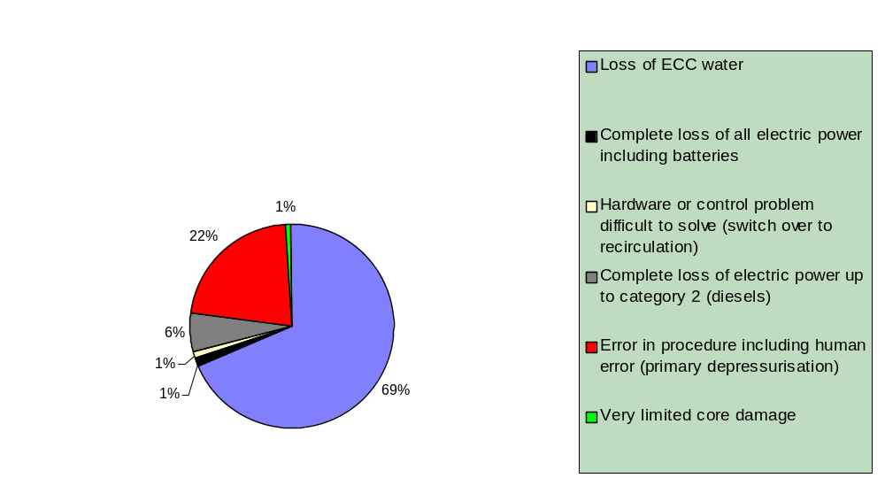
Table 2 PDS vectors

PDS | frequency 1/y | Init | HPI | LPI | Sprays | SHR | SecDP | PrimDP | ECCS Inv | VE_Cat2 | VE_CI | VE_CHR | BC-Drain
1 | 1.00E-07 | LG-LOCA | HPI | LPI | VE_Sp | SHR | aSecDP | aPrimDP | Sump | Cat2 | VE_CI | VE_CHR | Drained
2 | 2.00E-07 | M-LOCA | fHPR | fLPR | fVE_Sp | SHR | aSecDP | aPrimDP | Sump | Cat2 | VE_CI | fVE_CHR | Drained
3 | 1.30E-07 | M-LOCA | HPI | fLPI | VE_Sp | SHR | aSecDP | aPrimDP | Sump | Cat2 | VE_CI | VE_CHR | aDrain
4 | 2.60E-08 | M-LOCA | nHP | nLP | aVE_Sp | SHR | aSecDP | aPrimDP | Cavity | Cat2 | fSumpI | VE_CHR | aDrain
5 | 2.50E-07 | MS-LOCA | fHPI | LPI | VE_Sp | SHR | SecDP | aPrimDP | Sump | Cat2 | VE_CI | VE_CHR | aDrain
6 | 1.50E-07 | S-LOCA | fHPR | fLPR | fVE_Sp | SHR | SecDP | aPrimDP | Sump | Cat2 | VE_CI | fVE_CHR | Drained
7 | 6.50E-08 | S-LOCA | nHP | nLP | aVE_Sp | SHR | SecDP | aPrimDP | Cavity | Cat2 | fSumpI | VE_CHR | aDrain
8 | 1.55E-05 | RPV-PTS | fHPR | nLP | aVE_Sp | SHR | aSecDP | aPrimDP | Cavity | Cat2 | VE_CI | VE_CHR | Drained
9 | 6.00E-07 | RPV-PTS | nHP | nLP | aVE_Sp | SHR | aSecDP | aPrimDP | Cavity | Cat2 | VE_CI | VE_CHR | aDrain
10 | 1.30E-08 | RPV-PTS | nHP | nLP | aVE_Sp | SHR | aSecDP | aPrimDP | Cavity | Cat2 | VE_CI | VE_CHR | Drained
11 | 1.42E-06 | IL/RCP | nHP | nLP | aVE_Sp | SHR | aSecDP | aPrimDP | Cavity | Cat2 | VE_CI | VE_CHR | aDrain
12 | 2.10E-07 | IL/RCP | nHP | nLP | aVE_Sp | fSHR | SecDP | aPrimDP | Cavity | Cat2 | VE_CI | VE_CHR | Drained
13 | 5.00E-08 | IL/RCP | nHP | nLP | aVE_Sp | SHR | aSecDP | aPrimDP | Cavity | Cat2 | VE_CI | VE_CHR | fDrain
14 | 1.60E-08 | IL/RCP | fHPR | fLPR | fVE_Sp | SHR | aSecDP | aPrimDP | Sump | Cat2 | VE_CI | fVE_CHR | Drained
15 | 1.00E-08 | IL/RCP | nHP | nLP | aVE_Sp | SHR | aSecDP | aPrimDP | Cavity | Cat2 | fSumpI | VE_CHR | aDrain
16 | 1.30E-08 | IL/RCP | fHPI | aLPI | VE_Sp | SHR | aSecDP | aPrimDP | Sump | Cat2 | VE_CI | VE_CHR | aDrain
17 | 2.60E-08 | IL/POOL | nHP | nLP | aVE_Sp | SHR | aSecDP | aPrimDP | Cavity | Cat2 | VE_CI | VE_CHR | fDrain
18 | 7.30E-07 | IL/POOL | nHP | nLP | aVE_Sp | SHR | aSecDP | aPrimDP | Cavity | Cat2 | VE_CI | VE_CHR | aDrain
19 | 1.90E-07 | SGCB | nHP | nLP | aVE_Sp | SHR | aSecDP | aPrimDP | Unrec | Cat2 | nVE_CI | VE_CHR | Drained
20 | 1.80E-08 | SGCB | nHP | nLP | aVE_Sp | SHR | aSecDP | aPrimDP | Cavity | Cat2 | fSumpI | VE_CHR | aDrain
21 | 1.00E-07 | SGTR | nHP | nLP | aVE_Sp | SHR | fSecDP | nPrimDP | Unrec | Cat2 | nVE_CI | VE_CHR | Drained
22 | 3.50E-08 | SGTR | nHP | nLP | aVE_Sp | SHR | fSecDP | aPrimDP | Cavity | Cat2 | fSumpI | VE_CHR | aDrain
23 | 3.85E-06 | SB-OUT | HPI | nLP | VE_Sp | fSHR | fSecDP | nPrimDP | Sump | Cat2 | nVE_CI | VE_CHR | aDrain
24 | 7.40E-07 | SB-OUT | nHP | nLP | aVE_Sp | fSHR | fSecDP | aPrimDP | Cavity | Cat2 | fSumpI | VE_CHR | aDrain
25 | 4.60E-07 | SB-OUT | fHPR | LPI | VE_Sp | fSHR | fSecDP | aPrimDP | Sump | Cat2 | nVE_CI | VE_CHR | aDrain
26 | 1.10E-07 | SB-OUT | nHP | nLP | aVE_Sp | fSHR | fSecDP | nPrimDP | Cavity | Cat2 | fSumpI | VE_CHR | aDrain
27 | 4.20E-08 | SB-IN | HPI | LPI | VE_Sp | fSHR | SecDP | nPrimDP | Sump | Cat2 | VE_CI | VE_CHR | Drained
28 | 1.64E-06 | TRANS | HPI | nLP | VE_Sp | fSHR | fSecDP | nPrimDP | Sump | Cat2 | nVE_CI | VE_CHR | aDrain
29 | 3.80E-07 | TRANS | nHP | nLP | aVE_Sp | fSHR | fSecDP | aPrimDP | Cavity | Cat2 | fSumpI | VE_CHR | aDrain
30 | 1.80E-07 | TRANS | HPI | LPI | VE_Sp | aSHR | fSecDP | nPrimDP | Sump | Cat2 | nVE_CI | VE_CHR | aDrain
31 | 1.70E-07 | TRANS | aHPI | LPI | VE_Sp | aSHR | fSecDP | aPrimDP | Sump | Cat2 | nVE_CI | VE_CHR | aDrain
32 | 8.10E-08 | TRANS | nHP | nLP | aVE_Sp | fSHR | fSecDP | nPrimDP | Cavity | Cat2 | fSumpI | VE_CHR | aDrain
33 | 1.80E-06 | SBO | aHPI | aLPI | aVE_Sp | aSHR | aSecDP | aPrimDP | Tank | aCat2 | fSumpI | aVE_CHR | aDrain
34 | 3.80E-07 | SBO | fHPI | fLPI | fVE_Sp | fSHR | fSecDP | fPrimDP | Tank | fCat2 | nVE_CI | fVE_CHR | FDrain
total | 2.9685E-05

The main part of the event tree
The event tree was designed in 1996 to 1998, it was only modified in the following revisions. Its main part, nodes 13 to 85, was designed combining the main (top event) containment tree and eight sub-trees. In the containment tree, questions concerning the vessel bottom head failure and containment state (failure modes) early and late are included. The vessel bottom head failure by debris became node 49. The eight sub-trees had the following top events:
- ... RCS pressure at vessel failure
- ... ECC water early (similar question in the PDS nodes asks about water “very early”)
- ... early recirculation
- ... vessel failure
- ... containment state early
- ... late recirculation
- ... corium – concrete interaction (CCI)
- ... containment state late
The following in-vessel phenomena was identified in the PSA 2:
- cooling or cooling recovery of degraded core
- primary depressurisation by operator or stuck open valve
- induced hot leg or pressurizer surge rupture
- induced SG tubes rupture
- hydrogen production, mixing in the containment atmosphere, diffusion burn, deflagration, detonation
- in-vessel steam explosion
The last three phenomena can lead to containment bypass or large failure. For the early phase, questions concerning primary pressure and electricity category 2 are repeated to capture various events leading to depressurisation and the possibility of electricity recovery.
For the period of about two hours after vessel bottom head failure, following phenomena was treated in the event tree:
- high pressure melt ejection and cavity failure by gases or steam overpressure
- steam explosion in the cavity
- direct containment heating (DCH)
- cavity door failure by jet impingement
- hydrogen detonation
- containment failure by gases transfer from the cavity
- vessel rocket
- cavity door failure by thermal effects
It is clear that except of steam explosion in the cavity and cavity door failure by thermal effects, all the possible containment boundary failure is connected with vessel failure at high pressure. High pressure scenarios are rare in the last PSA 2 revision and will further decrease after SAMG adoption.
The following phenomena is traced for late ex-vessel period of the accident:
- corium concrete interaction (CCI), basemat penetration
- cooling of debris in the cavity
- hydrogen production, diffusion burn, deflagration, detonation
- cavity door failure by thermal effects
- containment failure by gases and steam overpressure
Both basemat penetration and containment failure by overpressure are identified by physical analyses as possible only after several days. In the PSA 2, which basically covers two days of accident, this fact was reflected by artificial decreasing of probability of these phenomena.
For the ex-vessel phase, repeating of water inventory location and cavity door status was necessary to describe the interconnected phenomena of door thermal failure inhibition by water in cavity and water loss outside the containment through the failed door. The questions concerning spray function are repeated in both early and late phases to prepare base for decontamination factors calculation.
The events in the tree are logical or basic events. Besides, physical parameters are included that can be changed in the input data. For the quantification of basic events and parameters, various methods have been used, from MELCOR results for plant sequences, through MELCOR analyses of individual problems like high pressure melt ejection, to hand calculations, engineering judgement or literature survey like for in-vessel steam explosion. Quantification tables have been then used to estimate the probability.

Treating of hydrogen
An important part of the event tree is the description of hydrogen as hydrogen was identified as one of dominant risks. Hydrogen is treated separately for the in-vessel phase and the ex-vessel phase, the physical model and some assumptions are the same for both phases. The hydrogen model was subjected to large modification between revision 1 and 2, because the previous results indicated only relatively small risk connected with hydrogen, it contributed to about 2 – 4 % of CDF to early containment failure. After the modification, the risk of early containment failure increased to almost 12 % of CDF (tab.4).
The first part of the hydrogen model is the assessment of in-vessel hydrogen production. The production was sorted to classes small – 160 kg, medium – 280 kg, high – 400 kg, where the high production represents about 50 % of all zirconium oxidation. The probabilities for this sorting, representing basic events for different sequences were obtained from a log-normal distribution and MELCOR 1.8.3 results. The hydrogen production calculated by MELCOR was mostly close to medium production. Limited core damage is assumed to lead to about 20 % oxidation and small hydrogen production.
Hydrogen concentration (molar concentration is always used) is calculated from all the hydrogen produced in-vessel (in moles) by dividing it by the containment volume. The volume of the whole containment is relatively large, about 51000 m³. The MELCOR analyses demonstrated and MAAP4 analyses confirmed [9], that the airtraps are ineffective to dilute hydrogen due to their pressurization by air and that a much smaller effective volume should be used. In revision 2, this effective volume was set to 25700 m³.
Four burning modes were assumed in the event tree:
- no burn
- diffusion burn
- deflagration
- detonation
The first two nodes are assumed to have no impact on containment integrity as they do not produce sufficient pressure peak. Detonation, on the other hand, is assumed to always fail the containment. When no burn occurs, the hydrogen is retained for the moment of vessel bottom head failure or late (ex-vessel) phase. The probability of no burning decreases with the increasing hydrogen concentration. Diffusion burn accounts mainly for the possibility that a hydrogen plume ignites after release from the primary system before it distributes in the volume. Deflagration starts with the concentration calculated as described above, adiabatic-isochoric complete combustion (AICC) model is used. Detonation is assumed to be possible only when the hydrogen concentration reaches 12 % and is prevented in cases when electric power is available. Possible steam inerting preventing detonation is also checked, the data for these basic events were obtained from MELCOR analyses. They indicate low probability of steam inerting. The quantification of basic events leading to different type of hydrogen combustion changed in revision 2, which alone changed the hydrogen risk dramatically. Treating of electric power as the source of sparks acting as natural igniters was the keypoint. The probability of early ignition and diffusion burn was lowered from the usual 0.75 in earlier revisions to 0.1 in revision 2 leaving thus 0.9 probability of deflagration or detonation.
Several improvements of the AICC model have been performed in revision 2. The MELCOR analyses showed, that there are two possible pressure levels before the hydrogen burn, depending on the sequence type and other events, especially the function of sprays. In revision 2, also different temperature and steam partial pressure were assigned to each initial pressure level. Gases densities, estimated in previous revisions, are calculated from the state equation in revision 2. Besides, incomplete hydrogen combustion was introduced for hydrogen concentration between 4 % and 8 % and after exhausting available oxygen.
The pressure peak obtained after hydrogen deflagration is reduced by spray reduction factor 0.9 and a reduction factor taking into account pressure relieve due to gases flow to airtraps, 0.6. The peak pressures and their probabilities are then compared with the containment strength curve described above. The result is the probability that a hydrogen burn leads to early containment rupture.
The late hydrogen burn uses the same model and collects hydrogen not burnt in the early phase or at vessel failure and combines it with hydrogen produced during CCI. Previous combustion usually leaves sparks, they are treated to be a very probable ignition source. The MELCOR analyses showed, that there were multiple burns even during the in-vessel (early) phase and that during the ex-vessel (late) phase only part of the remaining hydrogen burnt. The rest remained due to lack of oxygen. This was taken into account for the late phase, where the concentration is artificially lowered simulating multiple burns. Also, the containment already failed by hydrogen during the in-vessel phase cannot fail for the second time during the ex-vessel phase. All this leads to considerably lower risk of hydrogen in the late (ex-vessel) phase than in the early phase.

Fission product release and release categories
Questions concerning source term are asked in nodes 86 to 100. In-vessel release of Cs, Te, Ba and noble gases in fraction of inventory is specified first, distinguishing two levels of core damage – partial and complete. In the following questions, decontamination factors of the primary system, containment and sprays are calculated. Similarly, ex-vessel and re-volatilization releases are treated. Then, the user function is called calculating releases in the four groups of elements and sorting them according to magnitude. The magnitudes of Cs representing volatile fission products and Ba representing non-volatile fission products are combined into general release magnitude, using the thresholds 0.1%, 1.0%, 10% of inventory for Cs and 0.01%, 0.1%, 1% for Ba. This magnitude is combined with timing of containment failure in question 100, giving 12 release categories. Because it is complicated to understand the results presented as 12 release categories, these categories were binned in revision 2 into five release classes. These classes condense the higher release categories into early and late high classes and copy the low release categories into the remaining three classes. The classes used are:
- early high – more than 1% of Cs or 0.1% of Ba with early containment failure
- late high – the same with late containment failure
- early low– between 0.1% and 1% of Cs or 0.01% and 0.1% of Ba with early containment failure or no failure
- late low - the same with late containment failure
- very low – less than 0.1% of Cs and 0.01% of Ba
The last threshold was set to be in agreement with the Swedish and Finnish regulatory requirements that do not allow higher release than 0.1% of ¹³⁷Cs and other volatiles except noble gases [10].

Results
The last revision of the PSA 2 was performed in two versions, corresponding to cases with or without induced reactor vessel failure due to pressurized thermal shock, RPV-PTS. The core damage frequency (CDF) was 2.96∗10⁻⁵ or 1.36∗10⁻⁵/year respectively. According to present knowledge, the RPV-PTS was strongly overestimated in the presented results as mentioned before. The main summary results – release categories and containment damage are in fig.3 for the case with PTS and in fig.4 for the case without. We can see that the high early release frequency (LERF) not only drops in absolute terms as expected when excluding RPV-PTS, but also relatively, from 25.18 % in fig.3 to 20.63 % in fig.4. This trend is even stronger for low early release which drops from 36.75 % to 19.14 %. It should be noted that the term LERF is conservatively used to high early release. Usually, LERF means “large”, more than about 10 % of iodine inventory. In our case, LERF means more than 1 % of iodine inventory, this inventory being about 3 times smaller than for a large PWR.
The conditional probabilities of the containment failure and release spectrum were not too different in all revisions of PSA 2. In the last revision, the early containment rupture probability slightly increased to 23.8 % of CDF while the early leak dropped to 0.8 %. This is connected with rejecting the AC power as an important ignition source and higher relative risk of hydrogen burn. Hydrogen becomes one of two main contributors to the containment rupture and large release together with the reactor cavity or cavity door failure, which was the dominant contributor indicated in all revisions. As the CDF strongly decreased between revisions (it was about 6∗10⁻⁴/year in revision zero), the absolute containment failure frequency decreased considerably.
In fig.3 and 4 we can also observe a specific feature of less leak tight containment, the intact containment fraction is much higher than the very low release fraction. In case of spray system failure, “low” instead of “very low” release occurs. It is also evident that the case with PTS has not only higher absolute risk, but also higher relative risk given by the release spectrum. This is partly due to higher risk of steam explosion in the cavity and partly due to non functioning sprays because of water unavailability. When we compare fig.3 and 4, we can see much higher fraction of early low release in fig.3. This is because in all scenarios with ECC water loss including PTS, sprays are never functional and early low release occurs if the containment is intact.
Various probability characteristics were collected using binning and sorting to understand the accident progression and possible accident management measures. Sorting according to initiating event did not give much evidence, sorting according to PDS vectors was very useful. In table 3 we can see the risk dominant PDS vectors. All PDS vectors with early high or late high release frequency higher than 10⁻⁷ are included. This table was also used for definition of sequences for physical analyses with the MELCOR 1.8.5 code in 2004.

Figure 3 Release classes and containment failure, case with PTS
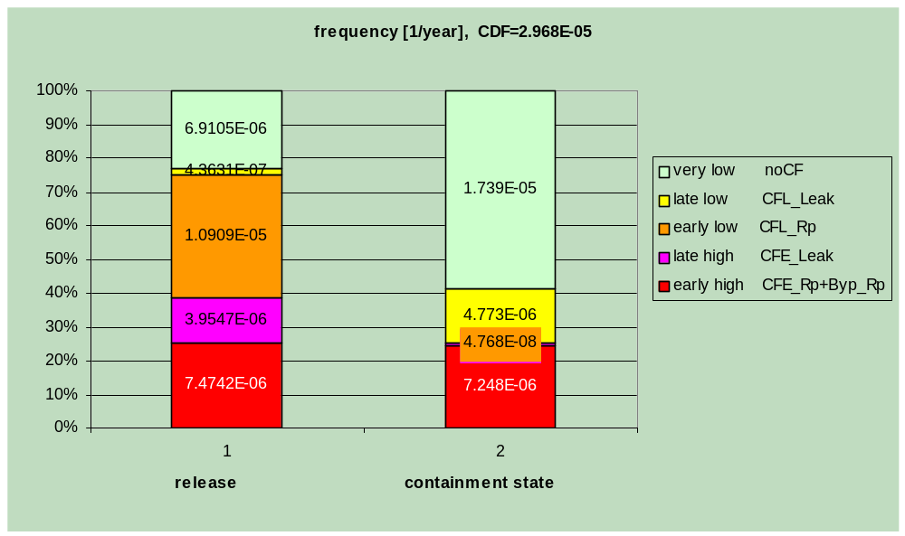
Figure 4 Release classes and containment failure, case without PTS
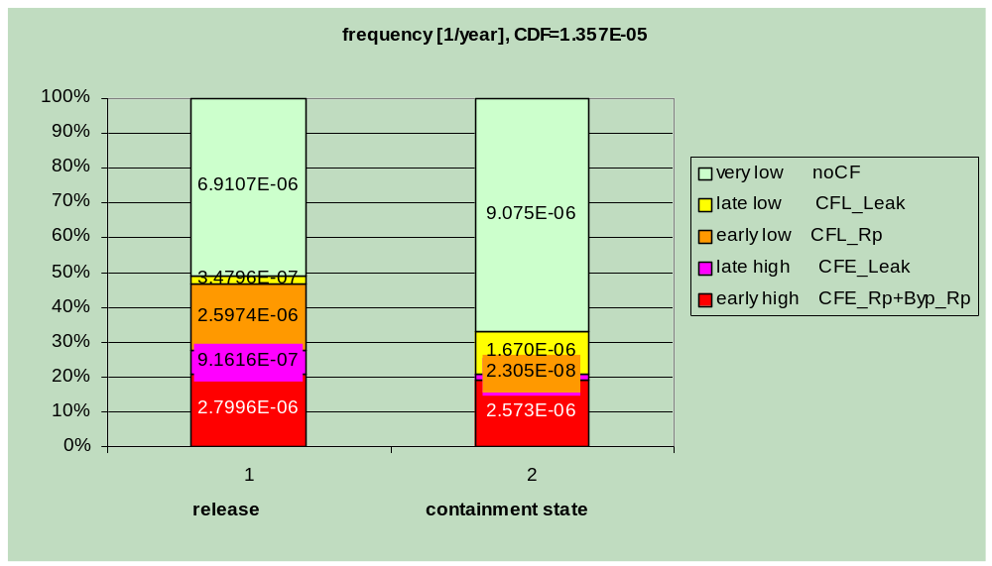

Table 3 Release classes for individual PDS vectors, case with PTS
PDS vector | Initiating event | frquency [1/year]
PDS vector | Initiating event | Early high | Late high | Early low | Late low | Very low | Total (=CDF)
8 | RPV-PTS | 4.497E-06 | 2.923E-06 | 7.996E-06 | 8.500E-08 | 0.000E+00 | 1.550E-05
9 | RPV-PTS | 1.739E-07 | 1.130E-07 | 3.091E-07 | 3.287E-09 | 0.000E+00 | 5.993E-07
11 | IL/RCP | 4.210E-07 | 2.653E-07 | 7.258E-07 | 7.716E-09 | 0.000E+00 | 1.420E-06
18 | IL/POOL | 2.057E-07 | 1.433E-07 | 3.810E-07 | 0.000E+00 | 0.000E+00 | 7.300E-07
19 | SGCB | 1.900E-07 | 0.000E+00 | 0.000E+00 | 0.000E+00 | 0.000E+00 | 1.900E-07
23 | SB-OUT | 2.836E-07 | 1.731E-09 | 1.852E-09 | 8.776E-08 | 3.475E-06 | 3.850E-06
24 | SB-OUT | 2.336E-07 | 1.360E-07 | 3.679E-07 | 2.460E-09 | 0.000E+00 | 7.399E-07
28 | TRANS | 1.208E-07 | 7.372E-10 | 7.890E-10 | 3.739E-08 | 1.480E-06 | 1.640E-06
29 | TRANS | 1.200E-07 | 6.983E-08 | 1.890E-07 | 1.264E-09 | 0.000E+00 | 3.800E-07
33 | SBO | 3.774E-07 | 1.101E-07 | 4.202E-07 | 1.987E-07 | 6.935E-07 | 1.800E-06
34 | SBO | 3.800E-07 | 0.000E+00 | 0.000E+00 | 0.000E+00 | 0.000E+00 | 3.800E-07

Other characteristics showed that we usually meet low pressure sequences – the pressure at the vessel failure was lower (medium low below accumulator injection 3.6 MPa or low below low pressure ECC injection 0.8 MPa) in 91.81 % of CDF for the case with PTS and 82.79 % for the case without. This is connected with the fact that primary system depressurisation is assumed already in EOP and with the property of PTS which always depressurises the primary system. The case without vessel bottom head failure represented about 20 % for the case with PTS and almost 40 % without PTS and roughly coincided with accident progression terminated after limited core damage. Again, this is influenced by the fact that the scenarios with water loss like PTS cannot be recovered and always lead to vessel bottom head failure.

Table 4 Containment failure modes percentage, case with PTS
 | Percentage of CDF [%]
 | Total for given event | Leading to containment failure | Reason of containment failure
Initial containment isolation failure | 23.48 | 2.378 | 2.378
Irreversible failure included in E_Rp (see 5) | 1.280 | 1.280 | 1.280
Early_Byp_Rupture |  |  | 0.642
1. SG collector lift off | 0.724 | 0.640 | 0.640
2. Induced multiple SG tube failure | 0.002 | 0.002 | 0.002
Early_Rupture without E_Bypass_Rupture |  |  | 23.78
3. Hydrogen detonation during the in-vessel phase | 0.455 | 0.455 | 0.455
4. Hydrogen deflagration during the in-vessel phase | 88.98 | 11.88 | 11.88
5. Isolation failure | 1.280 | 1.280 | 0.513
6. In-vessel steam explosion | 0.735 | 0.007 | 0.006
7. Ex-vessel steam explosion | 10.43 | 10.43 | ?
8. Cavity failure due to gases overpressure at vessel failure | 1.369 | 1.369 | ?
9. Debris contact with the cavity door | 81.86* | 0.758 | ?
Sum 7+8+9 |  | 12.30 | 10.47
10. DCH without (7+8+9) | 0.021 | ? | ?
11. Hydrogen detonation at vessel bottom head failure | 0.003 | 0.003 | ?
Sum 10+11 |  | 0.005 | 0.005
12. Vessel rocket causing containment failure | 0.033 | 0.033 | 0.0001
13. Cavity door failure shortly after vessel failure | 0.01 | 0.01 | 0.001
Early_Leak |  |  | 0.774
14. Containment isolation failure | 22.20 | 1.098 | 0.160
15. Early small bypass (= SG tube rupture) | 0.372 | 0.372 | 0.372
16. Cavity door leak shortly after vessel failure | 0.508 | 0.508 | 0.242
Late_Rupture |  |  | 0.160
17. Hydrogen detonation during the ex-vessel phase | 0.046 | 0.042 | 0.042
18. Hydrogen deflagration during the ex-vessel phase | 54.27 | 0.118 | 0.118
19. Cavity door failure late (thermal effects) | ? | 6*10⁻⁴ | 6*10⁻⁴
Late_Leak |  |  | 16.08
20. Cavity door leak late after vessel failure | ? | 13.05 | 12.54
21. Cavity basemat meltthrough | 3.844 | 3.844 | 2.672
22. Containment failure due to gases overpressure | 41.90** | 3.716 | 0.868
No containment failure |  |  | 58.62
* frequency of debris in cavity
** possibility of reaching overpressure

An interesting picture of reasons of different containment failure types is given in tab.4 for the case with PTS. It indicates hydrogen deflagration as the main risk of containment early rupture, followed by cavity phenomena where steam explosion is prevailing. SG collector lift off and containment isolation failure have also probabilities that are worth to mention. SG tube break and cavity door early leak due to thermal effects contribute to containment early leak. Late containment rupture is caused again by hydrogen deflagration mainly, but its probability is much less than that of early rupture. Thermal effects on the cavity door are also the main reason of containment late leak, which is more frequent than the early leak.
The picture changes in some points if we exclude PTS. The early containment rupture dropped to 17.56 %. This is caused by the fraction of CDF of both hydrogen burn and the steam explosion in the cavity dropping to 6.71 % and 6.18 % respectively (in the second case the number is “leading to containment failure”, not the exact reason of it). On the other hand, early containment leak slightly increased, from 0.77 % to 1.69 %, partly due to thermal effects on the cavity door shortly after vessel failure.

Sensitivity studies
Sensitivity studies were performed in all three revisions of the PSA 2. Their importance arises from the fact that they were the only method of treating uncertainties. In revision zero, 23 such studies were performed [1]. They were oriented both to showing importance of some phenomena like steam explosions and to accident management measures like external vessel cooling or hydrogen ignition at low concentration. The accident management measures study was rather simplified, because only changes in basic events were performed.
During the first revision, the sensitivity studies were oriented solely to quantify the efficiency of preventive measures and accident management. Unfortunately, this revision included only partially the new EOPs which were under development at that time, so the use of the results at present is limited.
For the study of preventive measures efficiency, the results were sorted according to PDS vectors like in tab.3. It can be also seen from this table that each PDS vector has a specific release spectrum. Preventive measures change the probability of individual PDS vectors and their efficiency in terms of reducing risk can be calculated from the table without recalculating the event tree. Often, the preventive measures had higher effect on CDF as found in PSA 1 than on the early high release. Those that had highest positive effect on both decreasing CDF and decreasing early high release were modifications of emergency feedwater and protection of steam lines against pipe whip, both leading to lower frequency of feedwater loss.
The efficiency of accident management measures was studied by modifying the event tree, its recalculation and comparison of the results with those for the base case. The modifications included re-specification of some basic events, but also changes in the tree logic. Following accident management measures were analyzed:
    - primary system depressurisation by operator,
    - thermal protection of cavity door,
    - insuring leak tightness of the room outside the cavity door,
    - cavity flooding and external vessel cooling,
    - hydrogen management,
    - measures to stop or reduce containment bypass and isolation failure,
    - start of sprays when they are not started automatically,
    - additional spray system or spray water source,
    - filtered venting to reduce containment natural leak,
    - flooding of debris in the cavity.
As the most efficient measure in decreasing high release, external vessel cooling 4) was identified followed by primary depressurisation 1). Measure 9) is inefficient and was rejected together with 2), where 3) or 4) were found more efficient. Combination of several measures, like 1) + 3) + 5) + 7) together with prevention of primary and ECC water loss through the MCP room appeared to be more efficient than the measure 4) alone. Measures 1), 7) were fully and measures 5), 6) and 10) partly (i.e. without a special supporting equipment) included into the Severe Accident Management Guidelines being introduced at the plant in 2004.
In the second revision, due to time and resources limitations, also the sensitivity studies were limited. We had to rely partly on the results of sensitivity studies from the previous revisions. Few basic studies have been performed, though:
- case without RPV-PTS (mentioned before)
- case without RPV-PTS and without IL/RCP with coolant loss outside the main sump
- primary system depressurisation in SAMG
- higher probability of hydrogen early ignition as in the previous revisions
- higher hydrogen source
- lower containment strength
- lower containment strength and higher hydrogen source
- lower steam explosion probability in the cavity.
The first two cases had to reflect the expected decrease in PTS frequency and the prepared technical modification of the drainage system. In the second sensitivity study, the CDF was 1.19∗10⁻⁵/year and the risk spectrum was more favourable than that shown in fig.4, the LERF dropped to 2.30∗10⁻⁶/year.
The primary depressurisation study showed very small efficiency of this measure, this is partly connected with its including into EOP and partly with the pressure spectrum of accidents studied including RPV-PTS which is always a low pressure accident and represents 54 % of CDF.
When using high frequency of hydrogen early ignition and diffusion burn we get similarly low risk of hydrogen, this sensitivity study had to confirm the main reason of the increase of hydrogen risk between revisions. Indeed, the risk of early hydrogen deflagration or detonation dropped from almost 12 % to 4 %.
There are indications that the in-vessel source of hydrogen obtained from MELCOR 1.8.3 calculations, corresponding to about 35 % of oxidation of all Zr in cladding and canisters was underestimated. The present results with MELCOR 1.8.5 indicate rather twice higher oxidation and hydrogen production. The sensitivity study with increased hydrogen source showed the high risk sensitivity on this parameter. The LERF increased from 7.47∗10⁻⁶ to 1.53∗10⁻⁵ 1/year and exceeded 50 % of CDF, the same happened to containment early rupture.
Besides of hydrogen production, the estimate of containment strength might have been also too optimistic. When using the more recent data for containment strength [11] and constructing new containment fragility curve, we got almost the same increase of risk as that caused by higher hydrogen source. When both higher in-vessel hydrogen production and lower containment strength were combined, the LERF and early containment rupture probabilities reached about 69 % of CDF. Early containment rupture due to hydrogen masks most of other modes of containment failure and becomes practically the only important phenomena leading to LERF. Intact containment represents still more than 25 % and very low release more than 20 % of CDF. Recent MELCOR 1.8.5 results, however, cast some doubt on the method used to asses the hydrogen risk in PSA 2 as is discussed in the accident management chapter.
The last sensitivity study was dealing with steam explosion in the reactor cavity. Its contribution is high as we can see in table 4, because of the assumption of its high probability in case that the conditions are favourable for it, i.e. high molten fraction in the corium and, of course, presence of larger amount of water in the cavity. In such case, its probability was estimated 0.5, because it is totally uncertain. For the case of low molten fraction, the probability was estimated 0.1. These probabilities are also the probabilities of cavity wall (and thus containment) failure due to steam explosion. The sensitivity study demonstrated that decreasing these probabilities to 0.1 and 0.01 respectively would decrease the LERF to 5.41∗10⁻⁶ and the probability of destructive steam explosion from 10.43 % (table 4) to 1.41 % of CDF. The gain in LERF is much smaller than that in cavity failure due to steam explosion because other phenomena of cavity or cavity door failure was masked by steam explosion. We plan to look at the steam explosion in the cavity in detail in the future and hope to decrease the probabilities even below 0.1 and 0.01. This might seem useless in the light of the fact that the cases with water in the cavity strongly decrease after the plant modification and PSA revision in the near future. The reason for studying steam explosion is the decision to use intentional cavity flooding to protect the cavity door and the idea to use it also for external vessel cooling.
The general conclusion from the sensitivity studies is the relatively low sensitivity of the main plant risks – hydrogen and cavity or cavity door failure on the plant modifications and changes of EOP. The hydrogen risk is relatively independent on accident scenario (high pressure, low pressure) and its decreasing will require specific equipment (such as igniters) and procedures. The cavity and cavity door failure is a physically complex problem. The plant modification and change of procedures often changes dramatically the impact of one phenomenon, but the whole risk does not change so much. Probably easiest way to decrease the risk would be an attempt to refine the estimate of steam explosion and, if it is much lower, follow the path of intentional cavity flooding to reduce the risk of thermal door attack. In any case, avoiding high pressure vessel bottom head failure is mandatory to rule out the phenomena connected with it, especially cavity pressurization by steam generated by high pressure melt ejection into water.

Accident management
The Dukovany plant concentrated in the previous years on severe accident prevention. This included hardware changes like that preventing ECC tank overflow, which was the dominant contributor to CDF in the revision zero PSA 2. It also included new EOP procedures that e.g. assured low probability of high pressure scenarios.
The plant modifications are not finished yet and some planned in the near future can strongly change the spectrum of PDS vectors comparing to that described here. It seems also realistic to reach CDF below 10⁻⁵/y. The main changes of this kind is the change of pump motor room drainage which eliminates the second most frequent reason for ECC water loss (the first being the RPV-PTS failure). Another change in cavity drainage should insure dry cavity in all other cases of ECC water loss except PTS failure or sump overflow. To follow the idea of ECC water loss, another technical solution would be needed, to prevent ECC water loss in case of RPV-PTS failure. It would be technically more complicated and there may be a request to use the same modification also for cavity flooding, so it has not been decided yet.
Other important modifications introduced recently are the procedure of gravitational filling of steam generators and modification of emergency feedwater line enabling the use of mobile fire pumps to supply emergency feedwater. They most probably strongly decrease the CDF of blackout sequences comparing to table 1.
Severe accident management started later than prevention. WOG generic severe accident management guidelines (SAMG) have been modified to VVER-440/213 specifics. The first version was finished in 2003 and is being introduced at the plant. It relies on the plant equipment available at present. The need to introduce specific equipment or modifying the existing one is felt especially in the areas identified as risk dominant – hydrogen management and protection against cavity or cavity door failure.
Before speaking about individual accident management measures, it is worth to remember that they can be divided according to the defence in depth concept into 3 levels:
- level 1 measures to restore cooling and recover the accident shortly after core damage,
- level 2 measures to prevent the containment failure,
- level 3 measures to mitigate releases if the containment failed or is bypassed.
It is a good strategy to prepare specific measures for all three levels realising that generally their efficiency versus cost drops from level 1 to level 3. An exception from this rule is the mitigation of containment bypass. For VVER-440 design with relatively high containment leak, measures of level 3 also reduce the natural leak from the intact containment.
Concerning level 1 measures, the currently planned plant configuration and SAMG seem (still some details should be analysed) well equilibrated and no special need is felt. The exception is the need to prevent ECC water loss from the reactor cavity and ensure its return to the main sump, which was discussed above in connection with preventive measures. Its function may depend on the size of vessel break after PTS. For large sizes, limited core damage may not be prevented and then it becomes level 1 instead of preventive measure. The need for this measure, however, strongly depends on the probability of vessel failure due to PTS. If this probability would be finally found e.g. two orders lower than the total CDF, it may become questionable.
From level 2 measures, hydrogen management is of highest importance. At present, the plant is equipped with passive autocatalytic recombiners (PAR) that were designed for design bases accidents and cannot cope with the hydrogen generated during severe accident. The recent analyses of severe accidents confirm the findings of PHARE 2.07 [12] that extremely large PAR capacity would be needed to reach a very low level of risk and that igniters offer better solution. A project partially financed by the government is being prepared in UJV for the plant, with the target to optimize the design of such igniter system. The final proposal may also include extension of existing PAR and modification of present spray system, depending on the result of analyses. At present we rely for atmosphere de-inerting on existing SAMG where the present spray system with the possibility of using water reserves from another unit or using containment ventilation systems is foreseen.
The first MELCOR 1.8.5 analyses provide somewhat controversial results concerning the hydrogen risk. It we use MELCOR default value for spontaneous hydrogen ignition at 10 % of its molar fraction in atmosphere and a somewhat finer, but reasonable, containment meshing, we get many localized hydrogen deflagrations during the in-vessel phase resulting in very small pressure peaks of the order of tens of kPa. At the first sight, hydrogen does not pose any threat to the containment integrity even without special igniters. The conclusion from these results may be opposite. The results depend on somewhat optimistic assumption about spontaneous ignition, but give a good prospect on solving the hydrogen problem using deliberate ignition by igniters and controlled combustion. In any case, re-evaluation of the hydrogen risk in PSA 2 will be needed.
The problem of protecting the cavity or cavity door against failure is more complex than the hydrogen problem. In any case, it will require some plant modification, but its type and extent is less clear than in the case of hydrogen. The decision is also connected with the idea of arresting the debris in-vessel by external vessel cooling, because if this option is taken and high credibility is given to its success, no need for additional cavity protection exists. The in-vessel cooling has been already implemented at the Loviisa plant [13] with similar reactor and cavity. Ventilation lines are used to flood the cavity. The need for cavity isolation against loss of water to the ventilation centre did not exist at Loviisa where the ventilation centre is located at higher level. Still the need to remove vessel lower head insulation and shielding rings existing also at Dukovany had to be solved. A hydraulic mechanism was used.
If the external vessel cooling is not accepted, the need to protect the cavity and cavity door becomes a necessity. There is practically no way to protect cavity against the pressure effects after high pressure vessel bottom head failure, this must be avoided by primary system depressurisation. Depressurisation is included in the present SAMG. To protect the door against thermal effects, preference is given to the “wet” way – using partial cavity flooding. PSA 2 results identify two threats to this approach. Because the cavity connections with the rest of the containment are narrow, there is a threat of cavity pressurization after intensive water boiling caused by molten debris ejection into the cavity. The primary pressure limit when it could happen is not certain, but it may be much lower than the primary pressure value to threaten cavity integrity due to gases expulsion. The latter is close to 10 MPa but can be lower if we account for fine dispersion of debris in the cavity atmosphere and DCH. The present target for primary depressurisation in SAMG is 1 MPa, it should be verified whether this is low enough to prevent fast steam generation after molten corium expulsion.
Even if primary system is fully depressurized, the problem of steam explosion in cavity remains. As mentioned before, the risk of steam explosion was estimated very high in PSA 2 which would make cavity flooding impractical. There are plans to decrease this risk estimate by more detailed analysis, splitting the problem into elementary events.
Other solutions have been considered to solve the problem of cavity door without using cavity flooding. In such case, the thermal attack on the door and its rubber seals becomes the main risk. In PSA 2, two solutions have been compared, a thermal shield of the door and making the room outside the door leaktight. The second option was found more promising, but was not accepted at the time being as it would complicate and possibly prolong plant shutdown operations. Later, the idea of much more simple but less efficient thermal shield attached directly to the door and foaming strips to replace the failed door seals was introduced and is still considered.
Besides of these needs of technical modifications covering the dominant risk areas as indicated by PSA 2, there are two others. One of them would be desirable for containment bypass sequences, namely those caused by primary to secondary leak, which, according to PSA 1, represent practically the only possibility for bypass sequences. Other types of bypass sequences, like those through water makeup or ECC systems have a very low frequency and were screened out of PDS vectors in table 1. Even the primary to secondary bypass sequences contribute to CDF by only about 1 %, but end always with high early release which was confirmed by MELCOR 1.8.3 analyses in the EU 5th Framework SGTR project [14] and recently by MELCOR 1.8.5. All the types of bypass leaks are covered in present SAMG, but specific case has been found for one type of SG collector break where only one action mentioned in SAMG seemed practical to avert a major release.
The other need is concerning control room habitability in the conditions of a severe accident. Initial study was prepared in this area, where important points were identified. There are plans for plant modification in this respect. One of the problems is the close location of the control room to the containment.
Besides of the issues discussed here, other seem according to PSA results unimportant or well covered by the new SAMG. An example of an issue covered by SAMG is the possible failure of containment isolation.

Conclusions and plans for the near future
The limited scope level 2 PSA proved to be an efficient tool for the assessment of the risk connected with severe accidents and radioactivity release, especially when comparing the importance of individual phenomena. This also helps in accident management development. Some conclusions related to accident management have been described.
Due to limited capacity, we do not expect revision of the existing PSA 2 scope before 2006. The new SAMG should be reflected in this revision. No plans exist for the full scope PSA 2 at present except extension the shutdown PSA to the Level 2 domain. Within a project dealing with severe accidents, in 2004, MELCOR 1.8.5 analyses of selected plant sequences will be finished. They will also include first assessment of the new SAMG. Other important results in this project should include more realistic information about retention of fission products transported by the containment natural leak. At present, all leaks through the containment wall are assumed as unmitigated and going directly to the environment. In the same project, information about the containment strength will be obtained. All this information will be important for future PSA 2.
In projects directly linked to PSA 2, closer link between level 1 and 2 PSA is prepared with the aim to use it in plant safety monitor for maintenance planning. Extension of shutdown PSA to Level 2 domain is also expected to start soon.

List of acronyms
AC … Alternating Current
AICC … Adiabatic-Isochoric Complete Combustion
APET … Accident Progression Event Tree
ATWS … Anticipated Transients Without SCRAM
CCI … Corium Concrete Interaction
CDF … Core Damage Frequency
DCH … Direct Containment Heating
DOE … US Department of Energy
ECC … Emergency Core Cooling
EOP … Emergency Operating Procedures
IL/RCP … Interfacing LOCA through Reactor Coolant Pump seals
IPE … Individual Plant Examination
LERF … Large Early Release Fraction, used to denote high early release as defined here
MCP … Main Circulator Pump
NPP … Nuclear Power Plant
PDS … Plant Damage State
PTS … see RPV-PTS
RPV-PTS … Reactor Vessel Pressurised Thermal Shock, assumed to possibly lead to vessel failure
SAMG … Severe Accident Management Guidelines
SBO … Station Blackout
SG … Steam Generator
SGTR … Steam Generator Tube Rupture
SGCB … Steam Generator primary Collector Break and lift-off
WOG … Westinghouse Owners Group

References
[1] D.R. Bradley, S.D. Clement, W.J. Puglia, J. Dienstbier, A. Rydl : NPP Dukovany VVER/440 V213 Unit 1. Probabilistic Safety Assessment Level 2 : Containment Performance. Vol. 1, 2. SAIC-98/2647. April 1998.
[2] J. Dienstbier, A. Rydl, S Hustak : Measures to reduce the risk and consequences of severe accidents for the Unit 1 of EDU (in Czech). Final report. UJV Z-372-T, December 1998.
[3] J. Dienstbier, B. Kujal : Probabilistic Safety Assessment for NPP Dukovany. Level 2 Severe accidents. Revision 2 (in Czech). UJV Z-903-T. October 2002.
[4] US NRC : Individual Plant Examination: Submittal Guidance. Final Report. NUREG-1335. August 1989.
[5] R.M. Summers et al. : MELCOR Computer Code Manuals. Version 1.8.3. Vol.1 Primer and User’s Guide. Vol.2 Reference Manuals. NUREG/CR-6119. SAND93-2185. September 1994.
[6] J.M. Griesmeyer, L.N. Smith : A Reference Manual for the Event Progression Analysis Code (EVNTRE). NUREG/CR-5174. SAND88-1607. September 1989.
[7] Severe Accident Risks: An Assessment for Five U.S. Nuclear Power Plants. NUREG-1150. U.S. Nuclear Regulatory Commission, June 1989.
[8] Department of Energy’s Team’s Analyses of Soviet Designed VVERs. DOE/NE-0086 Rev.1 September 1989.
[9] PHARE 4.2.7.a/93 VVER 440-213 BDB Accident Analysis and Accident Management. Analysis of BDBA and Severe Accidents Without Operator Actions. WENX-97-25. September 1997.
[10] M.L. Ang, W. Frid, E.J. Kersting, H-G. Friederichs, R.Y. Lee, A. Meyer-Heine, D.A. Powers, K. Soda, D. Sweet : A Comparison of World-Wide Uses of Severe Reactor Accident Source Terms. SAND94-2157. UC-523. September 1994.
[11] B.W. Spencer, J.J. Sienicki, R.F. Kulak, P.A. Pfeiffer, L. Vöröss, Z Téchy, T. Katona : Evaluation of Containment Peak Pressure and Structural Response for a Large-Break LOCA in a VVER-440/213 NPP. Teplofyzika-98. Obninsk, May 26-29 1998.
[12] H. Mauersberger (editor): PHARE 94 Projects 2.06 (VVER-440/213. Analysis of the Need and Alternatives for Filtered Venting of Containment) and 2.07 (Hydrogen Control During Severe Accidents) Final Report and Project Summary. WENX-99-19. April 1999.
[13] P. Lundstrom: Experience with Severe Accident Management Strategy Preparation, Development and Implementation at the Loviisa NPP in Finland. IAEA Workshop on Severe Accident Management, Ljubljana (Slovenia), 12-16 October 1998.
[14] J. Dienstbier, J. Duspiva : SGTR Scenarios Calculation results. SAM-SGTR-D002. September 2000.

