THERMODYNAMIC ANALYSIS FOR MOLTEN CORIUM STRATIFICATION USING
IONIC LIQUID DATABASE

FUKASAWA Masanori (1), TAMURA Shigeyuki (2) and HASEBE Mitsuhiro (3)
(1) Japan Nuclear Energy Safety Organization (JNES), Japan
(2) CRC Solutions Corporation, Japan
(3) Kyushu Institute of Technology, Japan

Abstract

A thermodynamic database using ionic sublattice model for liquid corium was developed and stratification of molten corium, supposed to occur in in-vessel retention accident management, was analyzed. The database consists of U-Zr-Fe-O-C-B-(FP Oxides) system. The most data are obtained from existing database, such as SGTE. Some lacking data were assessed to be consistent with existing phase diagrams. The liquid phase data were reconstructed based on ionic two-sublattice model for liquids. Liquidus temperatures, stratifications (phase separation by miscibility gap) and FP distributions of corium, which were tested under RASPLAV and MASCA projects, were analyzed. The results show these properties and phenomena are well analyzed with the database. Then, corium stratifications and the resultant decay heat fraction as well as the density (just estimating with density data of each component) of each layer, were calculated for various conditions.

Introduction

In-vessel retention (IVR) of molten corium (mixture of core materials; UO₂, Zr and ZrO₂) by external vessel cooling has been recognized as an effective accident management (AM) measure for a severe accident (SA) of a light water reactor. IVR has a possibility to arrest a severe accident inside the vessel and halt the accident progression. It would also eliminate the threads to containment integrity due to the ex-vessel phenomena.

Based on the experimental and analytical studies so far, IVR by external vessel cooling was accepted by regulatory authority as a major AM for Loviisa pressurized water reactor in Finland [1]. In the USA, the design of AP600, the advanced reactor with passive safety, also employs reactor ex-vessel flooding as an AM measure [2].

In these studies, heat transfer to the vessel from corium that is stratified into metal and oxide layers is one of keys for IVR possibility. The metal layer could focus heat transfer on its contact location with the vessel caused by its high thermal conductivity (focusing effect).

Recently RASPLAV project [3] demonstrated experimentally that material effects have a strong influence on the stratification of corium and, as a consequence, on the heat transfer to the surrounding structures under IVR. Furthermore, it has been observed in the frame of the MASCA project [4] that the addition of steel to U-Zr-O mixtures could result in a density inversion; the molten metal is stratified below the molten oxide. The possibility of the density inversion was also indicated previously [5] based on experimental data [6] that suggest some uranium will dissolve into unoxidized zirconium.

On the analytical side, thermodynamics based on its databases is effective to describe the corium stratification. However, no database has not been enough verified for the corium U-Zr-Fe-O system.

Thermodynamic database development

Thermodynamic corium database using ionic sublattice model for liquid was developed based on CALPHAD (Calculation of Phase Diagrams) method [7, 8]. Ionic sublattice models are physically more realistic than associate models and said to be effective especially for more than two component systems. The database consists of U-Zr-Fe-O-C-B-(FP Oxides) system. Thermodynamic data are mainly obtained from existing assessed database, however some lacking data were assessed here to be consistent with existing phase diagrams.

Liquid Model

Hillert’s ionic two-sublattice model for liquids [9] is used for the liquid phase. The model introduces negatively charged vacancies on the anion sublattice in order to deal with non-stoichiometric substances. Neutrals are also introduced on the anion sublattice. The sublattice formula of the model is written as;

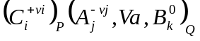 (1)
C: cations A: anions Va: vacancies B: neutrals v: charge of an ion
i, j, k: indices to denote specific constituents for cations, anions and neutrals
Q: average charge of cations (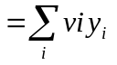) y: site fraction
P: average charge of anions including vacancies 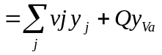

Here, the vacancies have an induced charge equal to -Q. These stoichiometric numbers, P and Q, calculated as average charges, maintain electro neutrality.

For simplicity, all the constituents in the anion sublattice are expressed as “j” and cations as “i”. Moreover, constituents are expressed with their charges. Then, the sublattice formula is written as follows;

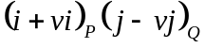 (2)

The integral Gibbs energy, G, is given by the sum of reference, ideal and excess energy terms.

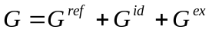 (3)

The reference term is given by summing the Gibbs energies of all the substances.

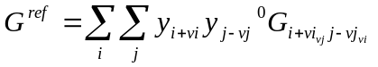 (4)
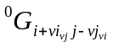: Gibbs energy of formation for the liquid substance, “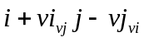”
(subscripts are stoichiometric number)

Here, when “j” comes to “Va”, the substance, which is expressed as “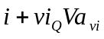” (charge of vacancies is not expressed), represents the pure metal of “i” constituent with Q moles. Then, 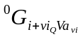 is expressed as 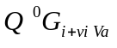, where 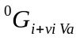 is the Gibbs energy of formation for 1 mole of metal “i”. The substance “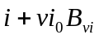” represents vi moles of just neutral “B”, as there is no site in cation sublattice. Then, 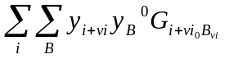is reduced to 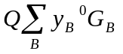, since 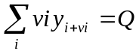.

The ideal term is the sum of mixing entropies in both the sublattices

(5)

The excess energy term is given with third power terms as follows;

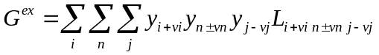 (6)
n: All the constituents in both the sublattices and its index
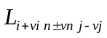: Interaction between constituents in the same sublattice, which is “n±vn” and “i+vi” or “j-vj”, with the other sublattice occupied by “j-vj” or “i+vi” respectively

When both “n” and “j” come to neutrals, summation of “i” is reduced because cations do not affect the interaction between neutrals. Then, 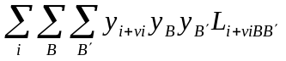 would be 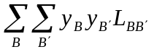. may be a constant or represented by a power series of the two site fractions in the same sublattice.

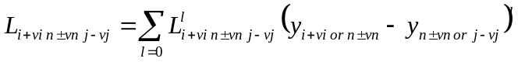 (7)
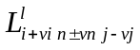: L parameter, which is usually a function of temperature and pressure

Liquid data

U-Zr-Fe-O-C-B system

The formulation of the liquid phase for U-Zr-Fe-O-C-B system is described as follows.
(8)
The Gibbs energies of the most substances were obtained from SGTE [10]. Zr-O and Fe-O system, including excess energies, were from Liang [11] and ION [12] database respectively. Excess energies between metals were mainly from Kurata’s data [13]. UO_{2.5} data and some excess energies were assessed in order to fit existing phase diagrams. Table 1 shows Gibbs energy parameters that we assessed. Table 2 shows references from which parameters were obtained for the ionic liquid phase of U-Zr-Fe-O-C-B system.

Table 1. Assessed parameters of excess energy for ionic liquid phase

Parameter | Value | Fitting points
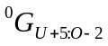 * | 2*(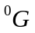 of FCC_UO₂) + 204000-200*T | Liquid line (hyper oxidation region) of U-O phase diagram [14]
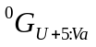 | ( of Orthorhombic_U) + 100000 | ”
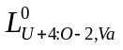 | 251417.773 | Liquid line and eutectic point of U-O phase diagram [14]
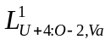 | -86324.2375 | ”
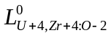 | 101379.025-62.1300584*T | Liquid line of UO₂-ZrO₂ pseudo phase diagram [15]
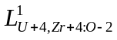 | -10534.1228 | ”
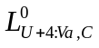 | 786377.30-3337.1786*T  +373.990429*T*LN(T) | Liquid line and eutectic point of U-C phase diagram [16]
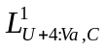 | -169886.529+85.0505095*T | ”
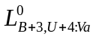 | -174689.372+26.4107657*T | Liquid line and eutectic point of U-B phase diagram [16]
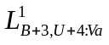 | -303802.939+101.035339*T | ”
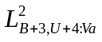 | -38805.1113-31.3588198*T | ”
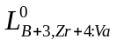 | -229083.942+22.9546222*T | Liquid line and eutectic point of Zr-B phase diagram [16]
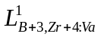 | -57294.2650 | ”
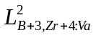 | -31055.5031+25.0330155*T | ”
*: The expression of subscription is modified from the previous section. Colons and commas are introduced between sublatices and constituents in the same sublattice respectively. Moreover, in case of the interaction between cations, the first and second constituent in the subscription are cations.

Table 2. Referenced data used for the database

System | Referenced data | Reference
Gibbs energy for substances | SGTE database | [10]
Excess energies
Fe-U-Zr | Kurata | [13]
Zr-O | Liang | [11]
Fe-O | KTH ION database | [12]
Zr-C | Guillermet | [17]
B-Fe | Li-Mei Pan | Private communication
B-C | Furukawa and Hasebe | Provisional

FP data

For FPs, interactions mainly with Oxygen are included in the database. Our main interest is in the partitioning of FPs between the oxide and metal phases, when molten corium is stratified. The amount of each FP is less than 1 mole% of the corium in SA conditions. Therefore, the interactions between FPs and Oxygen are thought to be enough for our corium database.

Ce, Ru, La, Sr, Ba, Nb and Mo are included in the database as FPs (Nb is not included in MASCA tests). They were selected as their various oxygen affinity, or Gibbs energies of formation for oxides per one mole of oxygen. Ce and La have strong oxygen affinity, on the other hand, Ru doesn’t. BaO has similar Gibbs energy of formation with UO₂ and ZrO₂. Oxides of Mo and Nb have less Gibbs energies of formation than Ba’s, and their chemical states are often used as indicators for the oxygen potential of a corium. Figure 1 shows decay heat fractions of dominant non-volatile FPs and their oxygen affinities [18].

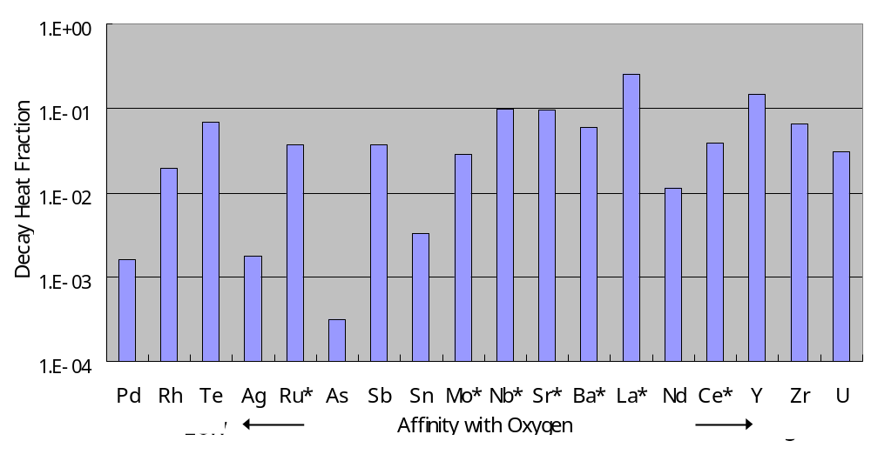
*: FPs included in the database

Figure 1. Decay heat fractions of dominant non-volatile FPs and their oxygen affinities

Comparisons with existing phase diagrams

Figures 2 and 3 show calculated phase diagrams and existing ones of U-O, UO₂-ZrO₂, U-Zr-O and Zr-B systems. Though, fitting at the low temperature of the UO₂-ZrO₂ system is not good enough, liquid and solid lines are well fitted. Then, our database is thought to be well assessed for thermodynamic analyses of corium melts.

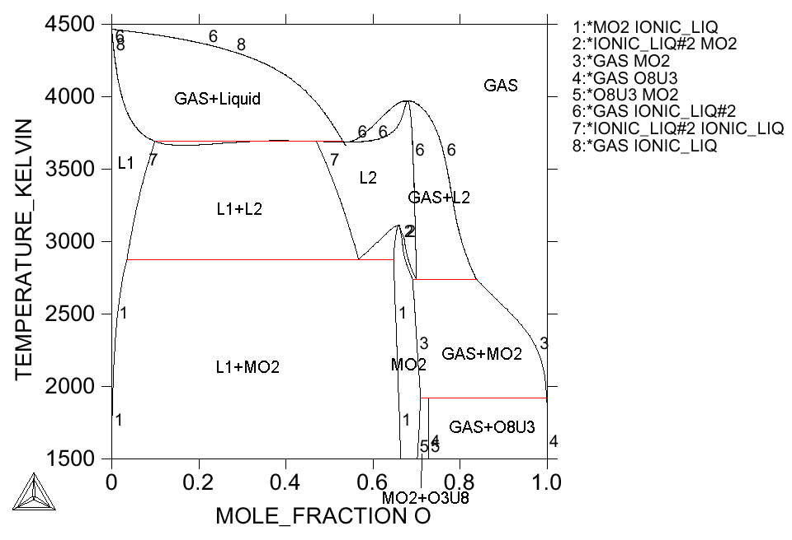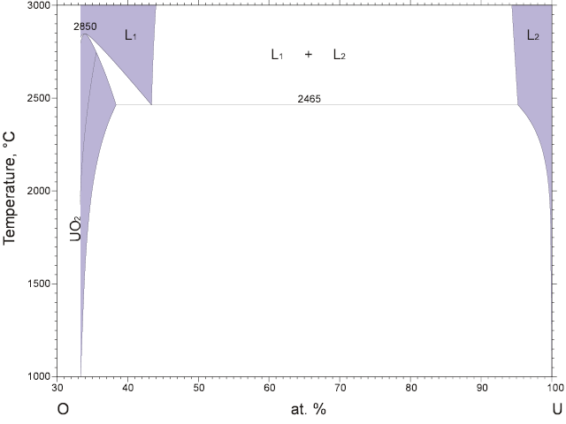
(a) Present calculation
(b) U-O binary phase diagram (ASM)
Figure 2. Comparison of U-O phase diagrams

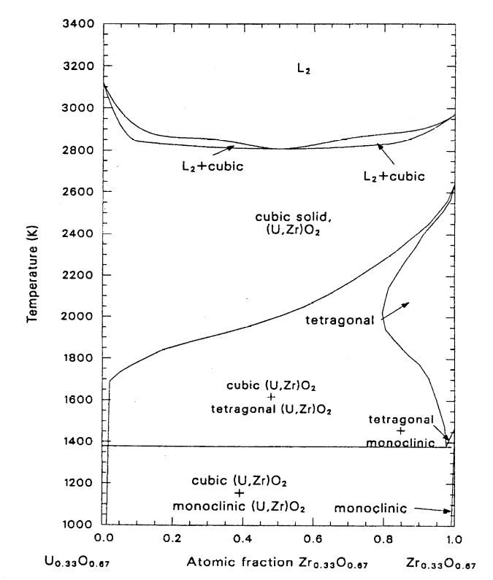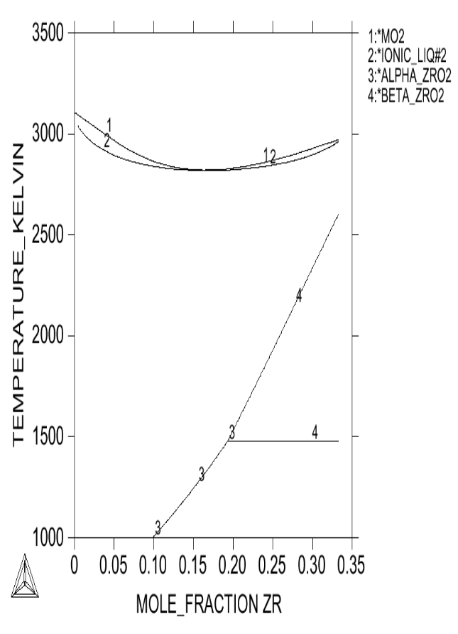
(b) UO₂－ZrO₂ pseudo-binary phase diagram (Romberger)
Figure 3. Comparison of UO₂-ZrO₂ phase diagramms
Mole fraction of Zr in (U,Zr)O₂
(a) Present calculation

MASCA/RASPLAV test analysis

MASCA and RASPLAV tests were analyzed with our database and thermodynamic equilibrium code, Thermo-Calc [19], to confirm the validity of the database.

Stratification (MA tests)

MASCA MA series were placed as medium scaled prototypic tests to examine the corium stratification. About 2 kg of U-Zr-O corium with SS and FP simulant for some cases were melted with the cold crucible.

Figure 4 shows analytical results compared with MA-1 test, in which 10wt% SS was added to C-32 (32% of Zr is oxidized) molten corium. Mass fractions of liquid oxide and metal phases as well as their compositions are well analyzed. In the test, uranium, which was originally a form of UO₂, was reduced and transferred into the metal phase. Then, the density of the metal phase became higher. The analysis also indicates this uranium transfer.

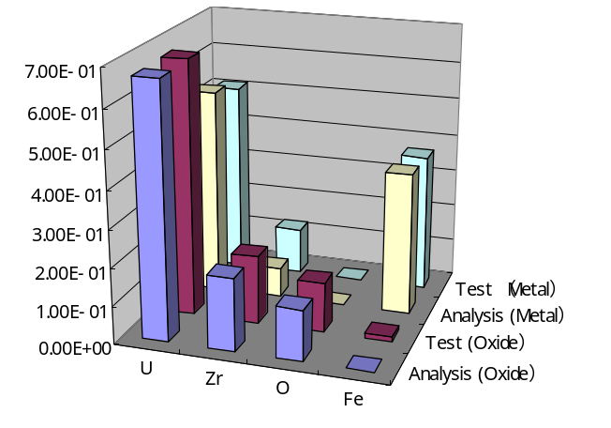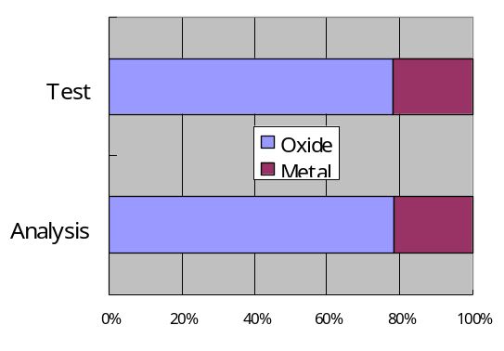
(b) Liquid phase composition（Mass fraction）
(a) Mass fraction of liquid phases
Figure 4. Comparisons of phase compositions (MA-1)

Figure 5 shows analytical results compared with MA-2, in which C-70 (70% of Zr is oxidezed) was melted. The decrease of U fraction in the metal phase, associated with the decrease of Zr metal is well analyzed.

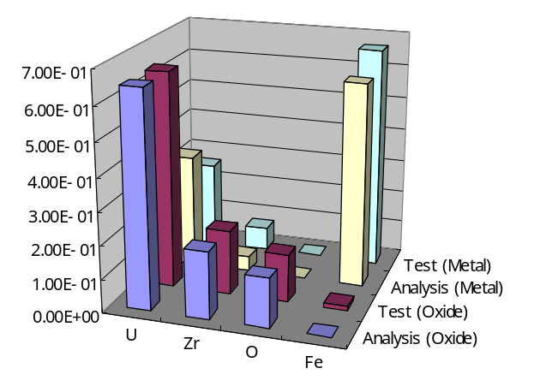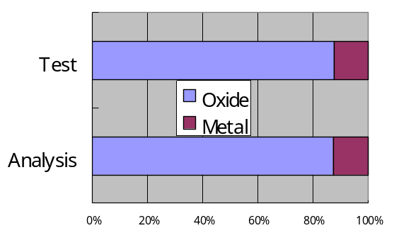
(b) Liquid phase composition（Mass fraction）
(a) Mass fraction of liquid phases
Figure 5. Comparisons of phase compositions (MA-2)

FP distribution

Figure 6 shows analytical and experimental results of FP distribution between oxide and metal phases (MA-3 test). Elements that have strong affinity with oxygen, such as La and Ce, are distributed in the oxide phase. Instead, elements with weak oxygen affinity are in the metal phase. As the figure shows, FP distribution is well analyzed. Therefore, considering only oxide interactions is verified for analyzing FP distribution in the stratified corium.
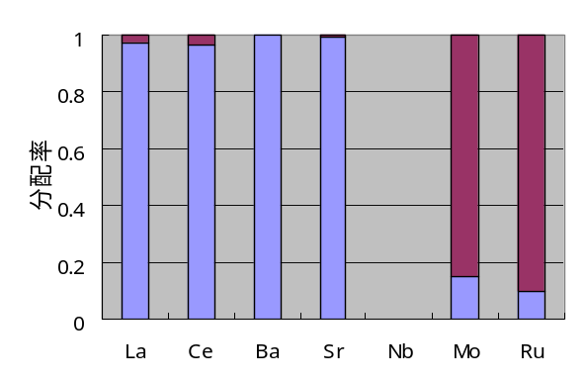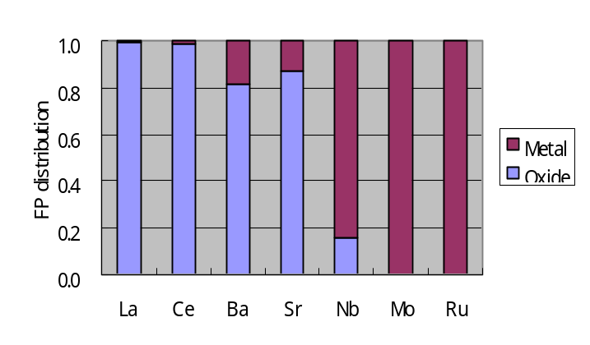
(Nb is not included in the test)
(a) Analysis
(b) Test
Figure 6. Comparison of FP distributions (MA-3)

Then, we can estimate the distributions of other FPs by considering oxygen affinities (Figure 1). For example, FPs that has lower oxygen affinity than Mo will transfer into the metal phase in this condition. Then, decay heat fractions of metal and oxide phases can be calculated.

B₄C effect

Figure 7 shows analytical and experimental results of B₄C effect on the stratification of corium with Fe (STFMB-3 and STFMFe-3 test). The metal phase is increased by adding B₄C in both the test and the analysis. Figure 8 shows calculated composition of each phase. When B₄C is added, most of B and C are included in the metal phase. Transfer of corium metal, especially Zr, to the metal phase is increased. Strong affinity of Zr with B mainly causes these phenomena. Further, calculated liquidus temperature of STFMB-3 corium is 40 K higher than the corium without B₄C. It is similar to the test result.
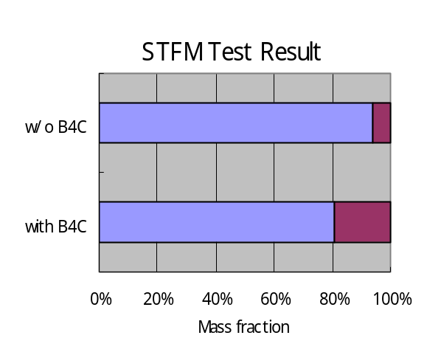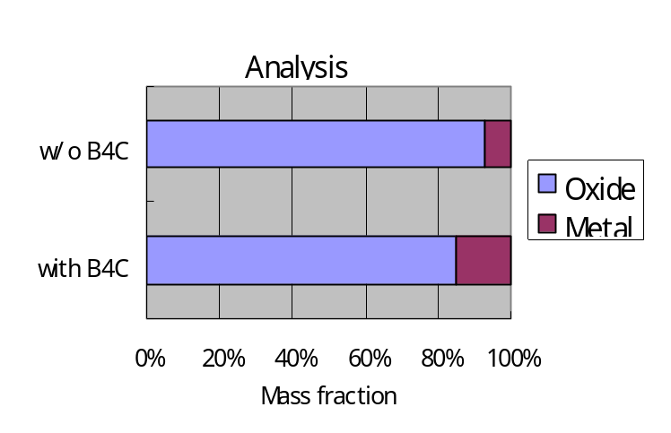
Figure 7. Comparison of liquid phase separation in corium test with B₄C
(a) Analysis
(b) Test

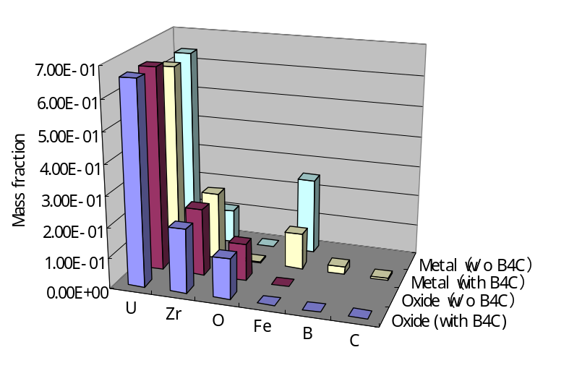
Figure 8. Comparison of calculated phase compositions in corium with and w/o B₄C

Liquidus temperature

Table 3 shows comparison of liquidus temperatures between tests and analyses. The test results of C-22, C-50 and C-100 corium are obtained in RASPLAV project [3], and that of C-32 corium is obtained from video observation during MASCA MA test. Our database predicts the test results within a few percent differences. Both the test and analysis show that the liquidus temperature of C-32 is lower than that of C-22. It comes from the higher Zr fraction of C-32 corium. The effect of Zr fraction increase exceeds the effect of Zr oxidation increase.

Table 3. Comparison of Liquidus temperature

Corium type | Composition (mol%) |  |  | U/Zr  (atomic) | Test（K） | Analysis（K）
Corium type | UO₂ | ZrO₂ | Zr | U/Zr  (atomic) | Test（K） | Analysis（K）
C-22 | 62.0 | 8.4 | 29.6 | 1.6 | 2680 | 2730
C-32 | 54.5 | 14.5 | 31.0 | 1.2 | 2653 | 2703
C-50 | 62.0 | 19.0 | 17.0 | 1.6 | 2760 | 2778
C-100 | 62.0 | 38.0 | 0.0 | 1.6 | 2840 | 2832

Analysis under various conditions

Corium stratification was analyzed under various conditions with the database in order to see the effect of some parameters. Here, U/Zr ratio was set to 0.8 atomic. This is typical for BWR and CANDU type reactors. Table 4 shows the other analytical conditions.

Table 4. Conditions of analysis for parameter effect

Parameter | Values
U/Zr ratio | 0.8 atomic
Zr oxidizing ratio | 32, 50, 70, 100% (expressed as ZrO2-32,-50, -70,-100)
Fe/(Corium+Fe) mass ratio | 10, 20, 50%
Temperature | ～Liquidus temperature

Figure 9 shows results of liquidus temperatures. The lower the oxidation ratio of Zr is, the lower the liquidus temperature will be, except for the ZrO2-100 with Fe 50%. Addition of Fe increases O fraction in oxide liquid phases that result in the increase of liquids temperature, but in the case of ZrO2-100, this effect does not work due to the saturated oxygen contents. In the case of higher Fe contents, the oxide liquid phase also includes some Fe that results in the decrease of liquids temperature.
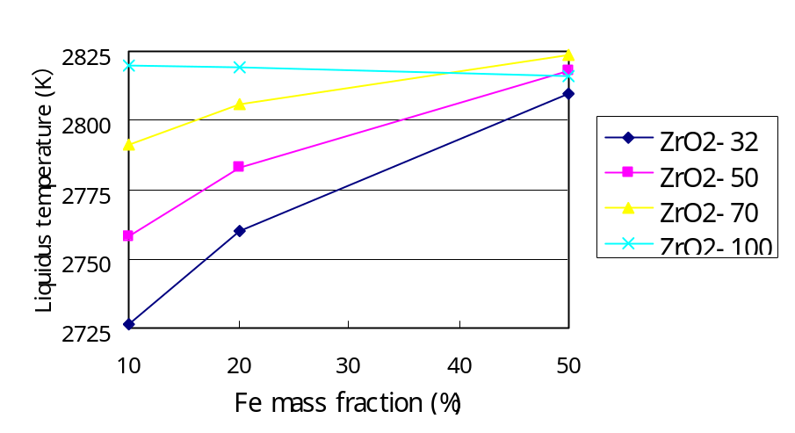
Figure 9. Liquidus temperature dependency on parameters

Figure 10 shows estimated densities of the metal phases at their liquidus temperatures of the corium. The density was estimated from the average of the specific volumes of the metal components weighted with their masses. The specific volumes and expansion coefficients of components were referred from MATPRO [20], INSC [21] and Metal Reference Book [22]. The density of oxide phase was also estimated with the same way. Since the compositions of the oxide phases in the calculations were almost constant, one horizontal line was depicted in this figure. This figure indicates that ZrO2-50 under 20 wt% Fe and ZrO2-32 under 30wt% Fe would be stratified with the metal phase being under the oxide phase.
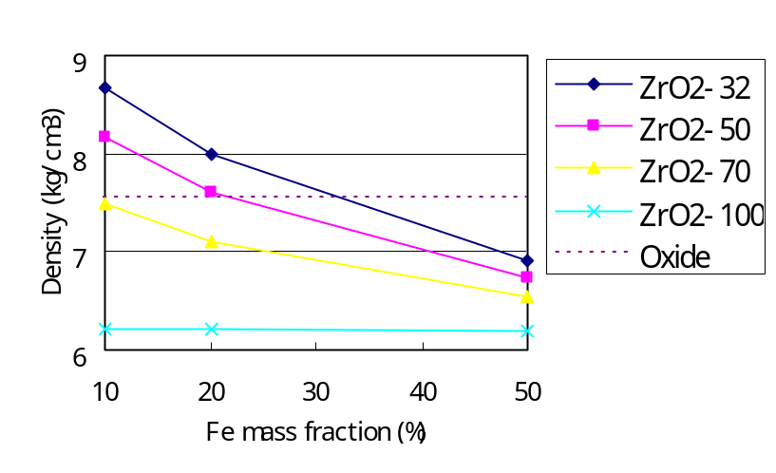
Figure 10. Density dependency on parameters of the phases

Figure 11 shows estimated decay heat fractions in the metal phase. The case ZrO2-32+B includes 1 wt% of B₄C in ZrO2-32 corium. FPs that are not included in our database were estimated by their oxygen affinity (Figure 1) and the fractions of the calculated FPs. This figure shows the higher the Fe fraction and the lower the Zr oxidation rate are, the higher the decay heat fraction in the metal will be. In the case that 1 wt% of B₄C is included, the decay heat in the metal increases about 10%

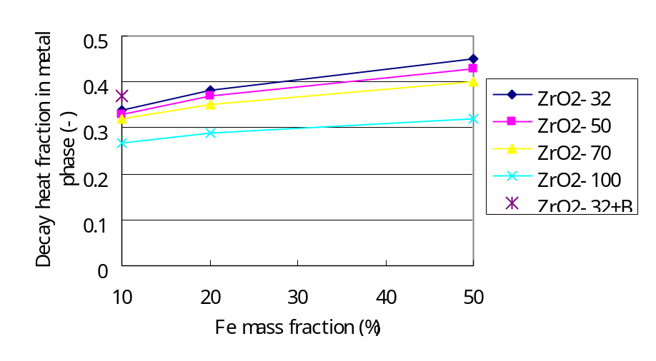
Figure 11. Decay heat fraction dependency on parameters

Conclusion

Thermodynamic database; U-Zr-Fe-O-C-B-(FP Oxides) system, using ionic sublattice model for liquid corium was developed. Data were mainly obtained from assessed databases, however some lacking data were assessed here to be consistent with existing phase diagrams.

Liquidus temperature, stratification into oxide and metal liquid layers (miscibility gap), mass and elemental composition of each layer, and FP distribution of corium were calculated and compared with tests of RASPLAV and MASCA projects. The comparison shows these parameters are well simulated and the validity of the database for analyzing the stratification of corium was confirmed.

Thermodynamic equilibrium analyses for U/Zr=0.8 corium shows that C-50 corium under 20 wt% Fe and C-32 under 30 wt% Fe would be stratified with the metal phase being under the oxide phase. In addition, the higher the Fe fraction and the lower the Zr oxidation rate are, the higher the decay heat fraction in the metal will be.

References

[1] O. Kymalainen, H. Tuomisto, T.G. Theofanous, “In-Vessel Retention of Corium at the Loviisa Plant”, Nuclear Engineering and Design, 169, (1997), pp.109-130.
[2] T.G. Theofanous, C. Liu, S. Additon, et al., “In-Vessel Coolability and Retention of a Core Melt”, DOE/ID-10460, November (1994).
[3] V. Asmolov, “Latest Findings of RASPLAV Project”, OECD/CSNI/NEA, Proceedings of Workshop on In-Vessel Core Debris Retention and coolability, Munich, Germany, 3-6 March, (1998), pp.89-110.
[4] S. Bechta and V. Asmolov, "Zr partitioning tests in the cold crucible test MA-1" OECD MASCA meeting, April 17-19, Helsinki, (2001).
[5] J.L. Rempe, D.L. Knudson et al., “Potential for In-Vessel Retention through Ex-Vessel Flooding”, OECD/CSNI/NEA, Proceedings of Workshop on In-Vessel Core Debris Retention and coolability, Munich, Germany, 3-6 March, (1998), pp.365-374.
[6] G.W. Parker and S.A. Hodge, “Small Scale BWR Core Debris Eutectics formation and Melting Experiment”, Nuclear Engineering and Design, 121, (1990), pp.341-347.
[7] N. Saunders and A.P. Miodownik, “CALPHAD”, Pergamon Press, (1998).
[8] S. Tamura and S. Minamoto, "Thermo-Calc, JMatPro and their applications.", Proceeding of 26th material seminar, Materials Science Society of Japan, (2002), pp.117-123.
[9] M. Hillert, B. Jansson, B. Sundman and J. Ågren, “A Two-sublattice Model for Molten Solutions with Different Tendency for Ionization”, Metall. Trans. A, 16A, (1985), pp.261-266.
[10] The SGTE Casebook: Thermodynamics at Work (ed. K. Hack), The Institute of Materials, London, (1996).
[11] P.Liang, N.Dupin, S.G.Fries, H.J.Seifert, I.Ansara, H.L., Likas and F.Aldinger, Z. Metallkd., 92(2001), pp 747-756.
[12] KTH IONIC Database for Thermo-Calc
[13] M.Kurata et al., “Thermodynamics assessment of the Fe-U, U-Zr and Fe-U-Zr systems,” J. Alloy Comp., Vol.271, (1998), pp 636-640.
[14] T.B. Massalski et al., Binary Alloy Phase Diagrams, 2nd Ed., ASM International, (1996).
[15] K.A.Romberger et al, “Phase Equilibrium Studies in the UO2-ZrO2 System,” Journal of Inorganic and Nuclear Chemistry, 29 (1966), pp.1619-1630.
[16] PaulingFile database; http://crystdb.nims.go.jp/
[17] A.F.Guillermet, J.Alloy comp., Vol.217, (1995), pp 69-89.
[18] D.A. Powers, “Thermochemistry of Core Debris: Partitioning of Uranium and Fission Products Among Condensed Core Debris Phases”, in RASPLAV Seminar 2000, Munich, Germany November 14-15, (2000).
[19] B.Sundman, B.Jansson and J.-O.Andersson,Calphad,Vol.9,(1985),pp153-190.
[20] C.M. Allison et al., “SCDAP/RELAP5/MOD3.1 Code Manual volume IV: MATPRO”, NUREG/CR-6150, (1993).
[21] INSC (International Nuclear Safety Center); http://www.insc.anl.gov/
[22] Metals Reference Book, 5th ed., Butterworths, (1976).

