AN EXPERIMENTAL AND THEORETICAL THERMODYNAMIC APPROACH TO STUDY THE MISCIBILITY GAP IN A U-Zr-O-Fe MODEL CORIUM

Christine Guéneau ª, Vincent Dauvois ^{b}, Philippe Pérodeaud ^{c}, Olivier Dugne ^{c}
ª DEN/DPC/SCP – CEA SACLAY 91191 Gif-sur-Yvette Cedex, France
^{b} DEN/DPC/SECR – CEA SACALY 91191 Gif-sur-Yvette Cedex, France
c DEN/DTEC/STCF – CEA VALRHO Pierrelatte Cedex, France

Abstract

Immiscibility in the liquid state is displayed experimentally in the quaternary system U-Zr-O-Fe. The model corium is melted at 3000+/-100 K by electron bombardment in the ISABEL1 device. A small content of yttrium is added to simulate a fission product. The analysis of the quenched microstructure of the ingot clearly shows the presence of an oxide rich liquid phase in the form of a layer at the ingot surface. The major metal rich liquid phase, heavier, is located in the bottom of the ingot in which some oxide liquid droplets are present. Post-mortem analyse of the ingot allow determining an experimental tieline in the miscibility gap. As expected, iron is located in the metallic phase and yttrium goes in the oxide liquid phase. Thermodynamic calculations are performed to prepare the experiment, interpret the quenched microstructure, estimate the final overall composition of the melt and finally verify the consistency of all experimental data.

1 - Introduction

To predict the heat transfer processes occuring in corium, the natures and relative fractions of solid and liquid phases must be known as a function of its composition and temperature. The U-Zr-O-Fe quaternary is the basic chemical system to simulate the in-vessel corium. As a considerable number of metal-oxide systems, the U-O and Fe-O binary systems exhibit a large miscibility gap in the liquid state. Two liquid phases coexist enriched respectively in metal and oxide. When both liquid densities are noticeably different, the melts can segregate in the form of layers. This phenomenon can change the heat transfer processes in the in-vessel corium. The aim of the present work is to study the extent of the miscibility gap in the U-Zr-O-Fe system by determining a tieline that gives the chemical compositions of both liquids at a fixed temperature.

To determine high temperature thermodynamic data on the U-Zr-O-Fe system, two experimental methods are used: i/ high temperature mass spectrometry to measure the activity of a constituent in a material mixture; ii/ electron bombardment melting / quenching tests to determine compositions of stable phases in equilibrium at a fixed temperature. The present experimental approach is systematically coupled with thermodynamic calculations. A database on the quaternary system is built by using the CALPHAD method. Thermodynamic calculations allow acquiring an analytical knowledge of both phase diagram and thermodynamic properties of the system, to check the consistency of literature’s data, to prepare the experiments by fixing for example the composition and temperature ranges, to interpret experimental results. Finally, by taking into account the new experimental data, the database is improved and can be used for application calculations.

The present paper will first deal with the extent of the miscibility gap in both U-UO₂ and U-Zr-O sub-systems on the basis of a previous work on these systems [1]. In the second part, the experimental results on the U-Zr-O-Fe system will be detailed. In the third part, some thermodynamic calculations will be presented. Finally, the whole experimental and theoritical work will be discussed.

2 – Miscibility gap in the U-Zr-O system

By convenience, “liquid 1” (L1) and “liquid 2” (L2) will designate respectively the metal and oxide rich liquid phases.

2-1 Binary system U-O

The U-UO₂ part of the phase diagram uranium-oxygen is presented in figure 1 [1].

Figure 1. Calculated phase diagram U-UO₂ with available experimental data [1]. Green lines correspond to the tielines in the [liquid 1 + liquid 2] miscibility gap.

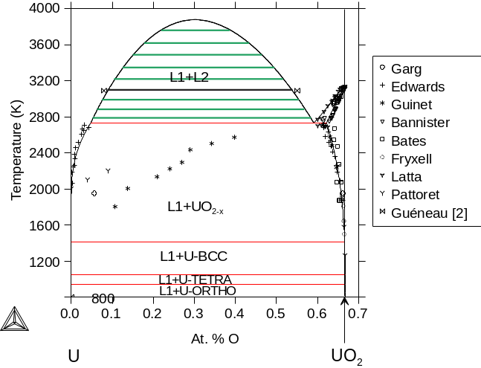

The miscibility gap in the liquid state is the extension of the two-phase domain [liquid + UO_{2-x}] of the phase diagram. The extent of the miscibility gap is then a function of the oxygen solubility limit in liquid uranium. The available experimental data on the oxygen solubility limit in liquid uranium are scattered [1]. By selecting Edwards’s data [2], the miscibility gap is very large. In the contrary, Guinet’s data [3] lead to a small two-liquid domain. In 1998, Gueneau [1] selected the lowest values of oxygen content in uranium liquid on the basis of experimental data on the U-Zr-O ternary system. In fact, Juenke [4] and Politis [5] reported the presence of a large miscibility gap respectively in the Zr-UO₂ and αZr(O)-UO₂ sections which extent could only be consistent with the existence of a large miscibility gap in the U-UO₂ system, then with Edwards’s [2] lowest values of oxygen solubility limit. In 2001, Baichi [6] performed a complete critical analysis of the thermochemical data in U-UO₂ that led also to the selection of Edwards’s data.

In the framework of the study of the miscibility gap in the U-Zr-O system, the miscibility gap in the U-UO₂ system was displayed by performing a melting/quenching test in the ISABEL1 device by electron bombardment. As it can be noted in figure 2, the ingot microstructure clearly showed the simultaneous presence of two layers, one on the top of the ingot, corresponding to the lightest liquid, enriched in UO₂ and the other one, on the bottom, enriched in uranium. Some droplets of the oxide liquid with the same composition as the top layer are also present in the uranium rich liquid phase. The post-mortem chemical analysis of the two regions of the ingot by WDS and EDS led to the determination of a tieline of the miscibility gap at 3090 K giving the overall compositions of both liquid phases (see figure 1). This experimental tieline of the phase diagram is consistent with the lowest values of oxygen solubility limit in uranium liquid [2].

Figure 2. Quenched microstructure of the U-UO₂ mixture melted at 3090 K by electron bombardment in ISABEL1 device [1].
(a) Layer of the oxide rich liquid (L2) present at the ingot surface.
(b) Droplets of oxide rich liquid (L2) in the major metal liquid phase (L1).
(a) (b)

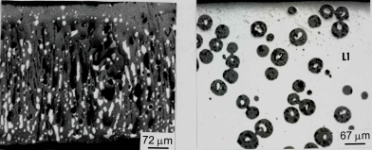

2-2 Ternary system U-O-Zr

By adding zirconium in the U-O system, the miscibility gap emanating from the binary U-O must be closed, since the binary systems Zr-O and U-Zr are completely miscible in the liquid state.

Politis has determined U-Zr-O isothermal sections at 2273 K from melting/quenching experiments [5]. The solubility limit of (U,Zr)O_{2-x} in (U,Zr,O) liquid deduced from Politis’s data is not consistent with the Zr-UO₂ section reported by Juenke [4]. To solve this ambiguity, Maurizi determined the [liquid/(U,ZrO)_{2-x}] liquidus position at 2273 K for U/Zr=1.35, representative of the corium [7]. The liquidus was evaluated from the variation of the oxygen activity with the oxygen content. The oxygen activity was determined from measurements of the partial pressures of UO and U species by using high temperature mass spectrometry. Figure 3 presents the oxygen activity versus oxygen content at 2273 K for a U/Zr ratio of 1.35. When the oxygen content increases in the (U,Zr,O) liquid, oxygen activity increases until about 7 at. % which corresponds to the oxygen solubility limit in the liquid. For oxygen contents higher than 7 at. %, the oxygen activity is fixed by the two phase [liquid+(U,Zr)O_{2-x}] equilibrium. The resulting value of 7 at.% differs from the one estimated by Politis (about 20 at.%) and is consistent with a large extent of the miscibility gap in U-Zr-O.

Figure 3. Oxygen activity versus oxygen content at 2273 K in (U,Zr,O) mixtures with a U/Zr ratio of 1.35 [7]; O activity is determined from U and UO partial pressure measurements by using high temperature mass spectrometry.

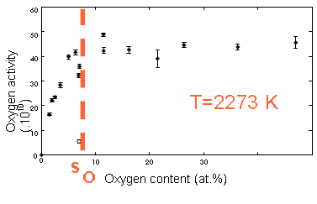

The miscibility gap in the liquid state in the ternary U-Zr-O was studied by performing melting/quenching tests in the ISABEL1 device [1]. Figure 4 shows the quenched microstructure of the ingot constituted of a major metal liquid phase where the minor oxide enriched liquid is present in the form of droplets.

Figure 4. Quenched microstructure of the (U,O,Zr) mixture melted at 3223 K by electron bombardment in ISABEL1 device showing some droplets of oxide rich liquid (L2) in the major metal liquid phase (L1) [1].
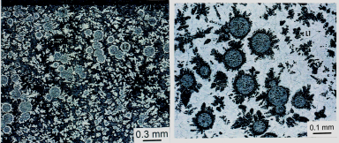

As in the U-UO₂ system, the post-mortem analysis of the ingot allowed to determine the overall compositions of both liquid phases, i.e. a tieline of the miscibility gap in U-Zr-O at 3223 K, as indicated in figure 5. In the same work, thermodynamic calculations by using the CALPHAD method were presented. The U-Zr-O database was assessed on the basis of Edwards’s data [2] for the oxygen solubility in liquid uranium in U-UO₂, Maurizi’s values [7] for the liquidus in U-O-Zr and the experimental results obtained in the ISABEL1 device for the U-UO₂ and U-Zr-O liquid miscibility gap description. These calculations allowed verifying the consistency of the selected experimental data. The U-Zr-O database was used to calculate the solidification paths of the U-Zr-O different liquid phases displayed in the experiments. Composition and mole fraction of the phases predicted by the thermodynamic calculations were in good agreement with the observed microstructures of both quenched liquid phases.

Figure 5. Calculated isothermal section U-Zr-O at 3223 K where the experimental tieline is reported [1].
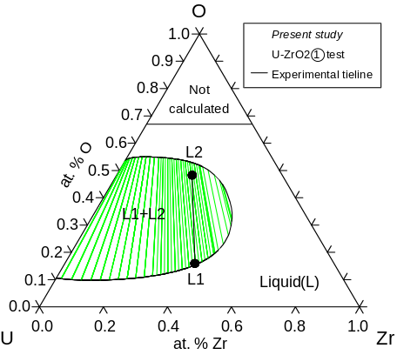

3 –Miscibility gap in the U-Zr-O-Fe system

The methodology described in the previous section is applied to study the miscibility gap in the U-O-Zr-Fe quaternary system. A small amount of yttrium is added to simulate a fission product in order to observe how it will distribute in both liquid phases of the U-Zr-O-Fe miscibility gap.

3-1 Experimental work

A schematic view of the ISABEL1 device is presented in figure 6.

Figure 6. Schematic view of the ISABEL1 device.

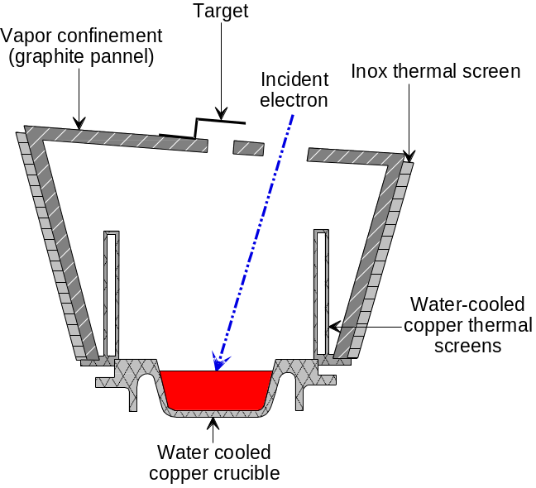

3-1-1 Materials

The ingot is filled with an initial mixture of U metal, Fe metal, Y metal, UO₂ and ZrO₂ with the following initial composition in at. %: U_{29.72} Zr_{11.17} O_{32.03} Fe_{26.38} Y_{0.7}. The initial overall weight of the ingot was of 2253.7 g.

3-1-2 Electron bombardment heating conditions

Heating is provided by a 60 kW Leybold electron gun operating under a secondary vacuum. The materials are placed in a water-cooled copper crucible, axially symmetric (h= 45 mm, Φ≈ 110 mm). Thermocouples located in the crucible allow monitoring the heat transferred in the crucible. The electron beam scans a rectangular surface. During the experiment, the ingot surface is observed with a camera.
Before performing the test at very high temperature to enter the miscibility gap, several successive heatings of the mixture are necessary to perform at an intermediate power density in order to obtain a homogeneous and as large as possible melt zone without evaporating the constituents.
In the last heating, the power is quickly increased to 40 kW to reach the desired temperature during a very short time, about one minute, to avoid vaporization. The scanned surface is of 2 cm × 2 cm. Figure 7 indicates the electron gun power, the temperature of the crucible bottom and the power evacuated in the cooled water of the crucible as a function of time during the last heating. The ingot is cooled by cutting off the electron beam in order to quench the high temperature structure of the liquid phases. The cooling time of the ingot is about several seconds.

Figure 7. Electron beam power, crucible temperature and crucible water power versus time during the experiment in the U-Zr-O-Fe miscibility gap.

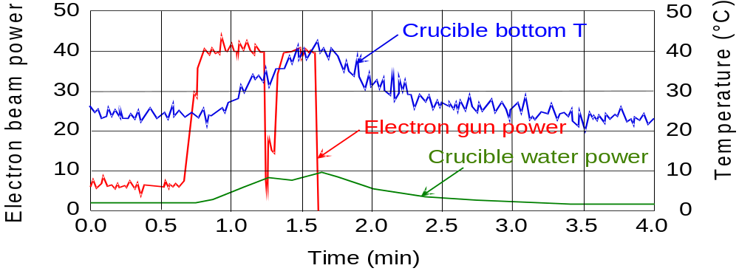

3-1-3 Melt temperature measurement

A 10-color pyrometer (0.5844 μm < λ < 1.033 μm) is used to measure the temperature of the melt at the ingot surface. A glass slide swept by an argon jet is placed ahead of the window to avoid the decreasing of the signal due to high vaporization of the melt. The temperature measurements are given with an uncertainty of +/- 100 K. Figure 8 presents the surface temperature of the melt as a function of time. At the beginning of the test, temperature reaches quickly about 2500 K. At the moment when the electron beam is cut off, the melt temperature reaches a maximum value of 3000 +/- 100 K. The time for solidification is estimated at about two seconds by using the visualization camera of the melt surface.

Figure 8. Measured temperature of the ingot surface by pyrometry versus time.
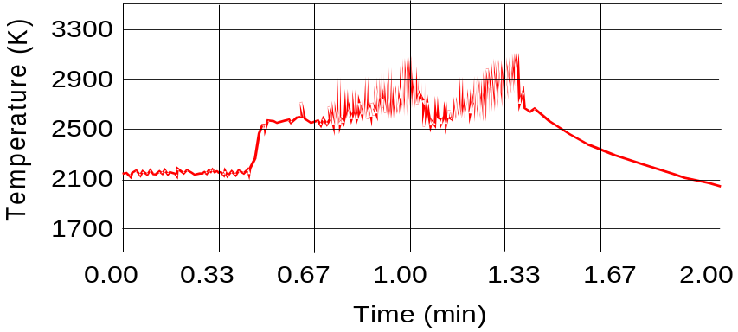
Cutting off of
the electron beam

3-1-4 Microstructure analysis of the U-Zr-O-Fe quenched alloy

A diametrical section is cut in the ingot center, then polished in order to perform the observations by using Scanning Electron Microscopy (SEM). The chemical compositions of the phases are measured by Wavelength Dispersive Spectrometry (WDS) and Energy Dispersive Spectrometry (EDS) and the phase fractions are determined by image analysis. Figure 9 presents the top part of the diametrical section of the ingot, close to the center.

Figure 9. Microstructure of the quenched ingot from the U-Zr-O-Fe miscibility gap.
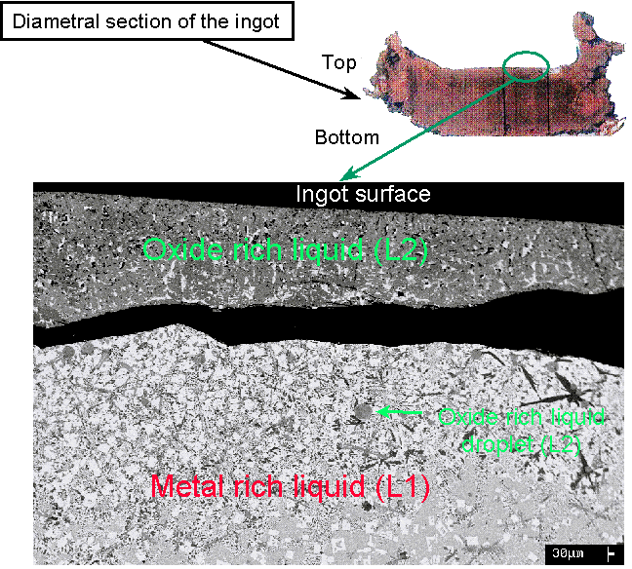

The grey and white phases correspond respectively to the mixed oxide (U,Zr)O_{2-x} and the intermetallic U₆Fe. An oxide rich layer is present at the ingot surface with a thickness of about several hundred of microns in comparison with the ingot thickness of about 2 cm. The top layer is detached from the bottom part of the ingot, metal enriched. Spherical globules enriched in oxide are also present below the oxide layer in the metallic matrix. This type of structure was observed in the (U-UO₂) quenched mixture (figure 2) [1]. The oxide rich regions correspond to the oxide rich liquid phase of the miscibility gap. The spherical globules are some droplets of this oxide liquid that were quenched during their rising to the melt surface. The matrix enriched in uranium corresponds to the metallic liquid phase of the miscibility gap. The oxide liquid, lighter than the metallic one, may segregate at the ingot surface. The separation between both layers may be due to the difference of thermal expansion coefficients of the oxide and metal rich phases during cooling. In figure 10, a metallic rich droplet is observed at the interface between the layers.

Figure 10. Droplet of metal rich liquid located in the oxide rich liquid layer.
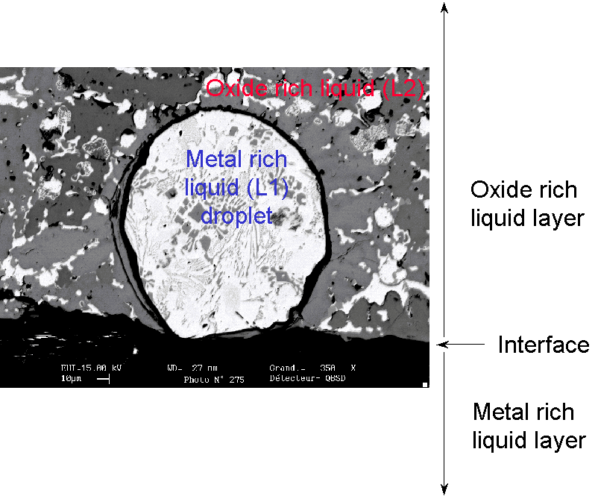

3-1-5 Chemical compositions of the liquid phases

It is necessary to estimate the overall compositions of both liquid phases. During cooling, when the quenching is quick enough, each liquid phase follows its own solidification path leading to the successive solidification of different phases. Qualitatively, the observation of the quenched liquid microstructures shows that the mixed oxide (U,Zr)O_{2-x} is the major phase solidified from the oxide liquid. In the metal liquid, U₆Fe is the major constituent. EDS and WDS methods are currently used to measure local chemical compositions of the phases. In the present work, a methodology is developed in order to determine the liquid overall compositions by using several methods such as EDS, WDS and image analysis [8]. Results are indicated in table 1.

Table 1 – Overall compositions of both oxide and metal liquid phases of the miscibility gap.
IA / WDS: local composition of phases by WDS + phase fractions by image analysis
IA / EDS: local composition of phases by EDS + phase fractions by image analysis
WDS overall: overall chemical analysis of a scanned area
EDS overall: overall chemical analysis of a scanned area
corrections: About 10 at. % of oxygen were detected in U₆Fe. The analyse showed that the oxidation is on the surface and not due to an oxygen solubility in the intermetallic phase, that would indicate the existence of a ternary phase U_{x}Fe_{y}Oz_{c}.

Liquid phase | Experimental method | At. % O | At. % Fe | At. % Y | At. % Zr | At. % U
Oxide | IA / WDS | 58.5 | 1.0 | 1.6 | 11.2 | 27.7
Oxide | IA / EDS | 58.3 | .9 | 1.4 | 11.9 | 27.5
Oxide | WDS overall | 62.8 | 2.5 | - | 6.5 | 28.3
Oxide | EDS overall | 64.8 | .9 | 1.3 | 8.5 | 24.5
Oxide | IA / WDS + corrections | 58.2 | 1.0 | 1.6 | 11.3 | 27.9
Oxide | IA / EDS + corrections | 57.6 | 1.0 | 1.4 | 12.1 | 28.0
Oxide | WDS overall + corrections | 58.3 | 2.8 | - | 7.3 | 31.6
Oxide | EDS overall + corrections | 58.3 | 1.1 | 1.5 | 1.1 | 29.0
Metal | WDS overall | 11.4 | 30.4 | 0.0 | 6.3 | 51.9
Metal | EDS overall | 17.4 | 21.7 | 0.0 | 8.4 | 53.0
Metal | WDS overall + corrections | 9.7 | 26.4 | 0.0 | 7.7 | 56.2
Metal | EDS overall + corrections | 10.6 | 21.2 | 0.0 | 9.3 | 59.0

Consistent results are obtained by using the different methods. The final value for the overall chemical composition of the oxide liquid is finally selected from coupling EDS and image analysis. This method is impossible to use for the metal rich liquid phase because the microstructure is complex with a lot of minor phases which some of them cannot be distinguished by image analysis. In this case, EDS performed on a scanned surface is chosen. It was verified that the overall oxide liquid composition was the same in the droplets and in the top layer.
The present estimation of the overall compositions of both liquids shows that iron concentrates in the metallic liquid whereas yttrium goes in the oxide phase.

3-1-6 Microstructures of the quenched liquid phases

Figures 11 and 12 show the microstructures of both quenched melts.

Figure 11. Quenched microstructure of the oxide rich liquid phase. The grey matrix is the (U,Zr)O_{2-x} phase. Black and white precipitates correspond respectively to α-Zr(O) and U₆Fe phases.
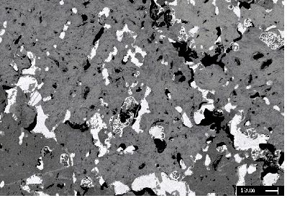
Figure 12. Quenched microstructure of the metal rich liquid phase. The white matrix is the U₆Fe phase.
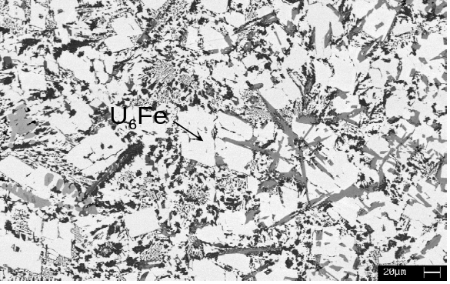

The chemical compositions and the molar fractions of the different phases formed during cooling from both oxide and metal rich liquids are indicated in table 2.

Table 2 – Chemical compositions and molar percentages of the phases formed during cooling of both liquid phases.

Liquid | Phases | Composition  (atomic fraction) | Phase molar percentages
Oxide | (U,Zr)O_{2-x} | U_{0.26} Zr_{0.06} O_{0.66} Y_{0.02} | 84.0
Oxide | α-Zr(O) | Zr_{0.77} O_{0.23} | 11.4
Oxide | Oxidized U₆Fe | U_{0.71} Zr_{0.04} O_{0.13} Y_{0.12} | 4.6
Metal | Oxidized U₆Fe | U_{0.71} Zr_{0.04} O_{0.13} Y_{0.12} | 61.6
Metal | (U,Zr)O_{2-x} | U_{0.3} Zr_{0.03} O_{0.66} | 7.2
Metal | Fe₂(U,Zr) | U_{0.23} Zr_{0.09} Fe_{0.65} O_{0.03} | Not measured
Metal | α-Zr(O) | U_{0.02} Zr_{0.84} Fe_{0.01} O_{0.13} | Not measured
Metal | U₁Zr₁Fe₁ | U_{0.33} Zr_{0.31} Fe_{0.31} O_{0.06} | Not measured
Metal | U₂Zr₃Fe₅ | U_{0.18} Zr_{0.29} Fe_{0.48} O_{0.04} | Not measured

3-1-7 Liquid fractions

Orders of magnitude of both liquid phases were estimated from the measurement of both liquid layer thicknesses. The metal liquid represents about 90 mol. % of the ingot.

3-1-8 Vapour composition above the U-Zr-O-Fe melt

During the experiment, a target is placed above the ingot to condensate the vapour coming from the melt. The chemical analysis of the condensate allows determining the composition of the vapour in equilibrium with the melt. This type of data can be correlated to the thermodynamic properties of the melt (activity coefficients of elements in the melt) and is very interested to compare with thermodynamic calculations to check the validity of a database.
Figures 13 (a) and (b) present respectively the lateral section of the condensate and the corresponding chemical composition profile measured by WDS.

Figure 13. (a) Lateral section of the condensate from the vapour phase and (b) the corresponding chemical composition profile A-B measured by WDS.
(a)
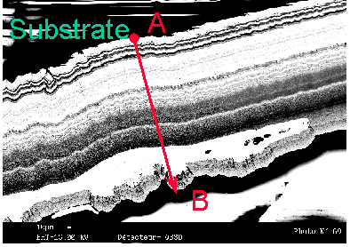
(b)
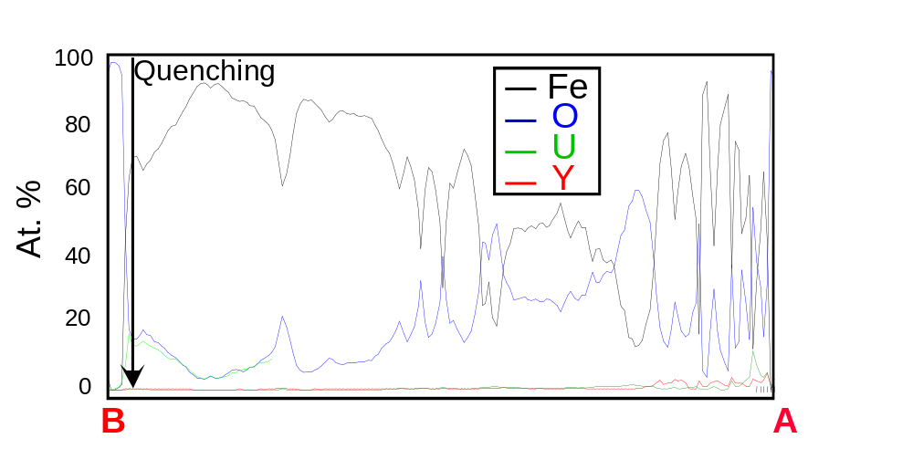

The variation in composition is correlated to the thermal treatment history of the ingot. As predicted by thermodynamic calculations, iron is the major specie in the vapour phase. The other major constituents are oxygen and uranium via the UO gas specie. The chemical composition of the vapour at the moment where the melt was quenched is estimated in atomic fraction at: U_{0.14} O_{0.15} Fe_{0.71}.

3-2 Thermodynamic calculations

Calculations are performed with the ThermoCalc software [9].

3-2-1 DPC01 Thermodynamic database

The U-O and Fe-U systems were completely reassessed on the basis of Baichi’s and Labroche’s critical analysis [6,10]. For Zr-O, Fe-O, U-Zr and Fe-Zr binary systems, databases from [11,12,13,14] were used. All ternary systems have been calculated by extrapolation from the binaries except U-Zr-O for which available experimental data [1,4,5,6,7,10] allowed optimizing ternary interaction parameters. When thermochemical properties of binary and ternary systems are well described, the quaternary system may be correctly represented.

3-2-2 Estimation of the final composition of the U-Zr-O-Fe melt

The disadvantage of the electron bombardment device is that the material is melted under vacuum that induces a noticeable vaporization of the melt, especially at very high temperature and with iron. The priority is to maintain the overall composition of the material inside the miscibility gap in order to quench the liquid phases and then to get the overall compositions of the liquids leading to an experimental tieline. Experimentally, the final composition of the ingot is impossible to get. Thermodynamic calculations are performed to estimate the final composition of the material and to check the consistency of all experimental data. Yttrium is not taken into account in the calculations.

At 3000 K, the initial composition of the corium leads to the equilibrium between about 50 mol. % of the oxide liquid and 50 mol. % of the metallic melt. Experimentally, the oxide liquid remains minor by comparison with the metal one. Vaporization calculations from the initial composition of the (U,Zr,O,Fe) melt show a very high flux of 5.8 10^{–4} g/h/cm² at 3000 K. During 15 seconds at 3000 K, the weight loss is of 126 g. The calculated chemical composition of the vapour is Fe_{0.93}O_{0.04}U_{0.03}(ε Zr). It shows that the melt is progressively depleted in iron and for a minor part, in oxygen and uranium. The final overall composition of the melt is searched by thermodynamic calculations to fit the available experimental data (chemical composition and relative fractions of the liquids, chemical composition of the vapour phase). An overall good agreement is found for the following final composition of the melt in atomic fraction: O_{0.15} Fe_{0.18} Zr_{0.17} U_{0.50}. Experimental and calculated results are compared in Table 3.

Table 3 – Comparison between experimental results and calculated data from a corium with the composition O_{0.15}Fe_{0.18}Zr_{0.17}U_{0.50}

 |  | Calculated data with  [O_{0.15}Fe_{0.18}Zr_{0.17}U_{0.50}] | Experimental data
Overall metal liquid composition  (Liquid 1)  in at. % | O  U  Zr  Fe  Y | 5.6  52.7  19.8  21.9  - | 10.6  59.0  9.3  21.2  -
Overall oxide liquid composition  (Liquid 2)  in at. % | O  U  Zr  Fe  Y | 57.75  37.8  4.4  0.05  - | 57.6  28.0  12.1  1.0  1.4
Molar fraction (%) | Liquid 1  Liquid 2 | 82  18 | ∼ 90  ∼ 10
Vapour composition  in at. % | O  U  Zr  Fe  Y | 12  10  ∼ 0  78  - | 15  14  ∼ 0  71  ∼ 0

3-2-3 Solidification paths of the U-Zr-O-Fe melts

Table 2 gives the experimental chemical compositions of the different phases located in both quenched liquid phases. The variation of the molar fractions of the phases formed during cooling from the oxide liquid [O_{0.58} Zr_{0.11} Fe_{0.01} U_{0.30}] is presented in figure 14.

Figure 14. Calculated molar fraction of the phases occurring during cooling of the oxide rich liquid
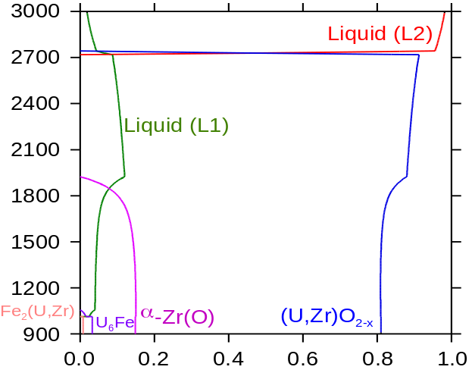
Phase Mol. %
T(K)

The different phase transformations are:
T=2700 K: L2 -> L1 + (U,Zr)O_{2-x}
T=1924 K: L1 + (U,Zr)O_{2-x} -> α-Zr(O)
T=1057 K : L1 + (U,Zr)O_{2-x} -> α-Zr(O) + U₆Fe
T _{solidus} =1013 K: L1 + α-Zr(O) -> UO₂ + U₆Fe + Fe₂(U,Zr)

As shown in table 4, the agreement between calculated mole fractions of the phases at T solidus and experimental data is good.

Table 4. Comparison between calculated and experimental phase molar fractions formed during cooling of the oxide rich liquid

Phases | Calculated mol. % | Experimental mol. %
UO₂ | 81.0 | 84.0
α-Zr(O) | 14.9 | 11.4
U₆Fe | 3.3 | 4.6
Fe₂(U,Zr) | 0.8 | Not detected

Mole fractions of the phases formed during cooling from the metal liquid [O_{0.1} Zr_{0.11} Fe_{0.21} U_{0.58}] are calculated in figure 15.

Figure 15. Calculated mole fractions of the phases occurring during cooling of the metal rich liquid
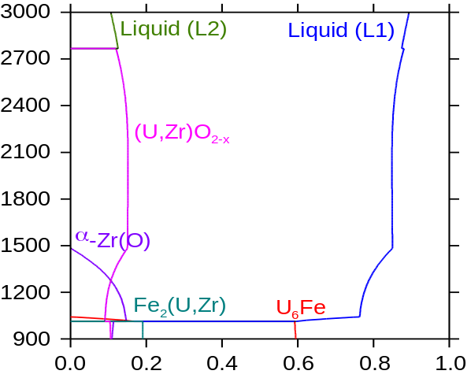
Phase mol. %
T(K)

In case of the metal rich liquid which microstructure is very complex, the thermodynamic calculations cannot be reliable enough, as the U-Zr-O-Fe database does not contain the description of all Fe_{x}U_{y}Zr_{z} phases that were detected experimentally. Furthermore, all phases could not be quantified by image analysis because of the lack of contrast in atomic number between some of them. As shown in table 5, the calculated and experimental molar fractions of U₆Fe and UO₂ can be compared. The agreement is very good for the matrix U₆Fe.

Table 5. Calculated and experimental mole fractions of the phases in the quenched metal rich liquid

Phase | Calculated mol. % | Experimental mol. %
U₆Fe | 61.1 | 61.6
Fe₂(U,Zr) | 18.4 | Not measured
α−Zr(O) | 9.3 | Not measured
UO₂ | 11.2 | 7.2

3-3 Discussion

To determine a tieline of a phase diagram at high temperature, it is important to avoid chemical interaction with the crucible, to reach the physicochemical equilibrium, to quench the phases as quick as possible, to control the temperature of the melt and to measure the most accurately as possible the overall chemical compositions of both quenched liquid phases.

The ISABEL1 device offers some advantages. Electron bombardment allows reaching very high temperatures. Problems of chemical interaction with the melt at high temperature are avoided by using a cold crucible. The maximum temperature is reached at the center of the ingot surface where the quench is the most efficient by cutting off the electron beam. The fact that the liquid droplets are perfectly spherical is a proof of the efficiency of the quench. The overall chemical compositions of the liquid phases are carefully determined close to the ingot surface, where the temperature is measured.

Melting by electron bombardment imposes to work under a secondary vacuum and with a cold crucible. Several consequences of these experimental conditions are discussed below.

Vaporization of the melt

In U-UO₂ and U-Zr-O systems, the consequence of melting under vacuum is that the liquid is depleted in oxygen as the major specie in the vapour is UO. With iron, of course, the vapour is enriched in iron and the melt is depleted in this element. The experimental conditions must be carefully determined not to leave the miscibility gap, especially with iron. But vaporization concerns only a very thin layer of the ingot surface. So it just changes the overall composition of the melt with time. The oxide liquid is systematically the minor phase. The important thing is to verify that the time to reach equilibrium in the liquid phases is short in comparison with the duration of the experiment.

Time delay necessary to reach physicochemical equilibrium

The characteristic time delay to reach physicochemical equilibrium is derived by supposing that the mass transfer between layers is limited by diffusion in a mass transfer sublayer δ. This time delay is maximized by considering thick corium layers H. In case of ISABEL1 tests, H corresponds to the ingot thickness (of about several centimeters). The mass transfer is mainly controlled by the major metallic phase (the oxide liquid thickness is of several hundred of microns). The characteristic delay time for reaching physicochemical equilibrium is given by [15]:

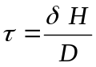
where : thickness of the mass transfer sublayer in the metallic phase (m)
: thickness of the metallic layer (m)
: molecular diffusivity in the metal liquid (m²/s)

The thickness of the mass transfer sublayer is linked to the convection (thermal hydraulics) by the following relation:
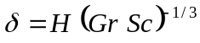
where 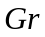: Grashof number characterizating the convection in the layer
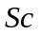: Schmidt number 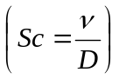
In a device such as ISABEL1 where heating is provided by electron bombardment, Marangoni’s convection is dominant. The Grashof number can be estimated by:
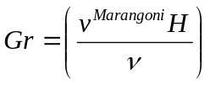
where 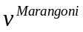: Marangoni speed (m/s) 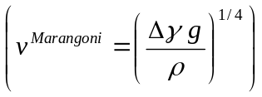where 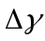 is the surface tension gradient (N/m), gravity acceleration (m/s²),  liquid density (kg/m³)
: kinematic viscosity of the metallic phase (m²/s)

Applying the previous relations, the characterizing time delay for reaching the physicochemical equilibrium is of the order of the minute by using the following input data for the corium fluid: 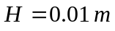,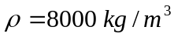, 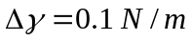, 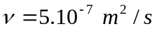, 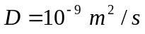. The time to reach physicochemical equilibrium is of the order of magnitude of the test duration.

Temperature gradient in the melt

The hotest region of the melt is at the center of the surface where the electron beam scans the ingot. The temperature decreases from the surface center of the ingot to the walls of the cold crucible. In the experiments, a thin solid crust is always maintained along the crucible walls. This solid crust insulates the melt from the cold crucible. The temperature gradient in the melt is difficult to estimate. In experiments in U-UO₂, U-Zr-O and U-Zr-O-Fe miscibility gaps, the microstructure is homogeneous in the major metal liquid zone with low composition gradients. Furthermore, close to the crucible walls, a large decrease of the temperature would induce the precipitation of the mixed oxide (U,Zr)O_{2-x} if the temperature was low enough to go in the [solid+liquid] domain of the phase diagram. In such case, the microstructure would change as shown in [1]. It was not the case in the present experiment. By supposing the formation of the miscibility gap at about 2773 K [1], the maximum temperature gradient ranges between 200 and 400 K.

Marangoni’s convection

The temperature gradient induces a surface tension gradient at the ingot surface. The resulting convection in the melt can contribute to the rising of the droplets of oxide rich liquid from the bottom to the top of the ingot. Origins of the segregation of the oxide phase at the ingot surface are not obvious to clearly explain. The first simplest explanation may be a gravity dependent effect, as the oxide rich liquid is the lightest phase but Marangoni’s convection can also be related to the rising of the droplets up to the ingot surface.

Temperature measurement

Measurement by using a pyrometer is currently used in high temperature experimental devices. The uncertainty of the measurement comes from the fact that the emmissivity of the corium is not known. Furthermore, during the experiment, the melt surface is very turbulent. The resulting uncertainty given in the present work is large, equal to +/-100 K. The measurement could perhaps be improved by using an apparatus that could measure the emmissivity of the melt and then use it as input data for the temperature measurement with a pyrometer.

4- Conclusion

A tieline of the U-Zr-O-Fe miscibility gap in the liquid state is experimentally determined at 3000 +/- 100 K by a melting / quenching test in the ISABEL1 device. The experimental work is coupled with thermodynamic calculations with the ThermoCalc software and the DPC01 database on the U-Zr-O-Fe system. In the DPC01 database, the ternary sub-systems are extrapolated from the binaries except U-Zr-O for which interaction parameters were optimized.
The oxide rich liquid segregates at the ingot surface in the form of a layer. Some droplets of the same oxide liquid are also present in the major metal liquid. This segregation phenomenon can be related to a gravity dependent effect. But Marangoni’s convection can also contribute to the rising of the droplets from the bottom to the top of the ingot, where droplets can coalesce to form a layer.
Several methods are tested to accurately determine the overall compositions of the quenched liquid phases. As expected, iron and yttrium are respectively located in the metal and oxide melts.
Thermodynamic calculations are performed to estimate the final composition of the melt that represents the best as possible the experimental results such as overall compositions and molar fractions of the oxide and metal melts as well as the vapour composition. A good agreement is found for the overall composition O_{0.15} Fe_{0.18} Zr_{0.17} U_{0.50}. Solidification paths of both liquid phases are calculated. The experimental fractions of the phases formed during cooling are well represented for the oxide rich liquid. The metal liquid quenched microstructure is complex and more difficult to simulate. An overall consistency of all experimental data obtained in the present work is verified. Furthermore, thermodynamic calculations with the DPC01 database show that the present experimental data on the miscibility gap of the U-Zr-O-Fe system are consistent with the previous study on the U-UO₂ and U-Zr-O sub-systems obtained with the same method [1], and with the experimental data of Hofmann and MASCA MA1 on the U-Zr-O-Fe miscibility gap [16,17,18].
The present study shows that the importance of coupling experimental and thermodynamic calculations. The quality of a thermodynamic database is related to the good description of the binary and ternary systems. In the U-Zr-O-Fe quaternary, the sub-systems Fe-Zr-O and Fe-U-O should be experimentally studied to improve the database.
The uncertainties due to the electron bombardment device are discussed. All experimental methods working at high temperature present advantages and disadvantages. The main important thing is to verify the overall agreement of the experimental results obtained with several experimental methods by performing thermodynamic calculations.

5- References

[1] C. Guéneau, V. Dauvois, P. Pérodeaud, C. Gonella, O. Dugne, Journal of Nuclear Materials 254 (1998) 153

[2] R.K. Edwards, A.E. Martin, Thermodynamics 2 (1966) 423

[3] P. Guinet, H. Vaugoyeau, P. Blum, French Atomic Energy Commission, Report CEA R 3060 (1966)

[4] E.F. Juenke, J.F. White, Report GEMP-731 (1969)

[5] C. Politis, Report KFK 2167 (1975)

[6] M. Baichi, PhD thesis, INPG Grenoble (2001)

[7] A. Maurizi, C. Guéneau, P. Pérodeaud, B. Schneider, O. Dugne, F. Valin, G. Bordier, EUROMAT 96 Proceedings, Conference on Materials and Nuclear Power, 21-23 Oct. 1996, Bournemouth, UK, p.49

[8] D. Blin, O. Dugne, P. Pérodeaud, C. Fucili, C. Guéneau, V. Dauvois, Journées d’Automne 1999, SF2M, Paris, 1999, Revue de Métallurgie, p.88

[9] B. Sundman, B. Jansson, J.O. Andersson, Calphad 9 (1985) p.153

[10] D. Labroche, PhD thesis, INPG Grenoble (2000)

[11] P. Liang, N. Dupin, S.G. Fries, H.J. Seifert, I. Ansara, H.L. Lukas, F. Aldinger, Zeitschrift für Metallkunde 92 (2001) 7 p. 747

[12] B. Sundman, Journal of Phase Equilibria, 12 (1991) p. 127

[13] T. Ogawa, T. Iwai, Journal of the Less-Common Metals, 170 (1991) p. 101

[14] C. Servant, C. Guéneau, I. Ansara, Journal of Alloys and Compounds, 220 (1995) p 19

[15] J.M. Seiler, A. Fouquet, K. Froment, F. Defoort, Nuclear Technology, 141 (2003) p.233

[16] P. Hofmann, KFK report 2220 (1976)

[17] V.G. Asmolov et al, Technical Report MP-TR-1, OECD MASCA Project (2001)

[18] F. Defoort, C. Guéneau, CEA Report 55/2001 (2001)

